מיני פרויקט בסיסי נתונים- שלב א'

מתנ"ס מחלקת רכש



מגישות :

אודליה מלול, אביגיל לוי, נעמי כהן

תוכן עניינים:

שלב א:

1. תיאור המערכת: תיאור מילולי של הארגון
2. תיאור מילולי של הטבלאות
3. הסבר על נרמול NF3 ERD
4. דיאגרמת DSD
5. יצירת הטבלאות
6. אכלוס הטבלאות
7. הצגת הנתונים בטבלאות
8. יצוא ויבוא בסיס הנתונים
9. Export
10. Import

שלב ב:

* + 1. תנאי אמינות Constrains-
    2. הגדרה
    3. בדיקת התנאים
    4. שאילתה 1
    5. שאילתה 2
    6. שאילתה 3
    7. שאילתה 4
    8. שאילתה 5
    9. שאילתה 6
    10. שאילתה 7
    11. שאילתה 8
    12. עדכונים ומחיקות

שלב ג:

1. SQL Plus
2. שאילתה 1
3. שאילתה 2
4. שאילתה 3
5. שאילתה 4
6. PL/SQL
7. פונקציה 1
8. פונקציה 2
9. פרוצדורה 1
10. פרוצדורה 2
11. Trigger 1
12. Trigger 2
13. Trigger 3

א. תיאור המערכת:

המערכת מנהלת מסד נתונים עבור מתנ"ס מחלקת רכש.

מחלקת רכש עובדת מול הספקים, מול עובדיה ומול הוצאות המתנ"ס.

מחלקת רכש מנהלת הזמנות שוטפות והזמנות גדולות עבור הצגות, מופעים, כלי מוזיקה וכל מה שנדרש לצרכי המתנ"ס.

המערכת מנהלת תיעוד רכישות ותשלומים מהספקים והלקוחות.

ב. תיאור מילולי של הטבלאות:

TABLES:

1. CITY (**CID**, CNAME)
2. DEPARTMENT (DID, DNAME)
3. ORDERS (**DID**, DNAME)
4. EMPLOYEE (**DID**, PID, JID, pid)
5. JOB (**JID**, JNAME)
6. MYORDER (**ORDER_ID**, **ORDER_DATE, SUMOFPRICE, SUPPLIER_ID**)
7. MYORDER_DETAILS (**MY_PID, QUANTITY, MYORD)**
8. products **(prod_ID, NAME, PRICE, myd)**
9. PAYMENTs **(PAYMENT_ID, PAYMENT_DATE, PAYMETHOD_ID, afterdiscount, myorderid)**
10. PAYMENT**_**METHODS **(PAYMETHOD_ID, PAYMENTNAME, payment_id)**
11. PERSON **(LNAME, FNAME, PID, BDATE, CID)**
12. SUPPLIER **(SUPPLIER_ID, P_ID, BEGINJOB)**

מקרא:

* **מפתח זר.**
* **מפתח ראשי.**

טבלאות נוספות בפרויקט האיחוד:

TABLES:

1. event (**ecode, edate, alltogetherexpense, hcode, evtycode, organizeid)**
2. eventextras (ecode, excode)
3. eventtypes (**evtycode**, ticketcost, evtyname)
4. extras (**exname, excode, excost)**
5. halls (hcode, hname, maxnumberofpeopleinhall)
6. JOB (**JID**, JNAME)

טבלאות :

|  |  |  |
| --- | --- | --- |
| **Table name** | **Attribute** | **Explanation (where needed)** |
| CITY | CID | מפתח |
|  | CNAME |  |
| DEPARTMENT | DID | מפתח |
|  | DNAME | שם מחלקה |
| EMPLOYEE | JID | מפתח זר מטבלת JOB |
|  | DID | מפתח זר מטבלת DEPARTMENT |
|  | PID | מפתח זר מטבלת PERSON |
| JOB | JID | מפתח |
|  | JNAME |  |
| MYORDER | ORDER_ID | מפתח |
|  | ORDER_DATE |  |
|  | SUPPLIER_ID | מפתח זר מטבלת SUPPLIER |
| MYORDER_DETAILS | **MY_PID** | מפתח |
|  | QUANTITY |  |
|  | **MYORD** | מפתח זר מטבלת MYORDER |
| PRODUCTS | NAME |  |
|  | **PRICE** |  |
|  | **prod_ID** | מפתח |
|  | **myd** | מפתח זר מטבלת MYORDER_DETAILS |
| PAYMENTS | PAYMENT_ID | מפתח |
|  | **afterdiscount** |  |
|  | PAYMENT_DATE |  |
|  | PAYMETHOD_ID | מפתח זר מpayment_METHOD |
|  | MYORDER_ID | מפתח זר מטבלת MYORDER |
| PAYMENT_METHODS | PAYMETHOD_ID | מפתח |
|  | PAYMENTNAME |  |
|  | **payment_id** | מפתח זר מטבלת PAYMENTS |
| PERSON | LNAME |  |
|  | FNAME |  |
|  | PID | מפתח |
|  | BDATE |  |
|  | CID | מפתח זר מטבלת CITY |
| SUPPLIER | SUPPLIER_ID | מפתח |
|  | BEGINJOB |  |
|  | P_ID | מפתח זר מטבלת PERSON |

ג. הסבר על נרמול 3NF :

**עבור כל הטבלאות כל השדות תלויות במפתח ראשי ואין תלויות נוספות.**

ד. ERD:

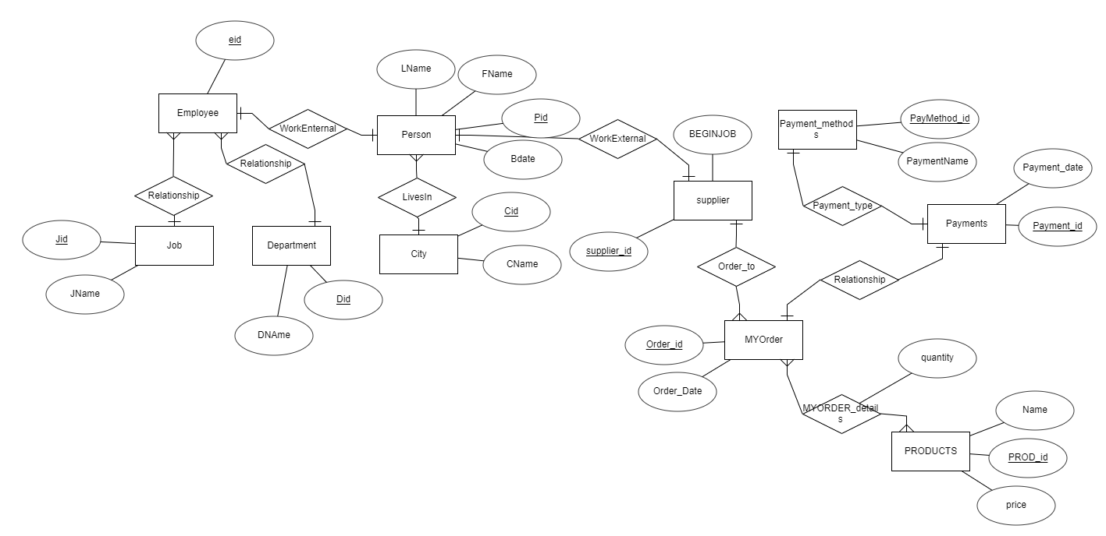

ה. DSD :

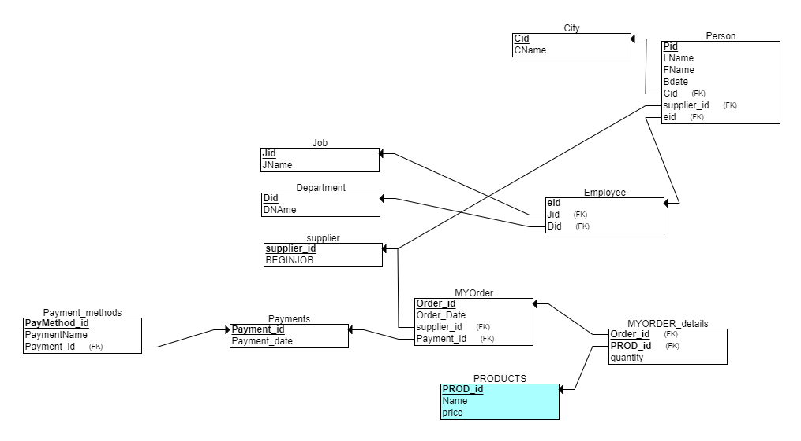

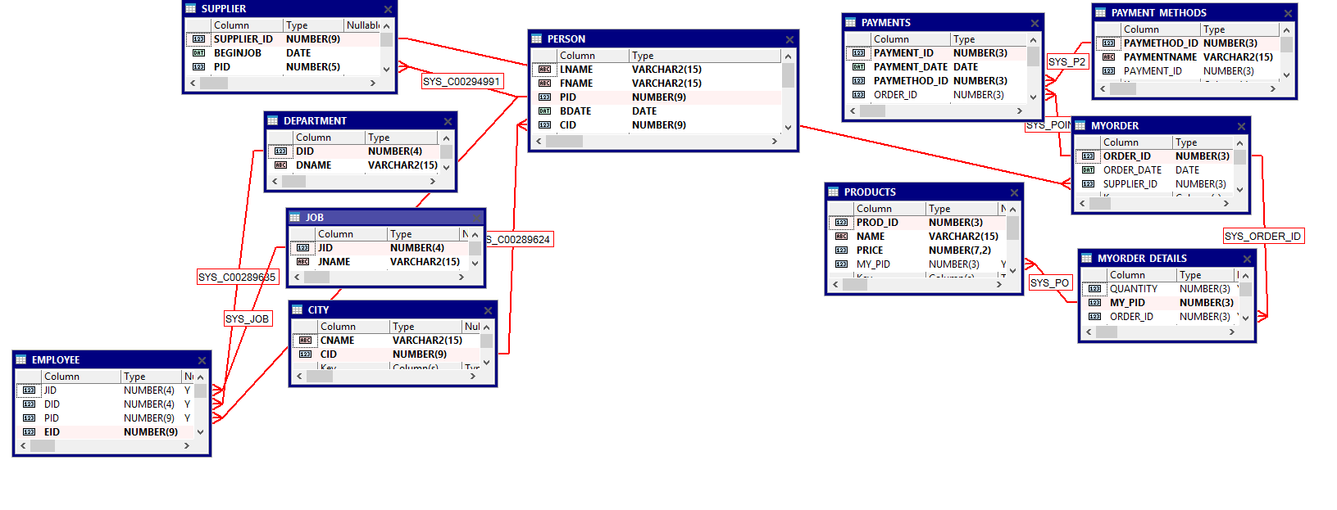

**ו. Create tables:**

**1)יצירת הטבלה JOB**

CREATE TABLE Job

(

Jid NUMERIC(3) NOT NULL,

JName VARCHAR(15) NOT NULL,

PRIMARY KEY (Jid)

);

* 1. **הכנסת הנתונים בעזרת INSERT**

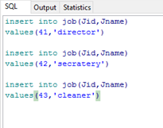

* 1. **הצגת הנתונים בעזרת SELECT**

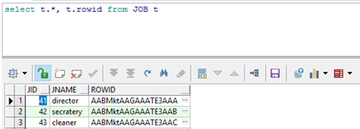

**1) Department יצירת הטבלה**

CREATE TABLE Department

(

Did NUMERIC(3) NOT NULL,

DNAme VARCHAR(15) NOT NULL,

PRIMARY KEY (Did)

);

**2)הכנסת הנתונים בעזרת Data generator**

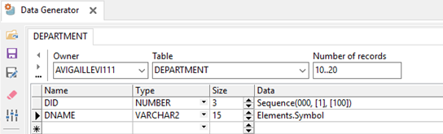

**3)הצגת הנתונים בעזרת SELECT**

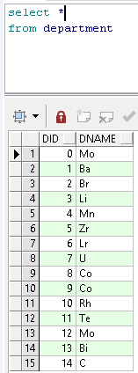

**1)יצירת הטבלה CITY**

CREATE TABLE City

(

CName VARCHAR(15) NOT NULL,

Cid NUMERIC(3) NOT NULL,

PRIMARY KEY (Cid)

);

**2)הכנסת הנתונים מקובץ EXCEL**

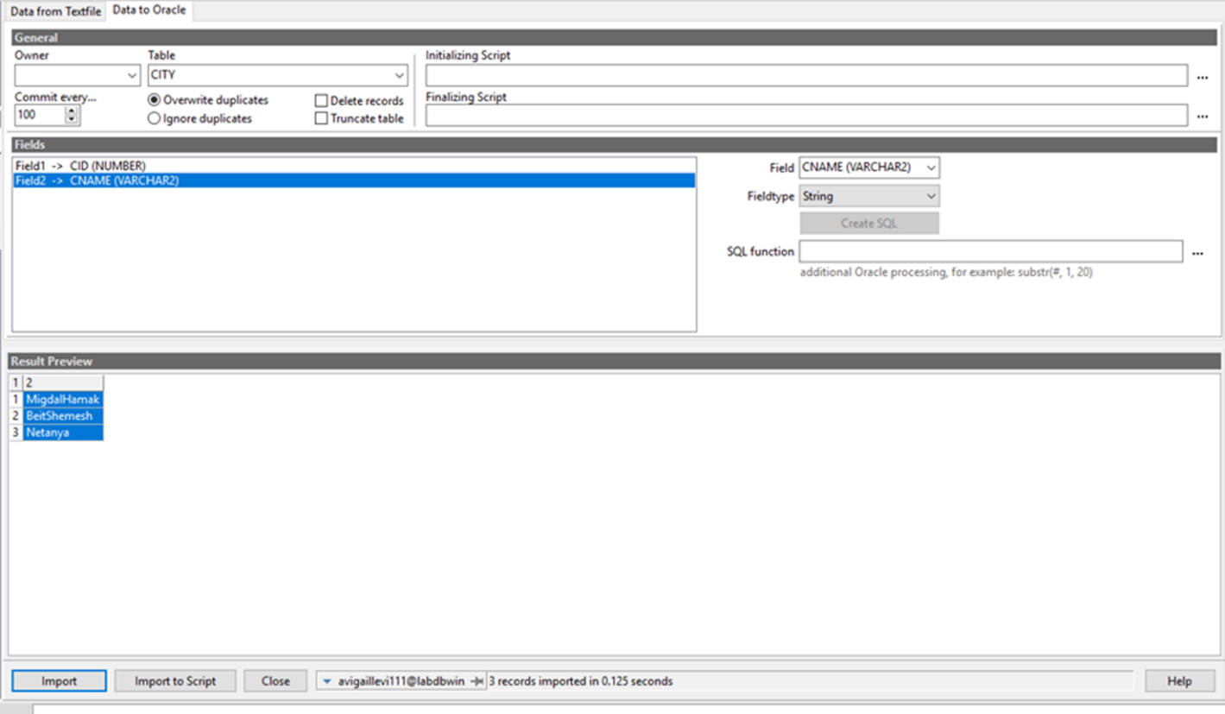

**3)הצגת הנתונים בעזרת SELECT**

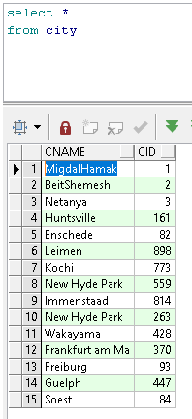

שלושת השורות הראשונות אלו הערים שהכנסנו בעזרת קובץ ה-EXCEL

לאחר מכן הכנסו בצורה גנרית עוד רשומות לטבלה אלו הרשמות מ-4 והילך.

**הכנסת הנתונים בעזרת DG:**

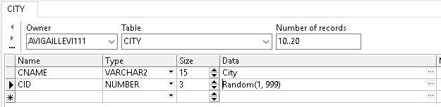

**1)יצירת הטבלה Order_details**

CREATE TABLE Order_details

(

OrderD_id NUMERIC(3) NOT NULL,

Name VARCHAR(15) NOT NULL,

price NUMERIC(7,2) NOT NULL,

PRIMARY KEY (OrderD_id)

);

**2)הכנסת הנתונים בעזרת DATA GENERATOR**

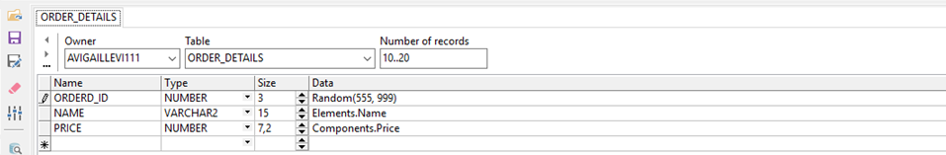

**הכנסת נתונים בעזרת INSERT:**

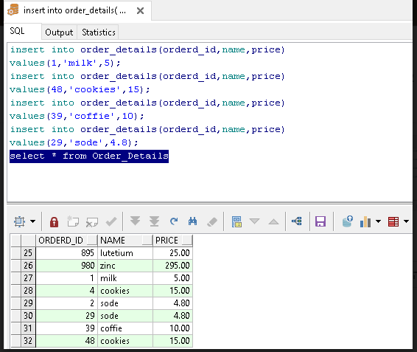

3)**הצגת הנתונים בעזרת SELECT**

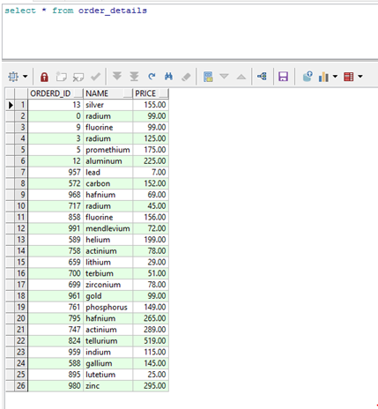

**1)יצירת הטבלה Payment_methods**

CREATE TABLE Payment_methods

(

PayMethod_id NUMERIC(3) NOT NULL,

PaymentName VARCHAR(15) NOT NULL,

PRIMARY KEY (PayMethod_id)

);

**2)הכנסת הנתונים מקובץ EXCEL**

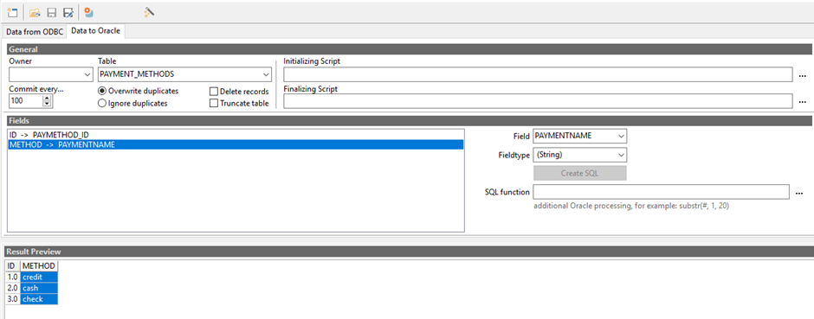

**3)הצגת הנתונים בעזרת SELSCT**

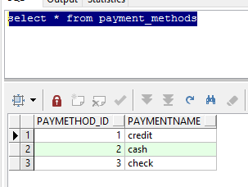

**1)יצירת הטבלה PERSON**

CREATE TABLE Person

(

LName VARCHAR(15) NOT NULL,

FName VARCHAR(15) NOT NULL,

Pid NUMERIC(3) NOT NULL,

Bdate DATE NOT NULL,

Cid NUMERIC(3) NOT NULL,

PRIMARY KEY (Pid),

FOREIGN KEY (Cid) REFERENCES City(Cid)

);

**2)הכנסת הנתונים בעזרת DATA GENERATOR**

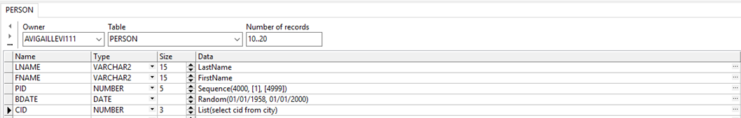

**3)הצגת הנתונים בעזרת SELECT**

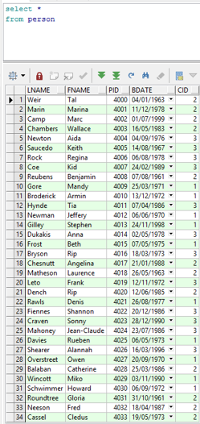 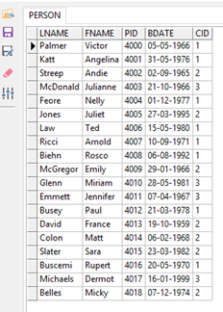

**1)יצירת הטבלה supplier**

CREATE TABLE supplier

(

Supplier_id NUMERIC(3) NOT NULL,

SupplierName VARCHAR(15) NOT NULL,

BeginJob DATE NOT NULL,

Pid NUMERIC(3) NOT NULL,

PRIMARY KEY (Supplier_id),

FOREIGN KEY (Pid) REFERENCES Person(Pid)

);

**2)הכנסת הנתונים בעזרת TXT_EDITOR**

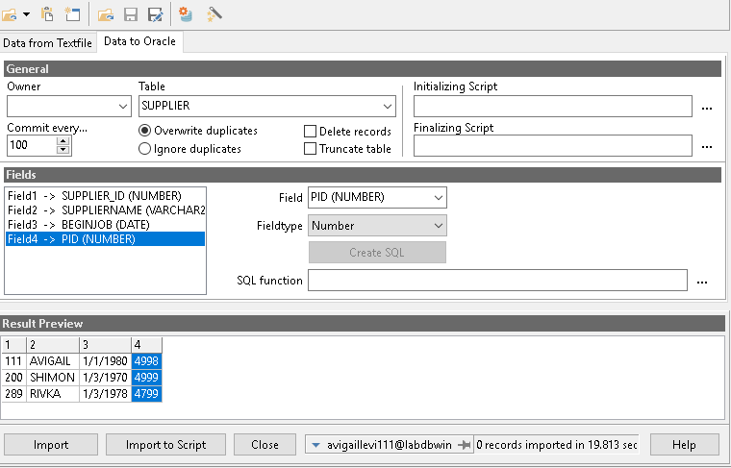

**3)הצגת הנתונים בעזרת SELECT**



**1)יצירת הטבלה MyOrder**

CREATE TABLE MyOrder

(

Order_id INT NOT NULL,

Order_Date DATE NOT NULL,

sumOfPrice NUMERIC(7,2) NOT NULL,

Supplier_id NUMERIC(3) NOT NULL,

PRIMARY KEY (Order_id),

FOREIGN KEY (Supplier_id) REFERENCES supplier(Supplier_id)

);

**2)הכנסת הנתונים בעזרת DATA GENERATOR**

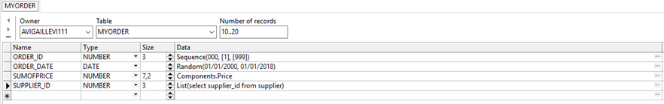

**3)הצגת הנתונים בעזרת SELECT**

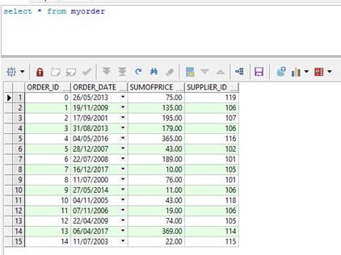

**1)יצירת טבלה EMPLOYEE**

CREATE TABLE Employee

(

Jid NUMERIC(3) NOT NULL,

Did NUMERIC(3) NOT NULL,

Pid NUMERIC(3) NOT NULL,

FOREIGN KEY (Jid) REFERENCES Job(Jid),

FOREIGN KEY (Did) REFERENCES Department(Did),

FOREIGN KEY (Pid) REFERENCES Person(Pid)

);

**2)הכנסת הנתונים באמצעות EXCEL**

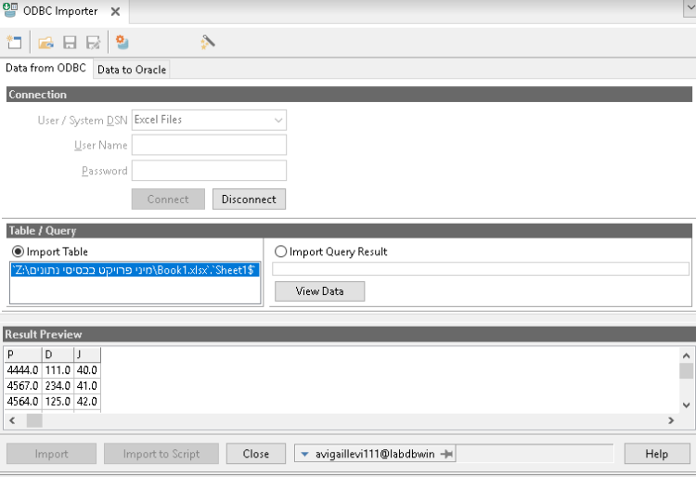

**3)הצגת הנתונים בעזרת SELECT**

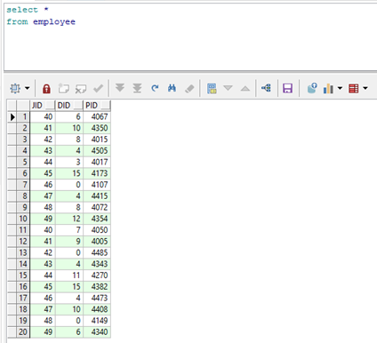

**1) O_details יצירת הטבלה**

CREATE TABLE (

quantity NUMERIC(3) NOT NULL,

Order_id INT NOT NULL,

OrderD_id NUMERIC(3) NOT NULL,

PRIMARY KEY (Order_id, OrderD_id),

FOREIGN KEY (Order_id) REFERENCES Order(Order_id),

FOREIGN KEY (OrderD_id) REFERENCES Order_details(OrderD_id)

);

**2)הכנסת הנתונים DATA GENERATOR**

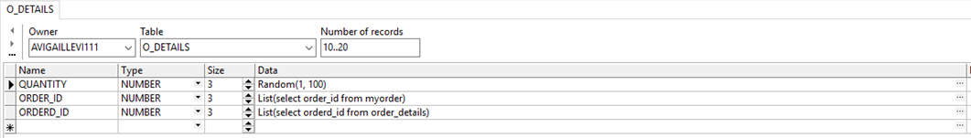

**3)הצגת הנתונים בעזרת SELECT**

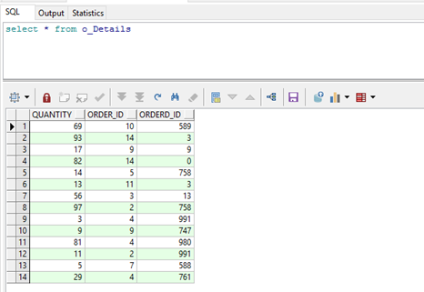

**1)יצירת טבלה Payments**

CREATE TABLE Payments

(

Payment_id NUMERIC(3) NOT NULL,

Payment_date DATE NOT NULL,

PayMethod_id NUMERIC(3) NOT NULL,

Order_id INT NOT NULL,

PRIMARY KEY (Payment_id),

FOREIGN KEY (PayMethod_id) REFERENCES Payment_methods(PayMethod_id),

FOREIGN KEY (Order_id) REFERENCES Order(Order_id)

);

**2)DG**

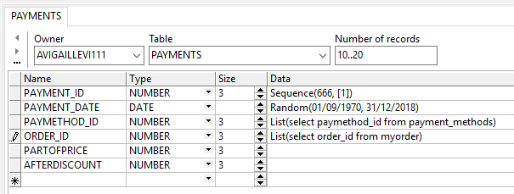

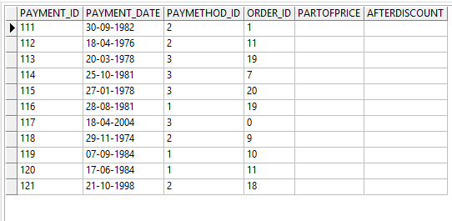

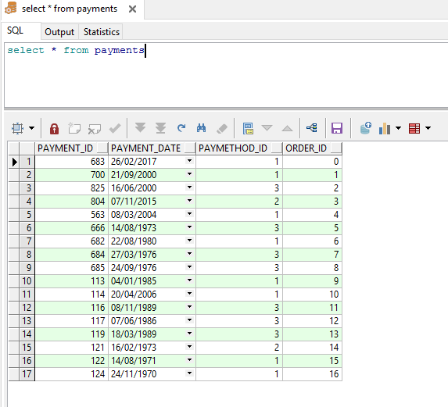

י. EXPORT :

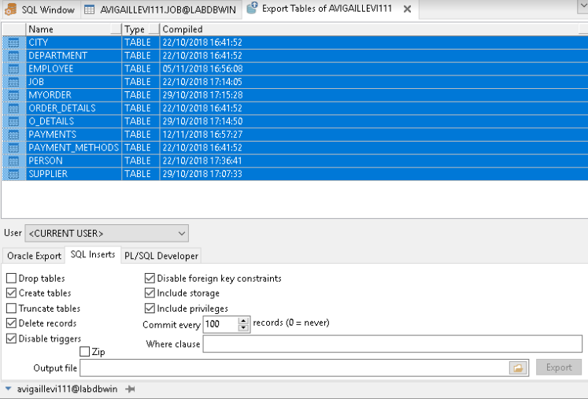

יא. IMPORT :

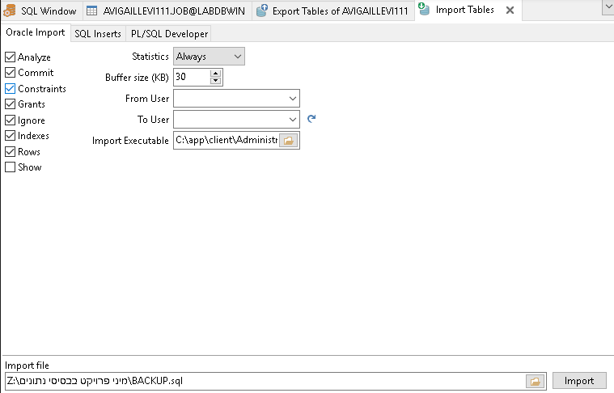

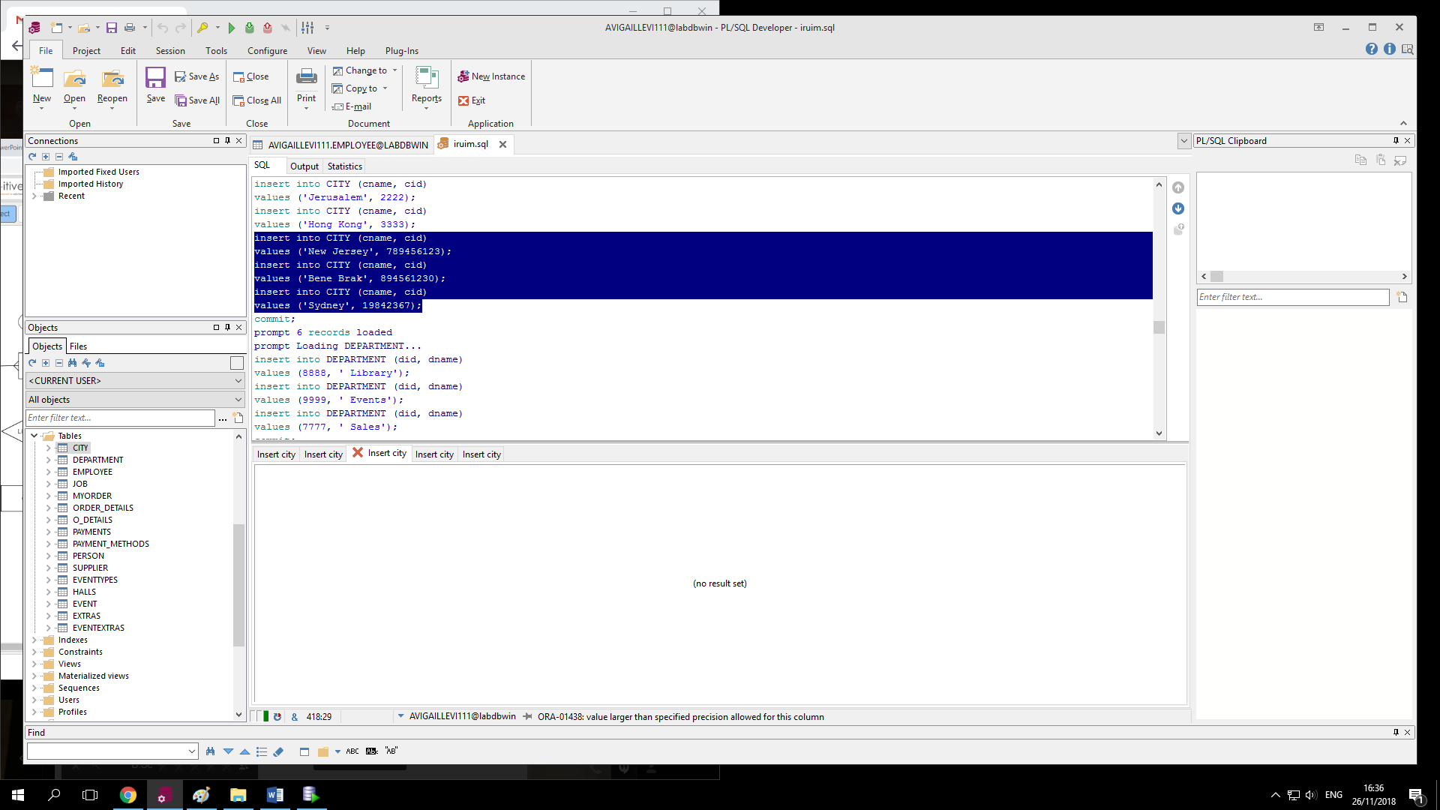

BACKUP :

prompt Creating CITY...

create table CITY

(

cname VARCHAR2(15) not null,

cid NUMBER(9) not null

)

tablespace USERS

pctfree 10

initrans 1

maxtrans 255

storage

(

initial 64K

next 1M

minextents 1

maxextents unlimited

);

create index CITY_INDEX on CITY (CNAME, CID)

tablespace USERS

pctfree 10

initrans 2

maxtrans 255

storage

(

initial 64K

next 1M

minextents 1

maxextents unlimited

);

alter table CITY

add primary key (CID)

using index

tablespace USERS

pctfree 10

initrans 2

maxtrans 255

storage

(

initial 64K

next 1M

minextents 1

maxextents unlimited

);

grant select on CITY to KOROB;

prompt Creating DEPARTMENT...

create table DEPARTMENT

(

did NUMBER(4) not null,

dname VARCHAR2(15) not null

)

tablespace USERS

pctfree 10

initrans 1

maxtrans 255

storage

(

initial 64K

next 1M

minextents 1

maxextents unlimited

);

alter table DEPARTMENT

add primary key (DID)

using index

tablespace USERS

pctfree 10

initrans 2

maxtrans 255

storage

(

initial 64K

next 1M

minextents 1

maxextents unlimited

);

prompt Creating JOB...

create table JOB

(

jid NUMBER(4) not null,

jname VARCHAR2(15) not null

)

tablespace USERS

pctfree 10

initrans 1

maxtrans 255

storage

(

initial 64K

next 1M

minextents 1

maxextents unlimited

);

alter table JOB

add primary key (JID)

using index

tablespace USERS

pctfree 10

initrans 2

maxtrans 255

storage

(

initial 64K

next 1M

minextents 1

maxextents unlimited

);

prompt Creating PERSON...

create table PERSON

(

lname VARCHAR2(15) not null,

fname VARCHAR2(15) not null,

pid NUMBER(9) not null,

bdate DATE not null,

cid NUMBER(9) not null

)

tablespace USERS

pctfree 10

initrans 1

maxtrans 255

storage

(

initial 64K

next 1M

minextents 1

maxextents unlimited

);

create index INX on PERSON (LNAME, FNAME, PID, BDATE, CID)

tablespace USERS

pctfree 10

initrans 2

maxtrans 255

storage

(

initial 64K

next 1M

minextents 1

maxextents unlimited

);

create index MY_PERSON on PERSON (PID, BDATE, CID)

tablespace USERS

pctfree 10

initrans 2

maxtrans 255

storage

(

initial 64K

next 1M

minextents 1

maxextents unlimited

);

alter table PERSON

add primary key (PID)

using index

tablespace USERS

pctfree 10

initrans 2

maxtrans 255

storage

(

initial 64K

next 1M

minextents 1

maxextents unlimited

);

alter table PERSON

add foreign key (CID)

references CITY (CID);

alter table PERSON

add constraint PENSIA

check (bdate>to_date('01/01/1959','DD/MM/YYYY'));

prompt Creating EMPLOYEE...

create table EMPLOYEE

(

jid NUMBER(4),

did NUMBER(4),

pid NUMBER(9),

eid NUMBER(9) not null

)

tablespace USERS

pctfree 10

initrans 1

maxtrans 255

storage

(

initial 64K

next 1M

minextents 1

maxextents unlimited

);

alter table EMPLOYEE

add constraint SYS_PRIM primary key (EID)

using index

tablespace USERS

pctfree 10

initrans 2

maxtrans 255

storage

(

initial 64K

next 1M

minextents 1

maxextents unlimited

);

alter table EMPLOYEE

add foreign key (DID)

references DEPARTMENT (DID);

alter table EMPLOYEE

add foreign key (PID)

references PERSON (PID);

alter table EMPLOYEE

add constraint SYS_JOB foreign key (JID)

references JOB (JID);

prompt Creating EVENTTYPES...

create table EVENTTYPES

(

evtycode NUMBER(4) not null,

ticketcost INTEGER not null,

evtyname VARCHAR2(15) not null

)

tablespace USERS

pctfree 10

initrans 1

maxtrans 255

storage

(

initial 64K

next 1M

minextents 1

maxextents unlimited

);

alter table EVENTTYPES

add primary key (EVTYCODE)

using index

tablespace USERS

pctfree 10

initrans 2

maxtrans 255

storage

(

initial 64K

next 1M

minextents 1

maxextents unlimited

);

prompt Creating HALLS...

create table HALLS

(

hcode NUMBER(4) not null,

hname VARCHAR2(15) default 'Weisberg',

maxnumberofpeopleinhall INTEGER

)

tablespace USERS

pctfree 10

initrans 1

maxtrans 255

storage

(

initial 64K

next 1M

minextents 1

maxextents unlimited

);

create index HALLS_INDEX on HALLS (HCODE, HNAME, MAXNUMBEROFPEOPLEINHALL)

tablespace USERS

pctfree 10

initrans 2

maxtrans 255

storage

(

initial 64K

next 1M

minextents 1

maxextents unlimited

);

alter table HALLS

add primary key (HCODE)

using index

tablespace USERS

pctfree 10

initrans 2

maxtrans 255

storage

(

initial 64K

next 1M

minextents 1

maxextents unlimited

);

alter table HALLS

add constraint MAXNUMBEROFPEOPLEINHALL

check ( maxnumberofpeopleinhall<10000);

prompt Creating EVENT...

create table EVENT

(

ecode NUMBER(5) not null,

edate DATE default to_date('31/12/2018','dd/mm/yyyy') not null,

alltogetherexpenses INTEGER not null,

hcode NUMBER(4) not null,

evtycode NUMBER(4) not null,

organizeid NUMBER(9)

)

tablespace USERS

pctfree 10

initrans 1

maxtrans 255

storage

(

initial 64K

next 1M

minextents 1

maxextents unlimited

);

alter table EVENT

add primary key (ECODE)

using index

tablespace USERS

pctfree 10

initrans 2

maxtrans 255

storage

(

initial 64K

next 1M

minextents 1

maxextents unlimited

);

alter table EVENT

add foreign key (HCODE)

references HALLS (HCODE);

alter table EVENT

add foreign key (EVTYCODE)

references EVENTTYPES (EVTYCODE);

prompt Creating EXTRAS...

create table EXTRAS

(

excode NUMBER(4) not null,

exname VARCHAR2(15) not null,

excost NUMBER(8,2) not null

)

tablespace USERS

pctfree 10

initrans 1

maxtrans 255

storage

(

initial 64K

next 1M

minextents 1

maxextents unlimited

);

create index EX_INDEX on EXTRAS (EXCODE, EXNAME, EXCOST)

tablespace USERS

pctfree 10

initrans 2

maxtrans 255

storage

(

initial 64K

next 1M

minextents 1

maxextents unlimited

);

alter table EXTRAS

add primary key (EXCODE)

using index

tablespace USERS

pctfree 10

initrans 2

maxtrans 255

storage

(

initial 64K

next 1M

minextents 1

maxextents unlimited

);

prompt Creating EVENTEXTRAS...

create table EVENTEXTRAS

(

excode NUMBER(4) not null,

ecode NUMBER(5) not null

)

tablespace USERS

pctfree 10

initrans 1

maxtrans 255

storage

(

initial 64K

next 1M

minextents 1

maxextents unlimited

);

alter table EVENTEXTRAS

add primary key (EXCODE, ECODE)

using index

tablespace USERS

pctfree 10

initrans 2

maxtrans 255

storage

(

initial 64K

next 1M

minextents 1

maxextents unlimited

);

alter table EVENTEXTRAS

add foreign key (EXCODE)

references EXTRAS (EXCODE);

alter table EVENTEXTRAS

add foreign key (ECODE)

references EVENT (ECODE);

prompt Creating SUPPLIER...

create table SUPPLIER

(

supplier_id NUMBER(9) not null,

beginjob DATE not null,

pid NUMBER(5) not null

)

tablespace USERS

pctfree 10

initrans 1

maxtrans 255

storage

(

initial 64K

next 1M

minextents 1

maxextents unlimited

);

alter table SUPPLIER

add primary key (SUPPLIER_ID)

using index

tablespace USERS

pctfree 10

initrans 2

maxtrans 255

storage

(

initial 64K

next 1M

minextents 1

maxextents unlimited

);

alter table SUPPLIER

add foreign key (PID)

references PERSON (PID);

grant select, insert, update, delete on SUPPLIER to NEOMIFISHER63;

prompt Creating MYORDER...

create table MYORDER

(

order_id NUMBER(3) not null,

order_date DATE,

supplier_id NUMBER(3)

)

tablespace USERS

pctfree 10

initrans 1

maxtrans 255

storage

(

initial 64K

next 1M

minextents 1

maxextents unlimited

);

alter table MYORDER

add primary key (ORDER_ID)

using index

tablespace USERS

pctfree 10

initrans 2

maxtrans 255

storage

(

initial 64K

next 1M

minextents 1

maxextents unlimited

);

alter table MYORDER

add foreign key (SUPPLIER_ID)

references SUPPLIER (SUPPLIER_ID);

prompt Creating MYORDER_DETAILS...

create table MYORDER_DETAILS

(

quantity NUMBER(3),

my_pid NUMBER(3) not null,

order_id NUMBER(3)

)

tablespace USERS

pctfree 10

initrans 1

maxtrans 255

storage

(

initial 64K

next 1M

minextents 1

maxextents unlimited

);

alter table MYORDER_DETAILS

add constraint SYS_O_D_PID primary key (MY_PID)

using index

tablespace USERS

pctfree 10

initrans 2

maxtrans 255

storage

(

initial 64K

next 1M

minextents 1

maxextents unlimited

);

alter table MYORDER_DETAILS

add constraint SYS_ORDER_ID foreign key (ORDER_ID)

references MYORDER (ORDER_ID);

prompt Creating PAYMENT_METHODS...

create table PAYMENT_METHODS

(

paymethod_id NUMBER(3) not null,

paymentname VARCHAR2(15) not null

)

tablespace USERS

pctfree 10

initrans 1

maxtrans 255

storage

(

initial 64K

next 1M

minextents 1

maxextents unlimited

);

alter table PAYMENT_METHODS

add primary key (PAYMETHOD_ID)

using index

tablespace USERS

pctfree 10

initrans 2

maxtrans 255

storage

(

initial 64K

next 1M

minextents 1

maxextents unlimited

);

prompt Creating PAYMENTS...

create table PAYMENTS

(

payment_id NUMBER(3) not null,

payment_date DATE not null,

paymethod_id NUMBER(3) not null,

order_id NUMBER(3)

)

tablespace USERS

pctfree 10

initrans 1

maxtrans 255

storage

(

initial 64K

next 1M

minextents 1

maxextents unlimited

);

alter table PAYMENTS

add primary key (PAYMENT_ID)

using index

tablespace USERS

pctfree 10

initrans 2

maxtrans 255

storage

(

initial 64K

next 1M

minextents 1

maxextents unlimited

);

alter table PAYMENTS

add constraint SYS_P2 foreign key (PAYMETHOD_ID)

references PAYMENT_METHODS (PAYMETHOD_ID);

alter table PAYMENTS

add constraint SYS_POINTE foreign key (ORDER_ID)

references MYORDER (ORDER_ID);

prompt Creating PRODUCTS...

create table PRODUCTS

(

prod_id NUMBER(3) not null,

name VARCHAR2(15) not null,

price NUMBER(7,2) not null,

my_pid NUMBER(3)

)

tablespace USERS

pctfree 10

initrans 1

maxtrans 255

storage

(

initial 64K

next 1M

minextents 1

maxextents unlimited

);

alter table PRODUCTS

add primary key (PROD_ID)

using index

tablespace USERS

pctfree 10

initrans 2

maxtrans 255

storage

(

initial 64K

next 1M

minextents 1

maxextents unlimited

);

alter table PRODUCTS

add constraint SYS_PO foreign key (MY_PID)

references MYORDER_DETAILS (MY_PID);

prompt Disabling triggers for CITY...

alter table CITY disable all triggers;

prompt Disabling triggers for DEPARTMENT...

alter table DEPARTMENT disable all triggers;

prompt Disabling triggers for JOB...

alter table JOB disable all triggers;

prompt Disabling triggers for PERSON...

alter table PERSON disable all triggers;

prompt Disabling triggers for EMPLOYEE...

alter table EMPLOYEE disable all triggers;

prompt Disabling triggers for EVENTTYPES...

alter table EVENTTYPES disable all triggers;

prompt Disabling triggers for HALLS...

alter table HALLS disable all triggers;

prompt Disabling triggers for EVENT...

alter table EVENT disable all triggers;

prompt Disabling triggers for EXTRAS...

alter table EXTRAS disable all triggers;

prompt Disabling triggers for EVENTEXTRAS...

alter table EVENTEXTRAS disable all triggers;

prompt Disabling triggers for SUPPLIER...

alter table SUPPLIER disable all triggers;

prompt Disabling triggers for MYORDER...

alter table MYORDER disable all triggers;

prompt Disabling triggers for MYORDER_DETAILS...

alter table MYORDER_DETAILS disable all triggers;

prompt Disabling triggers for PAYMENT_METHODS...

alter table PAYMENT_METHODS disable all triggers;

prompt Disabling triggers for PAYMENTS...

alter table PAYMENTS disable all triggers;

prompt Disabling triggers for PRODUCTS...

alter table PRODUCTS disable all triggers;

prompt Disabling foreign key constraints for PERSON...

alter table PERSON disable constraint SYS_C00289624;

prompt Disabling foreign key constraints for EMPLOYEE...

alter table EMPLOYEE disable constraint SYS_C00289635;

alter table EMPLOYEE disable constraint SYS_C00289636;

alter table EMPLOYEE disable constraint SYS_JOB;

prompt Disabling foreign key constraints for EVENT...

alter table EVENT disable constraint SYS_C00290930;

alter table EVENT disable constraint SYS_C00290931;

prompt Disabling foreign key constraints for EVENTEXTRAS...

alter table EVENTEXTRAS disable constraint SYS_C00290941;

alter table EVENTEXTRAS disable constraint SYS_C00290942;

prompt Disabling foreign key constraints for SUPPLIER...

alter table SUPPLIER disable constraint SYS_C00294991;

prompt Disabling foreign key constraints for MYORDER...

alter table MYORDER disable constraint SYS_C00289642;

prompt Disabling foreign key constraints for MYORDER_DETAILS...

alter table MYORDER_DETAILS disable constraint SYS_ORDER_ID;

prompt Disabling foreign key constraints for PAYMENTS...

alter table PAYMENTS disable constraint SYS_P2;

alter table PAYMENTS disable constraint SYS_POINTE;

prompt Disabling foreign key constraints for PRODUCTS...

alter table PRODUCTS disable constraint SYS_PO;

prompt Deleting PRODUCTS...

delete from PRODUCTS;

commit;

prompt Deleting PAYMENTS...

delete from PAYMENTS;

commit;

prompt Deleting PAYMENT_METHODS...

delete from PAYMENT_METHODS;

commit;

prompt Deleting MYORDER_DETAILS...

delete from MYORDER_DETAILS;

commit;

prompt Deleting MYORDER...

delete from MYORDER;

commit;

prompt Deleting SUPPLIER...

delete from SUPPLIER;

commit;

prompt Deleting EVENTEXTRAS...

delete from EVENTEXTRAS;

commit;

prompt Deleting EXTRAS...

delete from EXTRAS;

commit;

prompt Deleting EVENT...

delete from EVENT;

commit;

prompt Deleting HALLS...

delete from HALLS;

commit;

prompt Deleting EVENTTYPES...

delete from EVENTTYPES;

commit;

prompt Deleting EMPLOYEE...

delete from EMPLOYEE;

commit;

prompt Deleting PERSON...

delete from PERSON;

commit;

prompt Deleting JOB...

delete from JOB;

commit;

prompt Deleting DEPARTMENT...

delete from DEPARTMENT;

commit;

prompt Deleting CITY...

delete from CITY;

commit;

prompt Loading CITY...

insert into CITY (cname, cid)

values ('BeitShemesh', 2);

insert into CITY (cname, cid)

values ('Bene Brak', 894561230);

insert into CITY (cname, cid)

values ('Brussel', 681);

insert into CITY (cname, cid)

values ('Carlingford', 620);

insert into CITY (cname, cid)

values ('Chorz?w', 836);

insert into CITY (cname, cid)

values ('Enschede', 82);

insert into CITY (cname, cid)

values ('Erlangen', 139);

insert into CITY (cname, cid)

values ('Frankfu', 370);

insert into CITY (cname, cid)

values ('Freiburg', 93);

insert into CITY (cname, cid)

values ('Guelph', 447);

insert into CITY (cname, cid)

values ('Hong Kong', 3333);

insert into CITY (cname, cid)

values ('Huntsville', 161);

insert into CITY (cname, cid)

values ('Immenstaad', 814);

insert into CITY (cname, cid)

values ('Jerusalem', 2222);

insert into CITY (cname, cid)

values ('Kochi', 773);

insert into CITY (cname, cid)

values ('Leimen', 898);

insert into CITY (cname, cid)

values ('MigdalHamak', 1);

insert into CITY (cname, cid)

values ('Netanya', 3);

insert into CITY (cname, cid)

values ('New Hyde Park', 263);

insert into CITY (cname, cid)

values ('New Hyde Park', 559);

insert into CITY (cname, cid)

values ('New Jersey', 789456123);

insert into CITY (cname, cid)

values ('New York', 1111);

insert into CITY (cname, cid)

values ('Plymouth Meetin', 927);

insert into CITY (cname, cid)

values ('Soest', 84);

insert into CITY (cname, cid)

values ('Suwon-city', 306);

insert into CITY (cname, cid)

values ('Sydney', 19842367);

insert into CITY (cname, cid)

values ('Tokushima', 500);

insert into CITY (cname, cid)

values ('Wakayama', 428);

commit;

prompt 28 records loaded

prompt Loading DEPARTMENT...

insert into DEPARTMENT (did, dname)

values (8888, ' Library');

insert into DEPARTMENT (did, dname)

values (9999, ' Events');

insert into DEPARTMENT (did, dname)

values (7777, ' Sales');

insert into DEPARTMENT (did, dname)

values (0, 'Mo');

insert into DEPARTMENT (did, dname)

values (1, 'Ba');

insert into DEPARTMENT (did, dname)

values (2, 'Br');

insert into DEPARTMENT (did, dname)

values (3, 'Li');

insert into DEPARTMENT (did, dname)

values (4, 'Mn');

insert into DEPARTMENT (did, dname)

values (5, 'Zr');

insert into DEPARTMENT (did, dname)

values (6, 'Lr');

insert into DEPARTMENT (did, dname)

values (7, 'U');

insert into DEPARTMENT (did, dname)

values (8, 'Co');

insert into DEPARTMENT (did, dname)

values (9, 'Co');

insert into DEPARTMENT (did, dname)

values (10, 'Rh');

insert into DEPARTMENT (did, dname)

values (11, 'Te');

insert into DEPARTMENT (did, dname)

values (12, 'Mo');

insert into DEPARTMENT (did, dname)

values (13, 'Bi');

insert into DEPARTMENT (did, dname)

values (14, 'C');

insert into DEPARTMENT (did, dname)

values (15, 'Br');

commit;

prompt 19 records loaded

prompt Loading JOB...

insert into JOB (jid, jname)

values (8625, 'Barrydebitis' || chr(10) || '');

insert into JOB (jid, jname)

values (5381, 'Janiceid' || chr(10) || '');

insert into JOB (jid, jname)

values (1639, 'Mekhimolestias' || chr(10) || '');

insert into JOB (jid, jname)

values (6222, 'Rutgerdeleniti' || chr(10) || '');

insert into JOB (jid, jname)

values (9720, 'Hankelit' || chr(10) || '');

insert into JOB (jid, jname)

values (4860, 'Rosiedolores' || chr(10) || '');

insert into JOB (jid, jname)

values (4485, 'Vertical');

insert into JOB (jid, jname)

values (2288, 'Tomirure' || chr(10) || '');

insert into JOB (jid, jname)

values (3154, 'Giancarlo');

insert into JOB (jid, jname)

values (7178, 'Colesint' || chr(10) || '');

insert into JOB (jid, jname)

values (8647, 'Veruca');

insert into JOB (jid, jname)

values (8117, 'Emmarerum' || chr(10) || '');

insert into JOB (jid, jname)

values (8318, 'Donalest' || chr(10) || 'non' || chr(10) || '');

insert into JOB (jid, jname)

values (1269, 'Kevnaute' || chr(10) || 'dolor');

insert into JOB (jid, jname)

values (1101, 'Oliverduis' || chr(10) || '');

insert into JOB (jid, jname)

values (7884, 'Vinincididunt' || chr(10) || '');

insert into JOB (jid, jname)

values (3560, 'Desmondqui' || chr(10) || '');

insert into JOB (jid, jname)

values (9266, 'Burtonomnis' || chr(10) || '');

insert into JOB (jid, jname)

values (7097, 'Nanciet' || chr(10) || 'et' || chr(10) || '');

insert into JOB (jid, jname)

values (5786, 'Laurieculpa' || chr(10) || '');

insert into JOB (jid, jname)

values (2996, 'Madelinenon' || chr(10) || '');

insert into JOB (jid, jname)

values (7755, 'Hilarya' || chr(10) || 'ut' || chr(10) || 'fu');

insert into JOB (jid, jname)

values (3761, 'Lennie');

insert into JOB (jid, jname)

values (7033, 'Redproident' || chr(10) || '');

insert into JOB (jid, jname)

values (9415, 'Verucaet' || chr(10) || '');

insert into JOB (jid, jname)

values (3235, 'Geraldalias' || chr(10) || '');

insert into JOB (jid, jname)

values (7327, 'Udo');

insert into JOB (jid, jname)

values (7680, 'Linex' || chr(10) || '');

insert into JOB (jid, jname)

values (1193, 'Suzanne');

insert into JOB (jid, jname)

values (1890, 'Jayminus' || chr(10) || '');

insert into JOB (jid, jname)

values (1693, 'Jimmie');

insert into JOB (jid, jname)

values (3444, 'Fredericut' || chr(10) || '');

insert into JOB (jid, jname)

values (3852, 'Eliza');

insert into JOB (jid, jname)

values (8508, 'Bradley');

insert into JOB (jid, jname)

values (9074, 'Janicesunt' || chr(10) || 'qui');

insert into JOB (jid, jname)

values (3320, 'Lionelet' || chr(10) || '');

insert into JOB (jid, jname)

values (2190, 'Viennaea' || chr(10) || 'esse' || chr(10) || '');

insert into JOB (jid, jname)

values (1913, 'Dustinveniam' || chr(10) || '');

insert into JOB (jid, jname)

values (7556, 'Luke');

insert into JOB (jid, jname)

values (4811, 'Al');

insert into JOB (jid, jname)

values (9403, 'Glen');

insert into JOB (jid, jname)

values (6242, 'Tracy');

insert into JOB (jid, jname)

values (3411, 'Albertina');

insert into JOB (jid, jname)

values (9180, 'Sophie');

insert into JOB (jid, jname)

values (5289, 'Albertinaid' || chr(10) || 'ut');

insert into JOB (jid, jname)

values (8178, 'Ryannam' || chr(10) || '');

insert into JOB (jid, jname)

values (7223, 'Andy');

insert into JOB (jid, jname)

values (8711, 'Philsimilique' || chr(10) || '');

insert into JOB (jid, jname)

values (121, 'INSPECTOR');

insert into JOB (jid, jname)

values (0, 'HASHAV');

insert into JOB (jid, jname)

values (9999, 'YANIV');

insert into JOB (jid, jname)

values (9998, 'DIRECTOR');

insert into JOB (jid, jname)

values (49, 'director');

insert into JOB (jid, jname)

values (41, 'a');

insert into JOB (jid, jname)

values (42, 'b');

insert into JOB (jid, jname)

values (43, 'c');

insert into JOB (jid, jname)

values (48, 'secratery');

insert into JOB (jid, jname)

values (47, 'cleaner');

commit;

prompt 58 records loaded

prompt Loading PERSON...

insert into PERSON (lname, fname, pid, bdate, cid)

values ('Adler', 'Lloyd', 4345, to_date('04-11-2018', 'dd-mm-yyyy'), 2);

insert into PERSON (lname, fname, pid, bdate, cid)

values ('Affleck', 'Nathan', 4281, to_date('06-01-1968', 'dd-mm-yyyy'), 1);

insert into PERSON (lname, fname, pid, bdate, cid)

values ('Aglukark', 'Willie', 4211, to_date('06-02-1969', 'dd-mm-yyyy'), 2);

insert into PERSON (lname, fname, pid, bdate, cid)

values ('Alda', 'Glenn', 4302, to_date('21-12-1991', 'dd-mm-yyyy'), 2);

insert into PERSON (lname, fname, pid, bdate, cid)

values ('Allison', 'Andie', 4171, to_date('03-05-1962', 'dd-mm-yyyy'), 3);

insert into PERSON (lname, fname, pid, bdate, cid)

values ('Alston', 'Ceili', 912293997, to_date('01-01-2001', 'dd-mm-yyyy'), 894561230);

insert into PERSON (lname, fname, pid, bdate, cid)

values ('Andrews', 'Danny', 4102, to_date('06-09-1991', 'dd-mm-yyyy'), 1);

insert into PERSON (lname, fname, pid, bdate, cid)

values ('Applegate', 'Sheryl', 4073, to_date('25-09-1974', 'dd-mm-yyyy'), 2);

insert into PERSON (lname, fname, pid, bdate, cid)

values ('Arjona', 'Keanu', 4329, to_date('02-04-1979', 'dd-mm-yyyy'), 1);

insert into PERSON (lname, fname, pid, bdate, cid)

values ('Arjona', 'Roddy', 4182, to_date('19-09-1971', 'dd-mm-yyyy'), 3);

insert into PERSON (lname, fname, pid, bdate, cid)

values ('Armstrong', 'Mary', 4260, to_date('01-01-1972', 'dd-mm-yyyy'), 1);

insert into PERSON (lname, fname, pid, bdate, cid)

values ('Arthur', 'Elle', 4181, to_date('03-07-1977', 'dd-mm-yyyy'), 3);

insert into PERSON (lname, fname, pid, bdate, cid)

values ('Askew', 'Fisher', 4132, to_date('20-03-1965', 'dd-mm-yyyy'), 1);

insert into PERSON (lname, fname, pid, bdate, cid)

values ('Atkinson', 'Ethan', 4136, to_date('02-11-1987', 'dd-mm-yyyy'), 1);

insert into PERSON (lname, fname, pid, bdate, cid)

values ('Bachman', 'Gina', 4269, to_date('07-02-1965', 'dd-mm-yyyy'), 1);

insert into PERSON (lname, fname, pid, bdate, cid)

values ('Baez', 'Matt', 4116, to_date('11-07-1980', 'dd-mm-yyyy'), 3);

insert into PERSON (lname, fname, pid, bdate, cid)

values ('Baez', 'Natascha', 498709648, to_date('01-01-2001', 'dd-mm-yyyy'), 789456123);

insert into PERSON (lname, fname, pid, bdate, cid)

values ('Baez', 'Rhys', 4455, to_date('23-10-1981', 'dd-mm-yyyy'), 1);

insert into PERSON (lname, fname, pid, bdate, cid)

values ('Balaban', 'Catherine', 4028, to_date('25-03-1986', 'dd-mm-yyyy'), 2);

insert into PERSON (lname, fname, pid, bdate, cid)

values ('Banderas', 'Vincent', 4489, to_date('27-06-1962', 'dd-mm-yyyy'), 2);

insert into PERSON (lname, fname, pid, bdate, cid)

values ('Barkin', 'Rik', 4153, to_date('18-05-1971', 'dd-mm-yyyy'), 3);

insert into PERSON (lname, fname, pid, bdate, cid)

values ('Barnett', 'Leon', 4123, to_date('18-01-1976', 'dd-mm-yyyy'), 3);

insert into PERSON (lname, fname, pid, bdate, cid)

values ('Bassett', 'Julia', 4138, to_date('17-12-1995', 'dd-mm-yyyy'), 3);

insert into PERSON (lname, fname, pid, bdate, cid)

values ('Bassett', 'Ritchie', 4315, to_date('24-01-1963', 'dd-mm-yyyy'), 3);

insert into PERSON (lname, fname, pid, bdate, cid)

values ('Beatty', 'Rueben', 4456, to_date('30-04-1988', 'dd-mm-yyyy'), 2);

insert into PERSON (lname, fname, pid, bdate, cid)

values ('Beckinsale', 'Omar', 4194, to_date('06-04-1961', 'dd-mm-yyyy'), 3);

insert into PERSON (lname, fname, pid, bdate, cid)

values ('Begley', 'Bruce', 4098, to_date('25-08-1966', 'dd-mm-yyyy'), 1);

insert into PERSON (lname, fname, pid, bdate, cid)

values ('Bergen', 'Christine', 871006254, to_date('01-01-2001', 'dd-mm-yyyy'), 1111);

insert into PERSON (lname, fname, pid, bdate, cid)

values ('Berry', 'Rhys', 4094, to_date('13-12-1971', 'dd-mm-yyyy'), 2);

insert into PERSON (lname, fname, pid, bdate, cid)

values ('Biggs', 'Miriam', 4064, to_date('18-03-1991', 'dd-mm-yyyy'), 2);

insert into PERSON (lname, fname, pid, bdate, cid)

values ('Blades', 'Daryle', 4507, to_date('27-08-1995', 'dd-mm-yyyy'), 2);

insert into PERSON (lname, fname, pid, bdate, cid)

values ('Blanchett', 'Sandra', 4057, to_date('23-12-1995', 'dd-mm-yyyy'), 3);

insert into PERSON (lname, fname, pid, bdate, cid)

values ('Blossoms', 'Sheryl', 4174, to_date('09-06-1975', 'dd-mm-yyyy'), 1);

insert into PERSON (lname, fname, pid, bdate, cid)

values ('Bracco', 'Kelly', 4333, to_date('17-06-1998', 'dd-mm-yyyy'), 2);

insert into PERSON (lname, fname, pid, bdate, cid)

values ('Bragg', 'Kathy', 4375, to_date('07-09-1984', 'dd-mm-yyyy'), 1);

insert into PERSON (lname, fname, pid, bdate, cid)

values ('Branagh', 'Stevie', 4140, to_date('31-07-1969', 'dd-mm-yyyy'), 3);

insert into PERSON (lname, fname, pid, bdate, cid)

values ('Brock', 'Nickel', 4435, to_date('01-05-1964', 'dd-mm-yyyy'), 3);

insert into PERSON (lname, fname, pid, bdate, cid)

values ('Broderick', 'Armin', 4010, to_date('13-12-1972', 'dd-mm-yyyy'), 1);

insert into PERSON (lname, fname, pid, bdate, cid)

values ('Brothers', 'Loren', 4335, to_date('23-06-1967', 'dd-mm-yyyy'), 1);

insert into PERSON (lname, fname, pid, bdate, cid)

values ('Brown', 'Breckin', 4169, to_date('02-10-1987', 'dd-mm-yyyy'), 3);

insert into PERSON (lname, fname, pid, bdate, cid)

values ('Brown', 'Chely', 4440, to_date('13-10-1963', 'dd-mm-yyyy'), 2);

insert into PERSON (lname, fname, pid, bdate, cid)

values ('Brown', 'Eric', 4212, to_date('26-07-1964', 'dd-mm-yyyy'), 3);

insert into PERSON (lname, fname, pid, bdate, cid)

values ('Bryson', 'Rip', 4016, to_date('18-03-1973', 'dd-mm-yyyy'), 3);

insert into PERSON (lname, fname, pid, bdate, cid)

values ('Bullock', 'Machine', 4463, to_date('31-07-1962', 'dd-mm-yyyy'), 1);

insert into PERSON (lname, fname, pid, bdate, cid)

values ('Burstyn', 'April', 4049, to_date('02-09-1982', 'dd-mm-yyyy'), 2);

insert into PERSON (lname, fname, pid, bdate, cid)

values ('Burstyn', 'Tamala', 4285, to_date('15-12-1985', 'dd-mm-yyyy'), 2);

insert into PERSON (lname, fname, pid, bdate, cid)

values ('Burton', 'Kurtwood', 4296, to_date('12-02-1966', 'dd-mm-yyyy'), 1);

insert into PERSON (lname, fname, pid, bdate, cid)

values ('Byrd', 'Amy', 4062, to_date('08-04-1970', 'dd-mm-yyyy'), 3);

insert into PERSON (lname, fname, pid, bdate, cid)

values ('Byrne', 'Dylan', 4449, to_date('11-07-1960', 'dd-mm-yyyy'), 1);

insert into PERSON (lname, fname, pid, bdate, cid)

values ('Cale', 'Sandra', 4166, to_date('20-06-1962', 'dd-mm-yyyy'), 1);

insert into PERSON (lname, fname, pid, bdate, cid)

values ('Calle', 'Ryan', 4452, to_date('10-12-1971', 'dd-mm-yyyy'), 2);

insert into PERSON (lname, fname, pid, bdate, cid)

values ('Camp', 'Marc', 4002, to_date('01-07-1999', 'dd-mm-yyyy'), 2);

insert into PERSON (lname, fname, pid, bdate, cid)

values ('Candy', 'Cary', 4468, to_date('17-07-1990', 'dd-mm-yyyy'), 3);

insert into PERSON (lname, fname, pid, bdate, cid)

values ('Capshaw', 'Mitchell', 4433, to_date('23-07-1963', 'dd-mm-yyyy'), 1);

insert into PERSON (lname, fname, pid, bdate, cid)

values ('Cara', 'Rosanne', 4485, to_date('08-03-1988', 'dd-mm-yyyy'), 2);

insert into PERSON (lname, fname, pid, bdate, cid)

values ('Carrack', 'Marlon', 4363, to_date('29-01-1972', 'dd-mm-yyyy'), 1);

insert into PERSON (lname, fname, pid, bdate, cid)

values ('Carrere', 'Roscoe', 452398113, to_date('01-01-2001', 'dd-mm-yyyy'), 19842367);

insert into PERSON (lname, fname, pid, bdate, cid)

values ('Carrey', 'Rick', 4158, to_date('02-05-1966', 'dd-mm-yyyy'), 1);

insert into PERSON (lname, fname, pid, bdate, cid)

values ('Carrey', 'Ronny', 4279, to_date('11-10-1978', 'dd-mm-yyyy'), 1);

insert into PERSON (lname, fname, pid, bdate, cid)

values ('Cash', 'Gino', 4370, to_date('03-08-1976', 'dd-mm-yyyy'), 3);

insert into PERSON (lname, fname, pid, bdate, cid)

values ('Cassel', 'Cledus', 4033, to_date('19-05-1973', 'dd-mm-yyyy'), 2);

insert into PERSON (lname, fname, pid, bdate, cid)

values ('Caviezel', 'Kasey', 4372, to_date('10-03-1977', 'dd-mm-yyyy'), 3);

insert into PERSON (lname, fname, pid, bdate, cid)

values ('Ceasar', 'Liev', 4500, to_date('30-01-1996', 'dd-mm-yyyy'), 2);

insert into PERSON (lname, fname, pid, bdate, cid)

values ('Chambers', 'Wallace', 4003, to_date('16-05-1983', 'dd-mm-yyyy'), 2);

insert into PERSON (lname, fname, pid, bdate, cid)

values ('Channing', 'Eileen', 4313, to_date('22-04-1963', 'dd-mm-yyyy'), 1);

insert into PERSON (lname, fname, pid, bdate, cid)

values ('Chaplin', 'Etta', 4053, to_date('01-12-1987', 'dd-mm-yyyy'), 2);

insert into PERSON (lname, fname, pid, bdate, cid)

values ('Chaplin', 'Lara', 4474, to_date('07-12-1971', 'dd-mm-yyyy'), 1);

insert into PERSON (lname, fname, pid, bdate, cid)

values ('Chappelle', 'Julianne', 4082, to_date('28-02-1984', 'dd-mm-yyyy'), 2);

insert into PERSON (lname, fname, pid, bdate, cid)

values ('Chaykin', 'Halle', 4087, to_date('26-04-1970', 'dd-mm-yyyy'), 2);

insert into PERSON (lname, fname, pid, bdate, cid)

values ('Chesnutt', 'Andie', 4129, to_date('22-12-1985', 'dd-mm-yyyy'), 1);

insert into PERSON (lname, fname, pid, bdate, cid)

values ('Chesnutt', 'Angelina', 4017, to_date('21-01-1988', 'dd-mm-yyyy'), 2);

insert into PERSON (lname, fname, pid, bdate, cid)

values ('Chilton', 'Bobbi', 4225, to_date('15-11-1972', 'dd-mm-yyyy'), 1);

insert into PERSON (lname, fname, pid, bdate, cid)

values ('Chilton', 'Ike', 4293, to_date('29-01-1981', 'dd-mm-yyyy'), 2);

insert into PERSON (lname, fname, pid, bdate, cid)

values ('Chinlund', 'Miguel', 4332, to_date('11-08-1982', 'dd-mm-yyyy'), 2);

insert into PERSON (lname, fname, pid, bdate, cid)

values ('Church', 'Daryl', 4376, to_date('10-11-1993', 'dd-mm-yyyy'), 1);

insert into PERSON (lname, fname, pid, bdate, cid)

values ('Clooney', 'Sander', 4141, to_date('23-07-1963', 'dd-mm-yyyy'), 3);

insert into PERSON (lname, fname, pid, bdate, cid)

values ('Close', 'Bradley', 4305, to_date('01-09-1978', 'dd-mm-yyyy'), 1);

insert into PERSON (lname, fname, pid, bdate, cid)

values ('Coburn', 'Chrissie', 4217, to_date('09-10-1974', 'dd-mm-yyyy'), 3);

insert into PERSON (lname, fname, pid, bdate, cid)

values ('Cockburn', 'Dorry', 4264, to_date('05-02-1992', 'dd-mm-yyyy'), 2);

insert into PERSON (lname, fname, pid, bdate, cid)

values ('Coe', 'Kid', 4007, to_date('24-02-1989', 'dd-mm-yyyy'), 3);

insert into PERSON (lname, fname, pid, bdate, cid)

values ('Collette', 'Jamie', 4093, to_date('22-06-1960', 'dd-mm-yyyy'), 3);

insert into PERSON (lname, fname, pid, bdate, cid)

values ('Collie', 'Holland', 4479, to_date('08-04-1988', 'dd-mm-yyyy'), 2);

insert into PERSON (lname, fname, pid, bdate, cid)

values ('Collins', 'Omar', 4079, to_date('26-12-1961', 'dd-mm-yyyy'), 3);

insert into PERSON (lname, fname, pid, bdate, cid)

values ('Condition', 'Harriet', 4202, to_date('10-10-1960', 'dd-mm-yyyy'), 1);

insert into PERSON (lname, fname, pid, bdate, cid)

values ('Conners', 'Kathy', 4218, to_date('30-07-1975', 'dd-mm-yyyy'), 1);

insert into PERSON (lname, fname, pid, bdate, cid)

values ('Connick', 'Olga', 4256, to_date('20-10-1991', 'dd-mm-yyyy'), 1);

insert into PERSON (lname, fname, pid, bdate, cid)

values ('Cooper', 'Anita', 4067, to_date('13-10-1961', 'dd-mm-yyyy'), 1);

insert into PERSON (lname, fname, pid, bdate, cid)

values ('Cornell', 'Elijah', 4072, to_date('05-03-1967', 'dd-mm-yyyy'), 1);

insert into PERSON (lname, fname, pid, bdate, cid)

values ('Costa', 'Ryan', 4495, to_date('03-01-1968', 'dd-mm-yyyy'), 1);

insert into PERSON (lname, fname, pid, bdate, cid)

values ('Coyote', 'Danny', 4167, to_date('02-12-1974', 'dd-mm-yyyy'), 3);

insert into PERSON (lname, fname, pid, bdate, cid)

values ('Craven', 'Sonny', 4023, to_date('28-12-1990', 'dd-mm-yyyy'), 3);

insert into PERSON (lname, fname, pid, bdate, cid)

values ('Creek', 'Jason', 4441, to_date('25-12-1971', 'dd-mm-yyyy'), 2);

insert into PERSON (lname, fname, pid, bdate, cid)

values ('Crouse', 'Alex', 4270, to_date('08-03-1978', 'dd-mm-yyyy'), 1);

insert into PERSON (lname, fname, pid, bdate, cid)

values ('Crow', 'Holland', 4369, to_date('15-12-1995', 'dd-mm-yyyy'), 1);

insert into PERSON (lname, fname, pid, bdate, cid)

values ('Crowe', 'Guy', 4162, to_date('17-11-1980', 'dd-mm-yyyy'), 2);

insert into PERSON (lname, fname, pid, bdate, cid)

values ('Cruise', 'Celia', 4240, to_date('19-04-1990', 'dd-mm-yyyy'), 1);

insert into PERSON (lname, fname, pid, bdate, cid)

values ('Cruise', 'Elias', 892398192, to_date('06-01-2017', 'dd-mm-yyyy'), 1111);

insert into PERSON (lname, fname, pid, bdate, cid)

values ('Cruise', 'Latin', 4324, to_date('05-11-1975', 'dd-mm-yyyy'), 2);

insert into PERSON (lname, fname, pid, bdate, cid)

values ('Curry', 'Ty', 4213, to_date('20-06-1970', 'dd-mm-yyyy'), 3);

insert into PERSON (lname, fname, pid, bdate, cid)

values ('Curtis', 'James', 4089, to_date('25-09-1996', 'dd-mm-yyyy'), 2);

commit;

prompt 100 records committed...

insert into PERSON (lname, fname, pid, bdate, cid)

values ('Cusack', 'Katie', 4055, to_date('26-12-1972', 'dd-mm-yyyy'), 1);

insert into PERSON (lname, fname, pid, bdate, cid)

values ('Dalley', 'Ali', 4469, to_date('11-08-1985', 'dd-mm-yyyy'), 2);

insert into PERSON (lname, fname, pid, bdate, cid)

values ('David', 'Edwin', 4187, to_date('17-09-1984', 'dd-mm-yyyy'), 1);

insert into PERSON (lname, fname, pid, bdate, cid)

values ('Davidtz', 'Andre', 4155, to_date('28-01-1980', 'dd-mm-yyyy'), 2);

insert into PERSON (lname, fname, pid, bdate, cid)

values ('Davies', 'Christina', 4219, to_date('22-08-1969', 'dd-mm-yyyy'), 3);

insert into PERSON (lname, fname, pid, bdate, cid)

values ('Davies', 'Joanna', 4126, to_date('28-05-1972', 'dd-mm-yyyy'), 1);

insert into PERSON (lname, fname, pid, bdate, cid)

values ('Davies', 'Rueben', 4025, to_date('06-05-1973', 'dd-mm-yyyy'), 1);

insert into PERSON (lname, fname, pid, bdate, cid)

values ('Davis', 'Grant', 4503, to_date('05-09-1988', 'dd-mm-yyyy'), 1);

insert into PERSON (lname, fname, pid, bdate, cid)

values ('Dayne', 'Jeff', 4266, to_date('28-12-1993', 'dd-mm-yyyy'), 1);

insert into PERSON (lname, fname, pid, bdate, cid)

values ('DeVita', 'Larenz', 4274, to_date('22-12-1964', 'dd-mm-yyyy'), 3);

insert into PERSON (lname, fname, pid, bdate, cid)

values ('DeVita', 'Tanya', 4362, to_date('04-02-1994', 'dd-mm-yyyy'), 2);

insert into PERSON (lname, fname, pid, bdate, cid)

values ('DeVito', 'Victoria', 4494, to_date('24-12-1977', 'dd-mm-yyyy'), 1);

insert into PERSON (lname, fname, pid, bdate, cid)

values ('DeVito', 'Will', 4245, to_date('12-01-1985', 'dd-mm-yyyy'), 1);

insert into PERSON (lname, fname, pid, bdate, cid)

values ('Dean', 'Clay', 4473, to_date('15-11-1985', 'dd-mm-yyyy'), 3);

insert into PERSON (lname, fname, pid, bdate, cid)

values ('Dench', 'Debbie', 4336, to_date('24-11-1979', 'dd-mm-yyyy'), 3);

insert into PERSON (lname, fname, pid, bdate, cid)

values ('Dench', 'Rip', 4020, to_date('12-06-1985', 'dd-mm-yyyy'), 2);

insert into PERSON (lname, fname, pid, bdate, cid)

values ('Dern', 'Dorry', 4437, to_date('31-07-1988', 'dd-mm-yyyy'), 3);

insert into PERSON (lname, fname, pid, bdate, cid)

values ('Detmer', 'Alannah', 4143, to_date('07-01-1989', 'dd-mm-yyyy'), 2);

insert into PERSON (lname, fname, pid, bdate, cid)

values ('Devine', 'Tara', 4490, to_date('22-04-1990', 'dd-mm-yyyy'), 1);

insert into PERSON (lname, fname, pid, bdate, cid)

values ('DiFranco', 'Selma', 4321, to_date('21-08-1995', 'dd-mm-yyyy'), 2);

insert into PERSON (lname, fname, pid, bdate, cid)

values ('DiFranco', 'Wang', 4085, to_date('07-05-1991', 'dd-mm-yyyy'), 3);

insert into PERSON (lname, fname, pid, bdate, cid)

values ('Diddley', 'Mykelti', 773002786, to_date('01-01-2001', 'dd-mm-yyyy'), 19842367);

insert into PERSON (lname, fname, pid, bdate, cid)

values ('Dorn', 'Giovanni', 4243, to_date('03-03-1972', 'dd-mm-yyyy'), 3);

insert into PERSON (lname, fname, pid, bdate, cid)

values ('Dourif', 'Rosanne', 4149, to_date('14-06-1976', 'dd-mm-yyyy'), 1);

insert into PERSON (lname, fname, pid, bdate, cid)

values ('Downie', 'Donald', 4078, to_date('07-03-1962', 'dd-mm-yyyy'), 3);

insert into PERSON (lname, fname, pid, bdate, cid)

values ('Drive', 'Terri', 4114, to_date('23-09-1972', 'dd-mm-yyyy'), 3);

insert into PERSON (lname, fname, pid, bdate, cid)

values ('Dukakis', 'Anna', 4014, to_date('02-05-1978', 'dd-mm-yyyy'), 3);

insert into PERSON (lname, fname, pid, bdate, cid)

values ('Dunaway', 'Whoopi', 4248, to_date('31-10-1963', 'dd-mm-yyyy'), 1);

insert into PERSON (lname, fname, pid, bdate, cid)

values ('Duncan', 'Jesse', 4462, to_date('22-05-1978', 'dd-mm-yyyy'), 1);

insert into PERSON (lname, fname, pid, bdate, cid)

values ('Dunn', 'Carlene', 4319, to_date('22-12-1964', 'dd-mm-yyyy'), 2);

insert into PERSON (lname, fname, pid, bdate, cid)

values ('Dunn', 'Kieran', 4291, to_date('14-12-1994', 'dd-mm-yyyy'), 3);

insert into PERSON (lname, fname, pid, bdate, cid)

values ('Duschel', 'Pam', 4344, to_date('28-08-1964', 'dd-mm-yyyy'), 3);

insert into PERSON (lname, fname, pid, bdate, cid)

values ('Dysart', 'Belinda', 4393, to_date('29-04-1971', 'dd-mm-yyyy'), 2);

insert into PERSON (lname, fname, pid, bdate, cid)

values ('Dzundza', 'Diamond', 4454, to_date('04-11-1967', 'dd-mm-yyyy'), 2);

insert into PERSON (lname, fname, pid, bdate, cid)

values ('Easton', 'Grace', 4183, to_date('05-03-1971', 'dd-mm-yyyy'), 3);

insert into PERSON (lname, fname, pid, bdate, cid)

values ('Easton', 'Lonnie', 4131, to_date('14-08-1988', 'dd-mm-yyyy'), 2);

insert into PERSON (lname, fname, pid, bdate, cid)

values ('Eder', 'Gord', 4188, to_date('24-04-1964', 'dd-mm-yyyy'), 3);

insert into PERSON (lname, fname, pid, bdate, cid)

values ('Elliott', 'Paul', 4109, to_date('26-11-1976', 'dd-mm-yyyy'), 1);

insert into PERSON (lname, fname, pid, bdate, cid)

values ('English', 'Talvin', 4509, to_date('09-08-1975', 'dd-mm-yyyy'), 1);

insert into PERSON (lname, fname, pid, bdate, cid)

values ('Esposito', 'Liev', 4326, to_date('08-06-1968', 'dd-mm-yyyy'), 1);

insert into PERSON (lname, fname, pid, bdate, cid)

values ('Estevez', 'Linda', 4101, to_date('12-07-1983', 'dd-mm-yyyy'), 2);

insert into PERSON (lname, fname, pid, bdate, cid)

values ('Evanswood', 'Ving', 4035, to_date('28-05-1960', 'dd-mm-yyyy'), 1);

insert into PERSON (lname, fname, pid, bdate, cid)

values ('Faithfull', 'Nicolas', 4224, to_date('19-02-1988', 'dd-mm-yyyy'), 2);

insert into PERSON (lname, fname, pid, bdate, cid)

values ('Fariq', 'Lizzy', 4458, to_date('16-01-1999', 'dd-mm-yyyy'), 1);

insert into PERSON (lname, fname, pid, bdate, cid)

values ('Farrell', 'Rachel', 4354, to_date('11-05-1983', 'dd-mm-yyyy'), 3);

insert into PERSON (lname, fname, pid, bdate, cid)

values ('Farrow', 'Loretta', 4343, to_date('05-06-1983', 'dd-mm-yyyy'), 1);

insert into PERSON (lname, fname, pid, bdate, cid)

values ('Fender', 'Paula', 4327, to_date('20-09-1988', 'dd-mm-yyyy'), 3);

insert into PERSON (lname, fname, pid, bdate, cid)

values ('Fender', 'Trick', 4201, to_date('28-03-1963', 'dd-mm-yyyy'), 3);

insert into PERSON (lname, fname, pid, bdate, cid)

values ('Feuerstein', 'Gloria', 4221, to_date('14-07-1960', 'dd-mm-yyyy'), 3);

insert into PERSON (lname, fname, pid, bdate, cid)

values ('Feuerstein', 'Taylor', 4045, to_date('05-04-1964', 'dd-mm-yyyy'), 2);

insert into PERSON (lname, fname, pid, bdate, cid)

values ('Fichtner', 'Lesley', 4499, to_date('11-05-1961', 'dd-mm-yyyy'), 3);

insert into PERSON (lname, fname, pid, bdate, cid)

values ('Fiennes', 'Shannon', 4022, to_date('20-12-1986', 'dd-mm-yyyy'), 3);

insert into PERSON (lname, fname, pid, bdate, cid)

values ('Flanery', 'Bridgette', 4382, to_date('28-08-1974', 'dd-mm-yyyy'), 1);

insert into PERSON (lname, fname, pid, bdate, cid)

values ('Flanery', 'Juliette', 4234, to_date('28-06-1966', 'dd-mm-yyyy'), 2);

insert into PERSON (lname, fname, pid, bdate, cid)

values ('Flatts', 'Jaime', 4385, to_date('27-03-1973', 'dd-mm-yyyy'), 1);

insert into PERSON (lname, fname, pid, bdate, cid)

values ('Fogerty', 'Lorraine', 4445, to_date('13-07-1963', 'dd-mm-yyyy'), 3);

insert into PERSON (lname, fname, pid, bdate, cid)

values ('Fogerty', 'Samuel', 4487, to_date('07-06-1999', 'dd-mm-yyyy'), 3);

insert into PERSON (lname, fname, pid, bdate, cid)

values ('Fogerty', 'Suzi', 4047, to_date('18-06-1983', 'dd-mm-yyyy'), 1);

insert into PERSON (lname, fname, pid, bdate, cid)

values ('Foley', 'Stockard', 4342, to_date('24-09-1995', 'dd-mm-yyyy'), 1);

insert into PERSON (lname, fname, pid, bdate, cid)

values ('Forster', 'Trick', 4383, to_date('20-03-1981', 'dd-mm-yyyy'), 1);

insert into PERSON (lname, fname, pid, bdate, cid)

values ('Foxx', 'Vanessa', 4272, to_date('24-03-1973', 'dd-mm-yyyy'), 3);

insert into PERSON (lname, fname, pid, bdate, cid)

values ('Frost', 'Beth', 4015, to_date('07-05-1975', 'dd-mm-yyyy'), 1);

insert into PERSON (lname, fname, pid, bdate, cid)

values ('Gagnon', 'Albert', 4146, to_date('04-01-1993', 'dd-mm-yyyy'), 3);

insert into PERSON (lname, fname, pid, bdate, cid)

values ('Gambon', 'Billy', 4491, to_date('26-03-1994', 'dd-mm-yyyy'), 2);

insert into PERSON (lname, fname, pid, bdate, cid)

values ('Gandolfini', 'Morgan', 4204, to_date('08-06-1981', 'dd-mm-yyyy'), 1);

insert into PERSON (lname, fname, pid, bdate, cid)

values ('Gano', 'Stanley', 4122, to_date('05-03-1989', 'dd-mm-yyyy'), 3);

insert into PERSON (lname, fname, pid, bdate, cid)

values ('Garner', 'Lionel', 4328, to_date('11-09-1970', 'dd-mm-yyyy'), 1);

insert into PERSON (lname, fname, pid, bdate, cid)

values ('Garofalo', 'Scott', 4451, to_date('27-03-1963', 'dd-mm-yyyy'), 2);

insert into PERSON (lname, fname, pid, bdate, cid)

values ('Garza', 'King', 4068, to_date('11-04-1967', 'dd-mm-yyyy'), 1);

insert into PERSON (lname, fname, pid, bdate, cid)

values ('Gayle', 'Nancy', 4361, to_date('17-03-1960', 'dd-mm-yyyy'), 3);

insert into PERSON (lname, fname, pid, bdate, cid)

values ('Gertner', 'Tal', 786757716, to_date('01-01-2001', 'dd-mm-yyyy'), 1111);

insert into PERSON (lname, fname, pid, bdate, cid)

values ('Gilley', 'Stephen', 4013, to_date('24-11-1998', 'dd-mm-yyyy'), 1);

insert into PERSON (lname, fname, pid, bdate, cid)

values ('Glenn', 'Dorry', 4429, to_date('09-03-1997', 'dd-mm-yyyy'), 2);

insert into PERSON (lname, fname, pid, bdate, cid)

values ('Glenn', 'Norm', 4039, to_date('21-04-1986', 'dd-mm-yyyy'), 2);

insert into PERSON (lname, fname, pid, bdate, cid)

values ('Goldwyn', 'Molly', 4083, to_date('16-07-1980', 'dd-mm-yyyy'), 3);

insert into PERSON (lname, fname, pid, bdate, cid)

values ('Goldwyn', 'Petula', 4460, to_date('27-01-1977', 'dd-mm-yyyy'), 3);

insert into PERSON (lname, fname, pid, bdate, cid)

values ('Gooding', 'Hilary', 4276, to_date('18-04-1970', 'dd-mm-yyyy'), 3);

insert into PERSON (lname, fname, pid, bdate, cid)

values ('Gordon', 'Lorraine', 4190, to_date('31-05-1988', 'dd-mm-yyyy'), 3);

insert into PERSON (lname, fname, pid, bdate, cid)

values ('Gore', 'Lee', 4312, to_date('16-01-1993', 'dd-mm-yyyy'), 2);

insert into PERSON (lname, fname, pid, bdate, cid)

values ('Gore', 'Mandy', 4009, to_date('25-03-1971', 'dd-mm-yyyy'), 1);

insert into PERSON (lname, fname, pid, bdate, cid)

values ('Grant', 'Swoosie', 4061, to_date('12-11-1972', 'dd-mm-yyyy'), 2);

insert into PERSON (lname, fname, pid, bdate, cid)

values ('Gray', 'Lance', 4390, to_date('11-11-1978', 'dd-mm-yyyy'), 2);

insert into PERSON (lname, fname, pid, bdate, cid)

values ('Griffin', 'Emm', 4152, to_date('26-09-1994', 'dd-mm-yyyy'), 1);

insert into PERSON (lname, fname, pid, bdate, cid)

values ('Griffin', 'Gordon', 4203, to_date('29-08-1969', 'dd-mm-yyyy'), 1);

insert into PERSON (lname, fname, pid, bdate, cid)

values ('Guest', 'Tori', 4464, to_date('27-09-1967', 'dd-mm-yyyy'), 2);

insert into PERSON (lname, fname, pid, bdate, cid)

values ('Gugino', 'Toni', 4465, to_date('11-12-1972', 'dd-mm-yyyy'), 2);

insert into PERSON (lname, fname, pid, bdate, cid)

values ('Guinness', 'Kay', 4147, to_date('14-06-1993', 'dd-mm-yyyy'), 2);

insert into PERSON (lname, fname, pid, bdate, cid)

values ('Gyllenhaal', 'CeCe', 4497, to_date('22-12-1998', 'dd-mm-yyyy'), 2);

insert into PERSON (lname, fname, pid, bdate, cid)

values ('Hagerty', 'Caroline', 4223, to_date('21-07-1969', 'dd-mm-yyyy'), 3);

insert into PERSON (lname, fname, pid, bdate, cid)

values ('Hampton', 'Freddy', 4076, to_date('20-07-1993', 'dd-mm-yyyy'), 3);

insert into PERSON (lname, fname, pid, bdate, cid)

values ('Hampton', 'Stephanie', 4051, to_date('22-11-1970', 'dd-mm-yyyy'), 3);

insert into PERSON (lname, fname, pid, bdate, cid)

values ('Harper', 'Aida', 4290, to_date('26-09-1971', 'dd-mm-yyyy'), 2);

insert into PERSON (lname, fname, pid, bdate, cid)

values ('Harrison', 'Joey', 4042, to_date('16-12-1984', 'dd-mm-yyyy'), 2);

insert into PERSON (lname, fname, pid, bdate, cid)

values ('Harrison', 'Jonatha', 4104, to_date('15-04-1976', 'dd-mm-yyyy'), 2);

insert into PERSON (lname, fname, pid, bdate, cid)

values ('Harrison', 'Willem', 4239, to_date('02-11-1999', 'dd-mm-yyyy'), 2);

insert into PERSON (lname, fname, pid, bdate, cid)

values ('Haslam', 'Chad', 4097, to_date('09-06-1966', 'dd-mm-yyyy'), 3);

insert into PERSON (lname, fname, pid, bdate, cid)

values ('Haslam', 'Sydney', 4297, to_date('06-10-1978', 'dd-mm-yyyy'), 3);

insert into PERSON (lname, fname, pid, bdate, cid)

values ('Hauer', 'Illeana', 4041, to_date('01-04-1989', 'dd-mm-yyyy'), 1);

insert into PERSON (lname, fname, pid, bdate, cid)

values ('Hawthorne', 'Rachid', 4124, to_date('06-12-1989', 'dd-mm-yyyy'), 3);

insert into PERSON (lname, fname, pid, bdate, cid)

values ('Henriksen', 'Anthony', 4178, to_date('08-09-1979', 'dd-mm-yyyy'), 2);

commit;

prompt 200 records committed...

insert into PERSON (lname, fname, pid, bdate, cid)

values ('Herndon', 'France', 4399, to_date('30-01-1971', 'dd-mm-yyyy'), 2);

insert into PERSON (lname, fname, pid, bdate, cid)

values ('Hewett', 'Chazz', 4356, to_date('14-04-1984', 'dd-mm-yyyy'), 2);

insert into PERSON (lname, fname, pid, bdate, cid)

values ('Hewett', 'Marley', 4251, to_date('21-07-1994', 'dd-mm-yyyy'), 1);

insert into PERSON (lname, fname, pid, bdate, cid)

values ('Hewett', 'Rhona', 4373, to_date('26-01-1973', 'dd-mm-yyyy'), 2);

insert into PERSON (lname, fname, pid, bdate, cid)

values ('Hewitt', 'Clarence', 4247, to_date('06-01-1976', 'dd-mm-yyyy'), 3);

insert into PERSON (lname, fname, pid, bdate, cid)

values ('Hiatt', 'Jeanne', 4484, to_date('22-11-1970', 'dd-mm-yyyy'), 2);

insert into PERSON (lname, fname, pid, bdate, cid)

values ('Hiatt', 'Laurie', 4447, to_date('23-12-1985', 'dd-mm-yyyy'), 2);

insert into PERSON (lname, fname, pid, bdate, cid)

values ('Hiatt', 'Lupe', 4074, to_date('17-01-1982', 'dd-mm-yyyy'), 2);

insert into PERSON (lname, fname, pid, bdate, cid)

values ('Himmelman', 'Lee', 4432, to_date('31-03-1962', 'dd-mm-yyyy'), 2);

insert into PERSON (lname, fname, pid, bdate, cid)

values ('Hobson', 'Claude', 4483, to_date('15-04-1999', 'dd-mm-yyyy'), 1);

insert into PERSON (lname, fname, pid, bdate, cid)

values ('Holbrook', 'Gino', 894738751, to_date('01-01-2001', 'dd-mm-yyyy'), 789456123);

insert into PERSON (lname, fname, pid, bdate, cid)

values ('Holland', 'Jesus', 4367, to_date('20-08-1985', 'dd-mm-yyyy'), 3);

insert into PERSON (lname, fname, pid, bdate, cid)

values ('Holy', 'Wang', 4428, to_date('07-06-1991', 'dd-mm-yyyy'), 3);

insert into PERSON (lname, fname, pid, bdate, cid)

values ('Horton', 'Debbie', 4388, to_date('29-04-1963', 'dd-mm-yyyy'), 2);

insert into PERSON (lname, fname, pid, bdate, cid)

values ('Houston', 'Alessandro', 4069, to_date('19-05-1992', 'dd-mm-yyyy'), 3);

insert into PERSON (lname, fname, pid, bdate, cid)

values ('Houston', 'First', 619182778, to_date('01-01-2001', 'dd-mm-yyyy'), 789456123);

insert into PERSON (lname, fname, pid, bdate, cid)

values ('Hutch', 'Al', 4352, to_date('26-09-1999', 'dd-mm-yyyy'), 1);

insert into PERSON (lname, fname, pid, bdate, cid)

values ('Hutton', 'Gil', 4060, to_date('30-12-1961', 'dd-mm-yyyy'), 1);

insert into PERSON (lname, fname, pid, bdate, cid)

values ('Hyde', 'Edie', 4228, to_date('22-03-1967', 'dd-mm-yyyy'), 3);

insert into PERSON (lname, fname, pid, bdate, cid)

values ('Hynde', 'Powers', 4229, to_date('11-12-1981', 'dd-mm-yyyy'), 3);

insert into PERSON (lname, fname, pid, bdate, cid)

values ('Hynde', 'Tia', 4011, to_date('07-04-1986', 'dd-mm-yyyy'), 3);

insert into PERSON (lname, fname, pid, bdate, cid)

values ('Idol', 'Geggy', 4184, to_date('20-09-1988', 'dd-mm-yyyy'), 2);

insert into PERSON (lname, fname, pid, bdate, cid)

values ('Irving', 'Eliza', 4196, to_date('16-04-1994', 'dd-mm-yyyy'), 2);

insert into PERSON (lname, fname, pid, bdate, cid)

values ('Jackman', 'Hope', 4120, to_date('20-03-1990', 'dd-mm-yyyy'), 1);

insert into PERSON (lname, fname, pid, bdate, cid)

values ('Jackman', 'Howie', 4286, to_date('18-06-1970', 'dd-mm-yyyy'), 2);

insert into PERSON (lname, fname, pid, bdate, cid)

values ('Jackman', 'Ivan', 4443, to_date('12-02-1966', 'dd-mm-yyyy'), 3);

insert into PERSON (lname, fname, pid, bdate, cid)

values ('Jackson', 'Rachid', 111111111, to_date('01-01-2001', 'dd-mm-yyyy'), 789456123);

insert into PERSON (lname, fname, pid, bdate, cid)

values ('Jackson', 'Rachid', 111111112, to_date('01-01-2001', 'dd-mm-yyyy'), 789456123);

insert into PERSON (lname, fname, pid, bdate, cid)

values ('Jackson', 'Rachid', 111111113, to_date('01-01-2001', 'dd-mm-yyyy'), 789456123);

insert into PERSON (lname, fname, pid, bdate, cid)

values ('Jackson', 'Rachid', 332575999, to_date('01-01-2001', 'dd-mm-yyyy'), 789456123);

insert into PERSON (lname, fname, pid, bdate, cid)

values ('Jamal', 'Madeleine', 4222, to_date('04-05-1993', 'dd-mm-yyyy'), 3);

insert into PERSON (lname, fname, pid, bdate, cid)

values ('Janney', 'Gladys', 4320, to_date('29-11-1992', 'dd-mm-yyyy'), 3);

insert into PERSON (lname, fname, pid, bdate, cid)

values ('Janssen', 'Miguel', 4278, to_date('11-02-1987', 'dd-mm-yyyy'), 3);

insert into PERSON (lname, fname, pid, bdate, cid)

values ('Jay', 'Gene', 4496, to_date('24-05-1973', 'dd-mm-yyyy'), 3);

insert into PERSON (lname, fname, pid, bdate, cid)

values ('Jenkins', 'Angela', 4389, to_date('28-08-1982', 'dd-mm-yyyy'), 3);

insert into PERSON (lname, fname, pid, bdate, cid)

values ('Jenkins', 'Ann', 4092, to_date('01-01-1995', 'dd-mm-yyyy'), 1);

insert into PERSON (lname, fname, pid, bdate, cid)

values ('Johansen', 'France', 4059, to_date('21-01-1971', 'dd-mm-yyyy'), 2);

insert into PERSON (lname, fname, pid, bdate, cid)

values ('Johnson', 'Rachid', 4233, to_date('11-06-1960', 'dd-mm-yyyy'), 2);

insert into PERSON (lname, fname, pid, bdate, cid)

values ('Joli', 'Mia', 4448, to_date('07-07-1981', 'dd-mm-yyyy'), 3);

insert into PERSON (lname, fname, pid, bdate, cid)

values ('Kapanka', 'Omar', 4318, to_date('15-01-1972', 'dd-mm-yyyy'), 3);

insert into PERSON (lname, fname, pid, bdate, cid)

values ('Katt', 'Sonny', 4397, to_date('15-07-1983', 'dd-mm-yyyy'), 3);

insert into PERSON (lname, fname, pid, bdate, cid)

values ('Keener', 'Chalee', 4077, to_date('14-05-1960', 'dd-mm-yyyy'), 2);

insert into PERSON (lname, fname, pid, bdate, cid)

values ('Keith', 'Lenny', 4216, to_date('08-11-1976', 'dd-mm-yyyy'), 3);

insert into PERSON (lname, fname, pid, bdate, cid)

values ('Khan', 'Coley', 4467, to_date('24-01-1969', 'dd-mm-yyyy'), 2);

insert into PERSON (lname, fname, pid, bdate, cid)

values ('Kidman', 'Jena', 4117, to_date('18-08-1977', 'dd-mm-yyyy'), 2);

insert into PERSON (lname, fname, pid, bdate, cid)

values ('Kilmer', 'Crystal', 4189, to_date('13-09-1973', 'dd-mm-yyyy'), 2);

insert into PERSON (lname, fname, pid, bdate, cid)

values ('King', 'Gilberto', 4501, to_date('29-09-1961', 'dd-mm-yyyy'), 1);

insert into PERSON (lname, fname, pid, bdate, cid)

values ('Kirkwood', 'Cloris', 4084, to_date('23-08-1989', 'dd-mm-yyyy'), 1);

insert into PERSON (lname, fname, pid, bdate, cid)

values ('Klugh', 'Herbie', 4135, to_date('16-08-1965', 'dd-mm-yyyy'), 2);

insert into PERSON (lname, fname, pid, bdate, cid)

values ('Koyana', 'Claude', 4471, to_date('18-06-1980', 'dd-mm-yyyy'), 1);

insert into PERSON (lname, fname, pid, bdate, cid)

values ('Krabbe', 'Kim', 4192, to_date('24-06-1989', 'dd-mm-yyyy'), 2);

insert into PERSON (lname, fname, pid, bdate, cid)

values ('Kravitz', 'Willie', 4436, to_date('02-01-1962', 'dd-mm-yyyy'), 1);

insert into PERSON (lname, fname, pid, bdate, cid)

values ('Krieger', 'Nicolas', 4150, to_date('06-03-1971', 'dd-mm-yyyy'), 1);

insert into PERSON (lname, fname, pid, bdate, cid)

values ('Krumholtz', 'Humberto', 4257, to_date('24-03-1990', 'dd-mm-yyyy'), 2);

insert into PERSON (lname, fname, pid, bdate, cid)

values ('Kutcher', 'Swoosie', 4058, to_date('17-08-1974', 'dd-mm-yyyy'), 2);

insert into PERSON (lname, fname, pid, bdate, cid)

values ('LaPaglia', 'Amy', 4398, to_date('29-07-1997', 'dd-mm-yyyy'), 1);

insert into PERSON (lname, fname, pid, bdate, cid)

values ('Lange', 'Howie', 4151, to_date('21-09-1969', 'dd-mm-yyyy'), 3);

insert into PERSON (lname, fname, pid, bdate, cid)

values ('Lange', 'Toni', 4226, to_date('28-01-1970', 'dd-mm-yyyy'), 3);

insert into PERSON (lname, fname, pid, bdate, cid)

values ('Langella', 'Christina', 4480, to_date('03-07-1991', 'dd-mm-yyyy'), 3);

insert into PERSON (lname, fname, pid, bdate, cid)

values ('Larter', 'Frankie', 4348, to_date('25-01-1962', 'dd-mm-yyyy'), 3);

insert into PERSON (lname, fname, pid, bdate, cid)

values ('Lauper', 'Hugh', 4439, to_date('08-07-1983', 'dd-mm-yyyy'), 3);

insert into PERSON (lname, fname, pid, bdate, cid)

values ('Lawrence', 'Denis', 4118, to_date('13-02-1995', 'dd-mm-yyyy'), 1);

insert into PERSON (lname, fname, pid, bdate, cid)

values ('Leachman', 'Curt', 4265, to_date('20-01-1989', 'dd-mm-yyyy'), 1);

insert into PERSON (lname, fname, pid, bdate, cid)

values ('Lee', 'Katie', 835129590, to_date('01-01-2001', 'dd-mm-yyyy'), 894561230);

insert into PERSON (lname, fname, pid, bdate, cid)

values ('Lee', 'Remy', 4307, to_date('28-03-1987', 'dd-mm-yyyy'), 1);

insert into PERSON (lname, fname, pid, bdate, cid)

values ('Leguizamo', 'Sonny', 4292, to_date('24-04-1993', 'dd-mm-yyyy'), 2);

insert into PERSON (lname, fname, pid, bdate, cid)

values ('Leguizamo', 'Wesley', 4426, to_date('17-05-1972', 'dd-mm-yyyy'), 2);

insert into PERSON (lname, fname, pid, bdate, cid)

values ('Leigh', 'Praga', 4331, to_date('12-03-1977', 'dd-mm-yyyy'), 2);

insert into PERSON (lname, fname, pid, bdate, cid)

values ('Lemmon', 'Embeth', 4377, to_date('23-08-1977', 'dd-mm-yyyy'), 2);

insert into PERSON (lname, fname, pid, bdate, cid)

values ('Lemmon', 'France', 4252, to_date('22-08-1962', 'dd-mm-yyyy'), 3);

insert into PERSON (lname, fname, pid, bdate, cid)

values ('Lemmon', 'Regina', 4502, to_date('10-12-1994', 'dd-mm-yyyy'), 1);

insert into PERSON (lname, fname, pid, bdate, cid)

values ('Leto', 'Frank', 4019, to_date('12-11-1972', 'dd-mm-yyyy'), 3);

insert into PERSON (lname, fname, pid, bdate, cid)

values ('Levert', 'Gene', 4386, to_date('16-08-1994', 'dd-mm-yyyy'), 2);

insert into PERSON (lname, fname, pid, bdate, cid)

values ('Levert', 'Tzi', 4091, to_date('07-12-1992', 'dd-mm-yyyy'), 2);

insert into PERSON (lname, fname, pid, bdate, cid)

values ('Levin', 'Marianne', 4086, to_date('09-11-1968', 'dd-mm-yyyy'), 3);

insert into PERSON (lname, fname, pid, bdate, cid)

values ('Levy', 'Gino', 4365, to_date('10-03-1967', 'dd-mm-yyyy'), 2);

insert into PERSON (lname, fname, pid, bdate, cid)

values ('Lindo', 'Fionnula', 4353, to_date('25-01-1963', 'dd-mm-yyyy'), 3);

insert into PERSON (lname, fname, pid, bdate, cid)

values ('Liotta', 'Armin', 4427, to_date('04-04-1967', 'dd-mm-yyyy'), 1);

insert into PERSON (lname, fname, pid, bdate, cid)

values ('Liotta', 'Lila', 4230, to_date('24-07-1980', 'dd-mm-yyyy'), 3);

insert into PERSON (lname, fname, pid, bdate, cid)

values ('Lofgren', 'Dick', 4267, to_date('27-05-1974', 'dd-mm-yyyy'), 1);

insert into PERSON (lname, fname, pid, bdate, cid)

values ('Lonsdale', 'Julianna', 4311, to_date('07-09-1994', 'dd-mm-yyyy'), 3);

insert into PERSON (lname, fname, pid, bdate, cid)

values ('Lovitz', 'Simon', 4268, to_date('11-08-1986', 'dd-mm-yyyy'), 3);

insert into PERSON (lname, fname, pid, bdate, cid)

values ('LuPone', 'Mike', 4180, to_date('21-04-1983', 'dd-mm-yyyy'), 1);

insert into PERSON (lname, fname, pid, bdate, cid)

values ('Luongo', 'Azucar', 4191, to_date('18-01-1988', 'dd-mm-yyyy'), 1);

insert into PERSON (lname, fname, pid, bdate, cid)

values ('Luongo', 'Fiona', 4210, to_date('13-06-1987', 'dd-mm-yyyy'), 2);

insert into PERSON (lname, fname, pid, bdate, cid)

values ('Lynch', 'Freda', 4186, to_date('01-04-1965', 'dd-mm-yyyy'), 1);

insert into PERSON (lname, fname, pid, bdate, cid)

values ('Lynn', 'Aaron', 4355, to_date('14-08-1962', 'dd-mm-yyyy'), 3);

insert into PERSON (lname, fname, pid, bdate, cid)

values ('Lynn', 'Jeroen', 4289, to_date('02-04-1981', 'dd-mm-yyyy'), 3);

insert into PERSON (lname, fname, pid, bdate, cid)

values ('Lynne', 'Larnelle', 4277, to_date('21-11-1970', 'dd-mm-yyyy'), 1);

insert into PERSON (lname, fname, pid, bdate, cid)

values ('MacDonald', 'Rip', 4316, to_date('02-06-1982', 'dd-mm-yyyy'), 2);

insert into PERSON (lname, fname, pid, bdate, cid)

values ('MacLachlan', 'Marianne', 4173, to_date('07-01-1990', 'dd-mm-yyyy'), 3);

insert into PERSON (lname, fname, pid, bdate, cid)

values ('Macht', 'Aidan', 4357, to_date('01-07-1963', 'dd-mm-yyyy'), 1);

insert into PERSON (lname, fname, pid, bdate, cid)

values ('Madsen', 'Rachel', 4309, to_date('21-09-1997', 'dd-mm-yyyy'), 1);

insert into PERSON (lname, fname, pid, bdate, cid)

values ('Madsen', 'Tilda', 4391, to_date('01-03-1981', 'dd-mm-yyyy'), 2);

insert into PERSON (lname, fname, pid, bdate, cid)

values ('Magnuson', 'Powers', 4287, to_date('01-05-1978', 'dd-mm-yyyy'), 2);

insert into PERSON (lname, fname, pid, bdate, cid)

values ('Mahoney', 'Jean-Claude', 4024, to_date('23-07-1986', 'dd-mm-yyyy'), 3);

insert into PERSON (lname, fname, pid, bdate, cid)

values ('Mahood', 'Collective', 4121, to_date('21-04-1985', 'dd-mm-yyyy'), 1);

insert into PERSON (lname, fname, pid, bdate, cid)

values ('Mahood', 'Nils', 4237, to_date('07-02-1961', 'dd-mm-yyyy'), 1);

insert into PERSON (lname, fname, pid, bdate, cid)

values ('Margolyes', 'Phil', 4096, to_date('12-09-1976', 'dd-mm-yyyy'), 1);

insert into PERSON (lname, fname, pid, bdate, cid)

values ('Marin', 'Amanda', 4156, to_date('22-06-1971', 'dd-mm-yyyy'), 3);

commit;

prompt 300 records committed...

insert into PERSON (lname, fname, pid, bdate, cid)

values ('Marin', 'Debby', 4438, to_date('07-12-1979', 'dd-mm-yyyy'), 2);

insert into PERSON (lname, fname, pid, bdate, cid)

values ('Marin', 'Denis', 4070, to_date('23-04-1962', 'dd-mm-yyyy'), 1);

insert into PERSON (lname, fname, pid, bdate, cid)

values ('Marin', 'Halle', 4350, to_date('17-03-1975', 'dd-mm-yyyy'), 2);

insert into PERSON (lname, fname, pid, bdate, cid)

values ('Marin', 'Marina', 4001, to_date('11-12-1978', 'dd-mm-yyyy'), 2);

insert into PERSON (lname, fname, pid, bdate, cid)

values ('Martinez', 'Saul', 4466, to_date('01-02-1971', 'dd-mm-yyyy'), 1);

insert into PERSON (lname, fname, pid, bdate, cid)

values ('Mason', 'Hazel', 4250, to_date('07-05-1980', 'dd-mm-yyyy'), 2);

insert into PERSON (lname, fname, pid, bdate, cid)

values ('Masur', 'Mac', 4241, to_date('13-03-1994', 'dd-mm-yyyy'), 1);

insert into PERSON (lname, fname, pid, bdate, cid)

values ('Matarazzo', 'Teena', 4139, to_date('19-06-1965', 'dd-mm-yyyy'), 3);

insert into PERSON (lname, fname, pid, bdate, cid)

values ('Matheson', 'Laurence', 4018, to_date('26-05-1963', 'dd-mm-yyyy'), 2);

insert into PERSON (lname, fname, pid, bdate, cid)

values ('Matheson', 'Night', 4506, to_date('02-01-1981', 'dd-mm-yyyy'), 1);

insert into PERSON (lname, fname, pid, bdate, cid)

values ('Matheson', 'Raymond', 4046, to_date('18-11-1966', 'dd-mm-yyyy'), 3);

insert into PERSON (lname, fname, pid, bdate, cid)

values ('Mazzello', 'Christopher', 4387, to_date('02-08-1984', 'dd-mm-yyyy'), 3);

insert into PERSON (lname, fname, pid, bdate, cid)

values ('McClinton', 'Ahmad', 4379, to_date('03-10-1967', 'dd-mm-yyyy'), 1);

insert into PERSON (lname, fname, pid, bdate, cid)

values ('McClinton', 'Christopher', 4208, to_date('21-09-1974', 'dd-mm-yyyy'), 2);

insert into PERSON (lname, fname, pid, bdate, cid)

values ('McDonald', 'Vienna', 4111, to_date('11-08-1990', 'dd-mm-yyyy'), 2);

insert into PERSON (lname, fname, pid, bdate, cid)

values ('McDowall', 'Elijah', 4258, to_date('01-01-1982', 'dd-mm-yyyy'), 2);

insert into PERSON (lname, fname, pid, bdate, cid)

values ('McGoohan', 'Mira', 4144, to_date('20-11-1986', 'dd-mm-yyyy'), 3);

insert into PERSON (lname, fname, pid, bdate, cid)

values ('McNarland', 'Lonnie', 4366, to_date('24-12-1986', 'dd-mm-yyyy'), 2);

insert into PERSON (lname, fname, pid, bdate, cid)

values ('McNeice', 'Alice', 4244, to_date('03-05-1965', 'dd-mm-yyyy'), 2);

insert into PERSON (lname, fname, pid, bdate, cid)

values ('McPherson', 'CeCe', 4262, to_date('26-01-1979', 'dd-mm-yyyy'), 1);

insert into PERSON (lname, fname, pid, bdate, cid)

values ('McPherson', 'Saul', 4193, to_date('04-07-1999', 'dd-mm-yyyy'), 1);

insert into PERSON (lname, fname, pid, bdate, cid)

values ('McPherson', 'Taylor', 4185, to_date('20-08-1964', 'dd-mm-yyyy'), 3);

insert into PERSON (lname, fname, pid, bdate, cid)

values ('Melvin', 'Marty', 4461, to_date('31-10-1997', 'dd-mm-yyyy'), 3);

insert into PERSON (lname, fname, pid, bdate, cid)

values ('Metcalf', 'Joe', 759484958, to_date('01-01-2001', 'dd-mm-yyyy'), 789456123);

insert into PERSON (lname, fname, pid, bdate, cid)

values ('Mifune', 'Kristin', 4154, to_date('05-09-1974', 'dd-mm-yyyy'), 1);

insert into PERSON (lname, fname, pid, bdate, cid)

values ('Miles', 'Debbie', 4396, to_date('06-12-1966', 'dd-mm-yyyy'), 2);

insert into PERSON (lname, fname, pid, bdate, cid)

values ('Minogue', 'Wang', 4195, to_date('26-10-1978', 'dd-mm-yyyy'), 2);

insert into PERSON (lname, fname, pid, bdate, cid)

values ('Mitra', 'Brent', 4112, to_date('01-04-1965', 'dd-mm-yyyy'), 3);

insert into PERSON (lname, fname, pid, bdate, cid)

values ('Molina', 'Regina', 4209, to_date('17-01-1990', 'dd-mm-yyyy'), 3);

insert into PERSON (lname, fname, pid, bdate, cid)

values ('Monk', 'Wade', 4034, to_date('18-11-1969', 'dd-mm-yyyy'), 1);

insert into PERSON (lname, fname, pid, bdate, cid)

values ('Moore', 'Marianne', 4148, to_date('06-11-1996', 'dd-mm-yyyy'), 2);

insert into PERSON (lname, fname, pid, bdate, cid)

values ('Moore', 'Meredith', 4280, to_date('01-05-1994', 'dd-mm-yyyy'), 1);

insert into PERSON (lname, fname, pid, bdate, cid)

values ('Moorer', 'Hex', 4351, to_date('18-05-1979', 'dd-mm-yyyy'), 1);

insert into PERSON (lname, fname, pid, bdate, cid)

values ('Morales', 'Loren', 4115, to_date('01-07-1981', 'dd-mm-yyyy'), 3);

insert into PERSON (lname, fname, pid, bdate, cid)

values ('Morales', 'Marie', 4334, to_date('03-01-1970', 'dd-mm-yyyy'), 2);

insert into PERSON (lname, fname, pid, bdate, cid)

values ('Moreno', 'Vanessa', 4364, to_date('20-11-1998', 'dd-mm-yyyy'), 1);

insert into PERSON (lname, fname, pid, bdate, cid)

values ('Morrison', 'Mira', 4040, to_date('21-10-1995', 'dd-mm-yyyy'), 1);

insert into PERSON (lname, fname, pid, bdate, cid)

values ('Morse', 'Lili', 4504, to_date('22-04-1980', 'dd-mm-yyyy'), 2);

insert into PERSON (lname, fname, pid, bdate, cid)

values ('Morton', 'Tal', 4505, to_date('29-10-1983', 'dd-mm-yyyy'), 3);

insert into PERSON (lname, fname, pid, bdate, cid)

values ('Mueller-Stahl', 'Ian', 4360, to_date('08-07-1970', 'dd-mm-yyyy'), 2);

insert into PERSON (lname, fname, pid, bdate, cid)

values ('Mueller-Stahl', 'Terri', 4197, to_date('21-11-1981', 'dd-mm-yyyy'), 1);

insert into PERSON (lname, fname, pid, bdate, cid)

values ('Myers', 'Shelby', 4330, to_date('08-02-1973', 'dd-mm-yyyy'), 1);

insert into PERSON (lname, fname, pid, bdate, cid)

values ('Neeson', 'Fred', 4032, to_date('18-04-1987', 'dd-mm-yyyy'), 2);

insert into PERSON (lname, fname, pid, bdate, cid)

values ('Neil', 'Brenda', 4090, to_date('20-01-1994', 'dd-mm-yyyy'), 2);

insert into PERSON (lname, fname, pid, bdate, cid)

values ('Nelson', 'Frances', 4159, to_date('19-07-1995', 'dd-mm-yyyy'), 2);

insert into PERSON (lname, fname, pid, bdate, cid)

values ('Neville', 'Salma', 4238, to_date('15-12-1973', 'dd-mm-yyyy'), 2);

insert into PERSON (lname, fname, pid, bdate, cid)

values ('Newman', 'Jeffery', 4012, to_date('06-06-1970', 'dd-mm-yyyy'), 1);

insert into PERSON (lname, fname, pid, bdate, cid)

values ('Newman', 'Pelvic', 4052, to_date('06-07-1999', 'dd-mm-yyyy'), 2);

insert into PERSON (lname, fname, pid, bdate, cid)

values ('Newton', 'Aida', 4004, to_date('04-09-1976', 'dd-mm-yyyy'), 3);

insert into PERSON (lname, fname, pid, bdate, cid)

values ('Nicholas', 'Alfred', 4176, to_date('25-10-1961', 'dd-mm-yyyy'), 3);

insert into PERSON (lname, fname, pid, bdate, cid)

values ('Nicholas', 'Noah', 4368, to_date('05-01-1973', 'dd-mm-yyyy'), 3);

insert into PERSON (lname, fname, pid, bdate, cid)

values ('Nivola', 'Miles', 4066, to_date('05-06-1983', 'dd-mm-yyyy'), 2);

insert into PERSON (lname, fname, pid, bdate, cid)

values ('Nolte', 'Vondie', 4284, to_date('04-07-1977', 'dd-mm-yyyy'), 3);

insert into PERSON (lname, fname, pid, bdate, cid)

values ('Northam', 'Garland', 4214, to_date('06-06-1991', 'dd-mm-yyyy'), 1);

insert into PERSON (lname, fname, pid, bdate, cid)

values ('Noseworthy', 'Dar', 4249, to_date('21-06-1971', 'dd-mm-yyyy'), 2);

insert into PERSON (lname, fname, pid, bdate, cid)

values ('Numan', 'Taye', 4308, to_date('18-02-1964', 'dd-mm-yyyy'), 2);

insert into PERSON (lname, fname, pid, bdate, cid)

values ('O''Sullivan', 'Latin', 4294, to_date('19-06-1963', 'dd-mm-yyyy'), 1);

insert into PERSON (lname, fname, pid, bdate, cid)

values ('Oakenfold', 'Jaime', 4259, to_date('17-11-1969', 'dd-mm-yyyy'), 2);

insert into PERSON (lname, fname, pid, bdate, cid)

values ('Ojeda', 'Barry', 4337, to_date('14-05-1978', 'dd-mm-yyyy'), 1);

insert into PERSON (lname, fname, pid, bdate, cid)

values ('Ojeda', 'James', 4459, to_date('04-12-1966', 'dd-mm-yyyy'), 2);

insert into PERSON (lname, fname, pid, bdate, cid)

values ('Oldman', 'Celia', 4493, to_date('27-02-1975', 'dd-mm-yyyy'), 3);

insert into PERSON (lname, fname, pid, bdate, cid)

values ('Osmond', 'Queen', 4349, to_date('22-12-1984', 'dd-mm-yyyy'), 1);

insert into PERSON (lname, fname, pid, bdate, cid)

values ('Overstreet', 'Owen', 4027, to_date('20-09-1970', 'dd-mm-yyyy'), 1);

insert into PERSON (lname, fname, pid, bdate, cid)

values ('Palmieri', 'Collective', 4048, to_date('06-02-1963', 'dd-mm-yyyy'), 3);

insert into PERSON (lname, fname, pid, bdate, cid)

values ('Pantoliano', 'Cheech', 4215, to_date('16-09-1986', 'dd-mm-yyyy'), 2);

insert into PERSON (lname, fname, pid, bdate, cid)

values ('Paquin', 'Cesar', 4231, to_date('29-11-1995', 'dd-mm-yyyy'), 3);

insert into PERSON (lname, fname, pid, bdate, cid)

values ('Parish', 'Lauren', 4381, to_date('21-10-1998', 'dd-mm-yyyy'), 2);

insert into PERSON (lname, fname, pid, bdate, cid)

values ('Parker', 'Cheryl', 4134, to_date('04-07-1993', 'dd-mm-yyyy'), 1);

insert into PERSON (lname, fname, pid, bdate, cid)

values ('Parsons', 'Shelby', 4119, to_date('31-08-1982', 'dd-mm-yyyy'), 3);

insert into PERSON (lname, fname, pid, bdate, cid)

values ('Paxton', 'Nils', 4232, to_date('12-12-1963', 'dd-mm-yyyy'), 3);

insert into PERSON (lname, fname, pid, bdate, cid)

values ('Peet', 'Avril', 4457, to_date('10-10-1962', 'dd-mm-yyyy'), 3);

insert into PERSON (lname, fname, pid, bdate, cid)

values ('Peet', 'Paul', 4065, to_date('19-02-1992', 'dd-mm-yyyy'), 3);

insert into PERSON (lname, fname, pid, bdate, cid)

values ('Penders', 'Nikki', 4108, to_date('06-06-1964', 'dd-mm-yyyy'), 3);

insert into PERSON (lname, fname, pid, bdate, cid)

values ('Pepper', 'Fred', 4275, to_date('26-12-1984', 'dd-mm-yyyy'), 2);

insert into PERSON (lname, fname, pid, bdate, cid)

values ('Perlman', 'Mike', 4199, to_date('14-06-1998', 'dd-mm-yyyy'), 3);

insert into PERSON (lname, fname, pid, bdate, cid)

values ('Pesci', 'Rick', 4341, to_date('23-03-1975', 'dd-mm-yyyy'), 1);

insert into PERSON (lname, fname, pid, bdate, cid)

values ('Pfeiffer', 'Joanna', 280382355, to_date('01-01-2001', 'dd-mm-yyyy'), 789456123);

insert into PERSON (lname, fname, pid, bdate, cid)

values ('Phifer', 'Lara', 4253, to_date('22-05-1981', 'dd-mm-yyyy'), 1);

insert into PERSON (lname, fname, pid, bdate, cid)

values ('Pitney', 'Lynn', 4299, to_date('14-03-1971', 'dd-mm-yyyy'), 1);

insert into PERSON (lname, fname, pid, bdate, cid)

values ('Pollak', 'Avril', 4492, to_date('19-07-1988', 'dd-mm-yyyy'), 1);

insert into PERSON (lname, fname, pid, bdate, cid)

values ('Polley', 'Andy', 4488, to_date('03-01-1976', 'dd-mm-yyyy'), 2);

insert into PERSON (lname, fname, pid, bdate, cid)

values ('Portman', 'Allan', 4310, to_date('17-06-1992', 'dd-mm-yyyy'), 1);

insert into PERSON (lname, fname, pid, bdate, cid)

values ('Portman', 'Oded', 4075, to_date('27-04-1964', 'dd-mm-yyyy'), 2);

insert into PERSON (lname, fname, pid, bdate, cid)

values ('Price', 'Melba', 4304, to_date('13-03-1968', 'dd-mm-yyyy'), 2);

insert into PERSON (lname, fname, pid, bdate, cid)

values ('Pride', 'Hope', 112203615, to_date('01-01-2001', 'dd-mm-yyyy'), 1111);

insert into PERSON (lname, fname, pid, bdate, cid)

values ('Prowse', 'Lydia', 4384, to_date('26-04-1990', 'dd-mm-yyyy'), 1);

insert into PERSON (lname, fname, pid, bdate, cid)

values ('Quinones', 'Denis', 4301, to_date('29-08-1967', 'dd-mm-yyyy'), 1);

insert into PERSON (lname, fname, pid, bdate, cid)

values ('Rapaport', 'Leo', 4431, to_date('02-07-1963', 'dd-mm-yyyy'), 3);

insert into PERSON (lname, fname, pid, bdate, cid)

values ('Ratzenberger', 'Carolyn', 4164, to_date('08-07-1988', 'dd-mm-yyyy'), 2);

insert into PERSON (lname, fname, pid, bdate, cid)

values ('Rauhofer', 'Angie', 4071, to_date('02-01-1991', 'dd-mm-yyyy'), 1);

insert into PERSON (lname, fname, pid, bdate, cid)

values ('Rawls', 'Bobbi', 4395, to_date('15-07-1975', 'dd-mm-yyyy'), 3);

insert into PERSON (lname, fname, pid, bdate, cid)

values ('Rawls', 'Denis', 4021, to_date('26-08-1977', 'dd-mm-yyyy'), 1);

insert into PERSON (lname, fname, pid, bdate, cid)

values ('Red', 'Liv', 4081, to_date('27-12-1987', 'dd-mm-yyyy'), 1);

insert into PERSON (lname, fname, pid, bdate, cid)

values ('Red', 'Sonny', 4063, to_date('11-03-1995', 'dd-mm-yyyy'), 2);

insert into PERSON (lname, fname, pid, bdate, cid)

values ('Reilly', 'King', 4036, to_date('07-04-1983', 'dd-mm-yyyy'), 3);

insert into PERSON (lname, fname, pid, bdate, cid)

values ('Reubens', 'Benjamin', 4008, to_date('07-08-1961', 'dd-mm-yyyy'), 2);

insert into PERSON (lname, fname, pid, bdate, cid)

values ('Reynolds', 'Gil', 4498, to_date('19-07-1989', 'dd-mm-yyyy'), 3);

insert into PERSON (lname, fname, pid, bdate, cid)

values ('Reynolds', 'Rachid', 4145, to_date('26-06-1989', 'dd-mm-yyyy'), 1);

insert into PERSON (lname, fname, pid, bdate, cid)

values ('Rhys-Davies', 'Clay', 4444, to_date('25-04-1996', 'dd-mm-yyyy'), 1);

insert into PERSON (lname, fname, pid, bdate, cid)

values ('Rifkin', 'Doug', 4271, to_date('07-04-1994', 'dd-mm-yyyy'), 1);

commit;

prompt 400 records committed...

insert into PERSON (lname, fname, pid, bdate, cid)

values ('Rio', 'Millie', 4472, to_date('15-11-1993', 'dd-mm-yyyy'), 1);

insert into PERSON (lname, fname, pid, bdate, cid)

values ('Roberts', 'Gilberto', 4179, to_date('03-02-1996', 'dd-mm-yyyy'), 3);

insert into PERSON (lname, fname, pid, bdate, cid)

values ('Rock', 'Regina', 4006, to_date('06-08-1978', 'dd-mm-yyyy'), 3);

insert into PERSON (lname, fname, pid, bdate, cid)

values ('Rollins', 'Richie', 4170, to_date('28-02-1962', 'dd-mm-yyyy'), 3);

insert into PERSON (lname, fname, pid, bdate, cid)

values ('Romijn-Stamos', 'James', 4510, to_date('30-12-1988', 'dd-mm-yyyy'), 1);

insert into PERSON (lname, fname, pid, bdate, cid)

values ('Ronstadt', 'Rosanna', 4273, to_date('05-03-1987', 'dd-mm-yyyy'), 2);

insert into PERSON (lname, fname, pid, bdate, cid)

values ('Rooker', 'Danni', 4282, to_date('02-04-1994', 'dd-mm-yyyy'), 2);

insert into PERSON (lname, fname, pid, bdate, cid)

values ('Rooker', 'Gaby', 4303, to_date('30-11-1996', 'dd-mm-yyyy'), 3);

insert into PERSON (lname, fname, pid, bdate, cid)

values ('Rooker', 'Jim', 4038, to_date('13-09-1990', 'dd-mm-yyyy'), 3);

insert into PERSON (lname, fname, pid, bdate, cid)

values ('Roundtree', 'Andrae', 4374, to_date('09-08-1991', 'dd-mm-yyyy'), 3);

insert into PERSON (lname, fname, pid, bdate, cid)

values ('Roundtree', 'Gloria', 4031, to_date('31-10-1961', 'dd-mm-yyyy'), 2);

insert into PERSON (lname, fname, pid, bdate, cid)

values ('Roy Parnell', 'Debi', 4450, to_date('02-07-1981', 'dd-mm-yyyy'), 1);

insert into PERSON (lname, fname, pid, bdate, cid)

values ('Rucker', 'Embeth', 4099, to_date('16-08-1964', 'dd-mm-yyyy'), 2);

insert into PERSON (lname, fname, pid, bdate, cid)

values ('Ruffalo', 'Gerald', 4236, to_date('06-07-1997', 'dd-mm-yyyy'), 3);

insert into PERSON (lname, fname, pid, bdate, cid)

values ('Russell', 'Cathy', 4477, to_date('21-10-1973', 'dd-mm-yyyy'), 2);

insert into PERSON (lname, fname, pid, bdate, cid)

values ('Russo', 'Antonio', 4206, to_date('08-08-1984', 'dd-mm-yyyy'), 3);

insert into PERSON (lname, fname, pid, bdate, cid)

values ('Sandoval', 'Thelma', 4157, to_date('17-03-1991', 'dd-mm-yyyy'), 1);

insert into PERSON (lname, fname, pid, bdate, cid)

values ('Sarandon', 'Kylie', 4261, to_date('12-06-1998', 'dd-mm-yyyy'), 1);

insert into PERSON (lname, fname, pid, bdate, cid)

values ('Sarsgaard', 'Edward', 4175, to_date('25-11-1996', 'dd-mm-yyyy'), 3);

insert into PERSON (lname, fname, pid, bdate, cid)

values ('Sarsgaard', 'Remy', 4295, to_date('11-05-1991', 'dd-mm-yyyy'), 3);

insert into PERSON (lname, fname, pid, bdate, cid)

values ('Sartain', 'Janeane', 256749148, to_date('01-01-2001', 'dd-mm-yyyy'), 19842367);

insert into PERSON (lname, fname, pid, bdate, cid)

values ('Saucedo', 'Keith', 4005, to_date('14-08-1967', 'dd-mm-yyyy'), 3);

insert into PERSON (lname, fname, pid, bdate, cid)

values ('Savage', 'Ani', 4242, to_date('25-12-1990', 'dd-mm-yyyy'), 3);

insert into PERSON (lname, fname, pid, bdate, cid)

values ('Schiff', 'Jason', 4508, to_date('09-06-1985', 'dd-mm-yyyy'), 1);

insert into PERSON (lname, fname, pid, bdate, cid)

values ('Schock', 'Famke', 4453, to_date('24-04-1985', 'dd-mm-yyyy'), 1);

insert into PERSON (lname, fname, pid, bdate, cid)

values ('Schwarzenegger', 'Rickie', 4235, to_date('13-02-1967', 'dd-mm-yyyy'), 1);

insert into PERSON (lname, fname, pid, bdate, cid)

values ('Schwimmer', 'Howard', 4030, to_date('06-09-1972', 'dd-mm-yyyy'), 1);

insert into PERSON (lname, fname, pid, bdate, cid)

values ('Sedgwick', 'Angie', 4392, to_date('10-04-1970', 'dd-mm-yyyy'), 3);

insert into PERSON (lname, fname, pid, bdate, cid)

values ('Sellers', 'Brittany', 4340, to_date('15-07-1971', 'dd-mm-yyyy'), 2);

insert into PERSON (lname, fname, pid, bdate, cid)

values ('Senior', 'Amanda', 4380, to_date('21-02-1981', 'dd-mm-yyyy'), 3);

insert into PERSON (lname, fname, pid, bdate, cid)

values ('Serbedzija', 'Keanu', 456083720, to_date('01-01-2001', 'dd-mm-yyyy'), 19842367);

insert into PERSON (lname, fname, pid, bdate, cid)

values ('Serbedzija', 'Stewart', 4255, to_date('02-10-1979', 'dd-mm-yyyy'), 3);

insert into PERSON (lname, fname, pid, bdate, cid)

values ('Sevenfold', 'Cheech', 4378, to_date('16-08-1997', 'dd-mm-yyyy'), 3);

insert into PERSON (lname, fname, pid, bdate, cid)

values ('Sevigny', 'Elizabeth', 4220, to_date('20-02-1993', 'dd-mm-yyyy'), 1);

insert into PERSON (lname, fname, pid, bdate, cid)

values ('Sewell', 'Sandra', 4163, to_date('15-06-1973', 'dd-mm-yyyy'), 3);

insert into PERSON (lname, fname, pid, bdate, cid)

values ('Shand', 'Anthony', 4263, to_date('25-12-1966', 'dd-mm-yyyy'), 2);

insert into PERSON (lname, fname, pid, bdate, cid)

values ('Shearer', 'Alannah', 4026, to_date('16-03-1996', 'dd-mm-yyyy'), 3);

insert into PERSON (lname, fname, pid, bdate, cid)

values ('Short', 'Blair', 4323, to_date('21-04-1999', 'dd-mm-yyyy'), 2);

insert into PERSON (lname, fname, pid, bdate, cid)

values ('Shue', 'Cledus', 4044, to_date('01-04-1992', 'dd-mm-yyyy'), 3);

insert into PERSON (lname, fname, pid, bdate, cid)

values ('Silverman', 'Sheryl', 4227, to_date('25-05-1984', 'dd-mm-yyyy'), 1);

insert into PERSON (lname, fname, pid, bdate, cid)

values ('Sisto', 'Hazel', 4125, to_date('12-05-1983', 'dd-mm-yyyy'), 1);

insert into PERSON (lname, fname, pid, bdate, cid)

values ('Smith', 'Sarah', 4394, to_date('16-08-1975', 'dd-mm-yyyy'), 2);

insert into PERSON (lname, fname, pid, bdate, cid)

values ('Smith', 'Willie', 4056, to_date('25-10-1970', 'dd-mm-yyyy'), 1);

insert into PERSON (lname, fname, pid, bdate, cid)

values ('Smurfit', 'Will', 160684458, to_date('01-01-2001', 'dd-mm-yyyy'), 3333);

insert into PERSON (lname, fname, pid, bdate, cid)

values ('Snider', 'Rory', 4346, to_date('15-03-1988', 'dd-mm-yyyy'), 3);

insert into PERSON (lname, fname, pid, bdate, cid)

values ('Solido', 'Thelma', 4338, to_date('03-02-1963', 'dd-mm-yyyy'), 1);

insert into PERSON (lname, fname, pid, bdate, cid)

values ('Sorvino', 'Ed', 4314, to_date('22-12-1991', 'dd-mm-yyyy'), 2);

insert into PERSON (lname, fname, pid, bdate, cid)

values ('Statham', 'Gates', 4347, to_date('16-01-1986', 'dd-mm-yyyy'), 1);

insert into PERSON (lname, fname, pid, bdate, cid)

values ('Statham', 'Halle', 4172, to_date('08-09-1993', 'dd-mm-yyyy'), 3);

insert into PERSON (lname, fname, pid, bdate, cid)

values ('Steagall', 'Diane', 4110, to_date('29-11-1998', 'dd-mm-yyyy'), 2);

insert into PERSON (lname, fname, pid, bdate, cid)

values ('Stevens', 'Olympia', 4430, to_date('25-06-1996', 'dd-mm-yyyy'), 3);

insert into PERSON (lname, fname, pid, bdate, cid)

values ('Stevenson', 'Bryan', 4107, to_date('11-05-1999', 'dd-mm-yyyy'), 3);

insert into PERSON (lname, fname, pid, bdate, cid)

values ('Stills', 'Colleen', 4205, to_date('20-12-1965', 'dd-mm-yyyy'), 1);

insert into PERSON (lname, fname, pid, bdate, cid)

values ('Stills', 'Mekhi', 4088, to_date('21-06-1970', 'dd-mm-yyyy'), 3);

insert into PERSON (lname, fname, pid, bdate, cid)

values ('Strong', 'Miki', 4339, to_date('11-08-1998', 'dd-mm-yyyy'), 2);

insert into PERSON (lname, fname, pid, bdate, cid)

values ('Sutherland', 'Avenged', 4198, to_date('04-04-1973', 'dd-mm-yyyy'), 2);

insert into PERSON (lname, fname, pid, bdate, cid)

values ('Swinton', 'Loreena', 4130, to_date('28-03-1974', 'dd-mm-yyyy'), 1);

insert into PERSON (lname, fname, pid, bdate, cid)

values ('Tarantino', 'Nicolas', 4105, to_date('10-03-1983', 'dd-mm-yyyy'), 1);

insert into PERSON (lname, fname, pid, bdate, cid)

values ('Tarantino', 'Richie', 4103, to_date('19-11-1970', 'dd-mm-yyyy'), 3);

insert into PERSON (lname, fname, pid, bdate, cid)

values ('Ticotin', 'Beth', 4306, to_date('12-02-1964', 'dd-mm-yyyy'), 2);

insert into PERSON (lname, fname, pid, bdate, cid)

values ('Travolta', 'Antonio', 4161, to_date('08-06-1980', 'dd-mm-yyyy'), 3);

insert into PERSON (lname, fname, pid, bdate, cid)

values ('Travolta', 'Devon', 4442, to_date('20-10-1994', 'dd-mm-yyyy'), 1);

insert into PERSON (lname, fname, pid, bdate, cid)

values ('Trejo', 'Elvis', 4080, to_date('20-03-1972', 'dd-mm-yyyy'), 3);

insert into PERSON (lname, fname, pid, bdate, cid)

values ('Union', 'Burt', 4095, to_date('21-10-1978', 'dd-mm-yyyy'), 1);

insert into PERSON (lname, fname, pid, bdate, cid)

values ('Union', 'Thora', 4486, to_date('05-01-1996', 'dd-mm-yyyy'), 2);

insert into PERSON (lname, fname, pid, bdate, cid)

values ('Vai', 'Keith', 4325, to_date('15-07-1999', 'dd-mm-yyyy'), 1);

insert into PERSON (lname, fname, pid, bdate, cid)

values ('Van Damme', 'Lin', 4128, to_date('13-06-1988', 'dd-mm-yyyy'), 3);

insert into PERSON (lname, fname, pid, bdate, cid)

values ('Vance', 'Ivan', 4322, to_date('15-12-1993', 'dd-mm-yyyy'), 1);

insert into PERSON (lname, fname, pid, bdate, cid)

values ('Vaughan', 'Bonnie', 4482, to_date('28-06-1986', 'dd-mm-yyyy'), 3);

insert into PERSON (lname, fname, pid, bdate, cid)

values ('Vaughan', 'Toshiro', 4446, to_date('21-02-1981', 'dd-mm-yyyy'), 1);

insert into PERSON (lname, fname, pid, bdate, cid)

values ('Vince', 'Jody', 4050, to_date('11-08-1972', 'dd-mm-yyyy'), 1);

insert into PERSON (lname, fname, pid, bdate, cid)

values ('Voight', 'Ani', 4434, to_date('24-11-1985', 'dd-mm-yyyy'), 1);

insert into PERSON (lname, fname, pid, bdate, cid)

values ('Waite', 'Liam', 4137, to_date('18-04-1984', 'dd-mm-yyyy'), 2);

insert into PERSON (lname, fname, pid, bdate, cid)

values ('Waits', 'Albert', 4246, to_date('30-12-1984', 'dd-mm-yyyy'), 1);

insert into PERSON (lname, fname, pid, bdate, cid)

values ('Waits', 'Sammy', 4043, to_date('03-09-1960', 'dd-mm-yyyy'), 2);

insert into PERSON (lname, fname, pid, bdate, cid)

values ('Wakeling', 'Clive', 4106, to_date('27-06-1967', 'dd-mm-yyyy'), 2);

insert into PERSON (lname, fname, pid, bdate, cid)

values ('Walken', 'Susan', 202183174, to_date('01-01-2001', 'dd-mm-yyyy'), 3333);

insert into PERSON (lname, fname, pid, bdate, cid)

values ('Walsh', 'Toshiro', 4475, to_date('22-02-1982', 'dd-mm-yyyy'), 1);

insert into PERSON (lname, fname, pid, bdate, cid)

values ('Watson', 'Freddie', 147738229, to_date('01-01-2001', 'dd-mm-yyyy'), 789456123);

insert into PERSON (lname, fname, pid, bdate, cid)

values ('Watson', 'Kimberly', 4142, to_date('08-10-1991', 'dd-mm-yyyy'), 3);

insert into PERSON (lname, fname, pid, bdate, cid)

values ('Weaver', 'Caroline', 4207, to_date('11-12-1973', 'dd-mm-yyyy'), 1);

insert into PERSON (lname, fname, pid, bdate, cid)

values ('Weaving', 'Kurtwood', 4283, to_date('17-02-1999', 'dd-mm-yyyy'), 1);

insert into PERSON (lname, fname, pid, bdate, cid)

values ('Webb', 'Marie', 4254, to_date('17-10-1975', 'dd-mm-yyyy'), 1);

insert into PERSON (lname, fname, pid, bdate, cid)

values ('Weber', 'Luis', 4317, to_date('04-12-1963', 'dd-mm-yyyy'), 2);

insert into PERSON (lname, fname, pid, bdate, cid)

values ('Weir', 'Sissy', 4165, to_date('05-08-1968', 'dd-mm-yyyy'), 1);

insert into PERSON (lname, fname, pid, bdate, cid)

values ('Weir', 'Tal', 4000, to_date('04-01-1963', 'dd-mm-yyyy'), 2);

insert into PERSON (lname, fname, pid, bdate, cid)

values ('Weston', 'Luke', 4288, to_date('01-03-1965', 'dd-mm-yyyy'), 3);

insert into PERSON (lname, fname, pid, bdate, cid)

values ('White', 'Billy', 4054, to_date('14-09-1977', 'dd-mm-yyyy'), 1);

insert into PERSON (lname, fname, pid, bdate, cid)

values ('Whitford', 'Chely', 4160, to_date('23-02-1991', 'dd-mm-yyyy'), 3);

insert into PERSON (lname, fname, pid, bdate, cid)

values ('Wilson', 'Miki', 4037, to_date('30-03-1989', 'dd-mm-yyyy'), 2);

insert into PERSON (lname, fname, pid, bdate, cid)

values ('Winans', 'Angela', 868011204, to_date('01-01-2001', 'dd-mm-yyyy'), 789456123);

insert into PERSON (lname, fname, pid, bdate, cid)

values ('Winans', 'Saffron', 4371, to_date('16-10-1998', 'dd-mm-yyyy'), 3);

insert into PERSON (lname, fname, pid, bdate, cid)

values ('Wincott', 'Miko', 4029, to_date('03-11-1990', 'dd-mm-yyyy'), 1);

insert into PERSON (lname, fname, pid, bdate, cid)

values ('Winwood', 'Edie', 4113, to_date('11-09-1973', 'dd-mm-yyyy'), 3);

insert into PERSON (lname, fname, pid, bdate, cid)

values ('Winwood', 'Jon', 4298, to_date('19-12-1977', 'dd-mm-yyyy'), 1);

insert into PERSON (lname, fname, pid, bdate, cid)

values ('Withers', 'Carlene', 4511, to_date('02-10-1976', 'dd-mm-yyyy'), 1);

insert into PERSON (lname, fname, pid, bdate, cid)

values ('Womack', 'Garry', 4359, to_date('05-10-1998', 'dd-mm-yyyy'), 2);

insert into PERSON (lname, fname, pid, bdate, cid)

values ('Womack', 'Jose', 4133, to_date('14-05-1992', 'dd-mm-yyyy'), 2);

insert into PERSON (lname, fname, pid, bdate, cid)

values ('Wopat', 'Oded', 4177, to_date('14-01-1965', 'dd-mm-yyyy'), 2);

insert into PERSON (lname, fname, pid, bdate, cid)

values ('Wopat', 'Ronny', 4470, to_date('04-10-1961', 'dd-mm-yyyy'), 1);

commit;

prompt 500 records committed...

insert into PERSON (lname, fname, pid, bdate, cid)

values ('Worrell', 'Ellen', 4100, to_date('12-09-1979', 'dd-mm-yyyy'), 2);

insert into PERSON (lname, fname, pid, bdate, cid)

values ('Worrell', 'Mia', 4476, to_date('15-10-1961', 'dd-mm-yyyy'), 3);

insert into PERSON (lname, fname, pid, bdate, cid)

values ('Yulin', 'Vondie', 4358, to_date('03-09-1988', 'dd-mm-yyyy'), 1);

insert into PERSON (lname, fname, pid, bdate, cid)

values ('Zappacosta', 'Joanna', 4127, to_date('11-05-1992', 'dd-mm-yyyy'), 2);

insert into PERSON (lname, fname, pid, bdate, cid)

values ('Zellweger', 'Emm', 4481, to_date('08-01-1997', 'dd-mm-yyyy'), 1);

insert into PERSON (lname, fname, pid, bdate, cid)

values ('jhg', 'jhgv', 123456789, to_date('01-01-2001', 'dd-mm-yyyy'), 1111);

insert into PERSON (lname, fname, pid, bdate, cid)

values ('noyman', 'shimi', 5991, to_date('01-01-1960', 'dd-mm-yyyy'), 1);

insert into PERSON (lname, fname, pid, bdate, cid)

values ('urban', 'Loretta', 4478, to_date('22-07-1977', 'dd-mm-yyyy'), 1);

insert into PERSON (lname, fname, pid, bdate, cid)

values ('urban', 'Pierce', 4168, to_date('03-07-1966', 'dd-mm-yyyy'), 1);

commit;

prompt 509 records loaded

prompt Loading EMPLOYEE...

insert into EMPLOYEE (jid, did, pid, eid)

values (121, 7777, 4018, 31);

insert into EMPLOYEE (jid, did, pid, eid)

values (42, 3, 4017, 30);

insert into EMPLOYEE (jid, did, pid, eid)

values (43, 15, 4173, 29);

insert into EMPLOYEE (jid, did, pid, eid)

values (41, 0, 4107, 28);

insert into EMPLOYEE (jid, did, pid, eid)

values (42, 8, 4072, 27);

insert into EMPLOYEE (jid, did, pid, eid)

values (41, 12, 4354, 26);

insert into EMPLOYEE (jid, did, pid, eid)

values (42, 7, 4050, 25);

insert into EMPLOYEE (jid, did, pid, eid)

values (121, 7777, 4090, 24);

insert into EMPLOYEE (jid, did, pid, eid)

values (43, 0, 4485, 23);

insert into EMPLOYEE (jid, did, pid, eid)

values (43, 4, 4343, 22);

insert into EMPLOYEE (jid, did, pid, eid)

values (43, 11, 4270, 21);

insert into EMPLOYEE (jid, did, pid, eid)

values (9999, 11, 4340, 1);

insert into EMPLOYEE (jid, did, pid, eid)

values (42, 7, 4475, 2);

insert into EMPLOYEE (jid, did, pid, eid)

values (3560, 6, 4229, 3);

insert into EMPLOYEE (jid, did, pid, eid)

values (0, 11, 4434, 4);

insert into EMPLOYEE (jid, did, pid, eid)

values (121, 0, 4211, 5);

insert into EMPLOYEE (jid, did, pid, eid)

values (1193, 11, 619182778, 6);

insert into EMPLOYEE (jid, did, pid, eid)

values (121, 5, 4024, 7);

insert into EMPLOYEE (jid, did, pid, eid)

values (5786, 9999, 4098, 8);

insert into EMPLOYEE (jid, did, pid, eid)

values (7097, 5, 4153, 9);

insert into EMPLOYEE (jid, did, pid, eid)

values (42, 1, 4345, 10);

insert into EMPLOYEE (jid, did, pid, eid)

values (7884, 11, 4104, 11);

insert into EMPLOYEE (jid, did, pid, eid)

values (1269, 4, 4182, 12);

insert into EMPLOYEE (jid, did, pid, eid)

values (1693, 9999, 4036, 13);

insert into EMPLOYEE (jid, did, pid, eid)

values (3411, 5, 4150, 14);

insert into EMPLOYEE (jid, did, pid, eid)

values (8117, 10, 4289, 15);

insert into EMPLOYEE (jid, did, pid, eid)

values (1269, 8888, 4007, 16);

insert into EMPLOYEE (jid, did, pid, eid)

values (4485, 10, 4254, 17);

insert into EMPLOYEE (jid, did, pid, eid)

values (49, 9999, 4376, 18);

insert into EMPLOYEE (jid, did, pid, eid)

values (7097, 4, 4219, 19);

insert into EMPLOYEE (jid, did, pid, eid)

values (3235, 2, 4501, 20);

commit;

prompt 31 records loaded

prompt Loading EVENTTYPES...

insert into EVENTTYPES (evtycode, ticketcost, evtyname)

values (1, 25, 'EROBY');

insert into EVENTTYPES (evtycode, ticketcost, evtyname)

values (3, 28, 'ZUMBA');

insert into EVENTTYPES (evtycode, ticketcost, evtyname)

values (2, 30, 'FILATIS');

insert into EVENTTYPES (evtycode, ticketcost, evtyname)

values (3337, 1250, 'brit');

insert into EVENTTYPES (evtycode, ticketcost, evtyname)

values (5556, 1250, 'wid');

commit;

prompt 5 records loaded

prompt Loading HALLS...

insert into HALLS (hcode, hname, maxnumberofpeopleinhall)

values (1070, 'Byrd', 1346);

insert into HALLS (hcode, hname, maxnumberofpeopleinhall)

values (1258, 'Calle', 7967);

insert into HALLS (hcode, hname, maxnumberofpeopleinhall)

values (1754, 'Renfro', 9949);

insert into HALLS (hcode, hname, maxnumberofpeopleinhall)

values (1907, 'Rapaport', 8162);

insert into HALLS (hcode, hname, maxnumberofpeopleinhall)

values (3157, 'Browne', 6810);

insert into HALLS (hcode, hname, maxnumberofpeopleinhall)

values (3363, 'Lunch', 9902);

insert into HALLS (hcode, hname, maxnumberofpeopleinhall)

values (3565, 'Mazar', 4725);

insert into HALLS (hcode, hname, maxnumberofpeopleinhall)

values (3612, 'Quinn', 8659);

insert into HALLS (hcode, hname, maxnumberofpeopleinhall)

values (3902, 'Porter', 69);

insert into HALLS (hcode, hname, maxnumberofpeopleinhall)

values (4062, 'Jeter', 8886);

insert into HALLS (hcode, hname, maxnumberofpeopleinhall)

values (4602, 'Michaels', 5726);

insert into HALLS (hcode, hname, maxnumberofpeopleinhall)

values (4749, 'Trejo', 6968);

insert into HALLS (hcode, hname, maxnumberofpeopleinhall)

values (4971, 'Weisberg', 8184);

insert into HALLS (hcode, hname, maxnumberofpeopleinhall)

values (4972, 'Weisberg', 9000);

insert into HALLS (hcode, hname, maxnumberofpeopleinhall)

values (5056, 'Botti', 1468);

insert into HALLS (hcode, hname, maxnumberofpeopleinhall)

values (5082, 'Spader', 6540);

insert into HALLS (hcode, hname, maxnumberofpeopleinhall)

values (5095, 'Cervine', 6384);

insert into HALLS (hcode, hname, maxnumberofpeopleinhall)

values (5151, 'Neil', 6667);

insert into HALLS (hcode, hname, maxnumberofpeopleinhall)

values (5761, 'Pullman', 3301);

insert into HALLS (hcode, hname, maxnumberofpeopleinhall)

values (5767, 'Deejay', 4979);

insert into HALLS (hcode, hname, maxnumberofpeopleinhall)

values (5891, 'Stiller', 7169);

insert into HALLS (hcode, hname, maxnumberofpeopleinhall)

values (6460, 'Spears', 5395);

insert into HALLS (hcode, hname, maxnumberofpeopleinhall)

values (6512, 'Amos', 6627);

insert into HALLS (hcode, hname, maxnumberofpeopleinhall)

values (6759, 'Flanery', 4409);

insert into HALLS (hcode, hname, maxnumberofpeopleinhall)

values (7099, 'Mahoney', 988);

insert into HALLS (hcode, hname, maxnumberofpeopleinhall)

values (7274, 'Folds', 8327);

insert into HALLS (hcode, hname, maxnumberofpeopleinhall)

values (7529, 'Cocker', 9961);

insert into HALLS (hcode, hname, maxnumberofpeopleinhall)

values (8165, 'Cruz', 8080);

insert into HALLS (hcode, hname, maxnumberofpeopleinhall)

values (8326, 'Leachman', 7278);

insert into HALLS (hcode, hname, maxnumberofpeopleinhall)

values (8714, 'Gano', 481);

insert into HALLS (hcode, hname, maxnumberofpeopleinhall)

values (8952, 'Derringer', 7077);

insert into HALLS (hcode, hname, maxnumberofpeopleinhall)

values (9314, 'Zane', 6731);

insert into HALLS (hcode, hname, maxnumberofpeopleinhall)

values (9472, 'Zahn', 4492);

insert into HALLS (hcode, hname, maxnumberofpeopleinhall)

values (9691, 'Rossellini', 4571);

insert into HALLS (hcode, hname, maxnumberofpeopleinhall)

values (9773, 'Burrows', 2812);

insert into HALLS (hcode, hname, maxnumberofpeopleinhall)

values (9844, 'Love', 930);

commit;

prompt 36 records loaded

prompt Loading EVENT...

insert into EVENT (ecode, edate, alltogetherexpenses, hcode, evtycode, organizeid)

values (5556, to_date('04-11-2018', 'dd-mm-yyyy'), 50000, 4971, 3, 4343);

insert into EVENT (ecode, edate, alltogetherexpenses, hcode, evtycode, organizeid)

values (3337, to_date('06-01-2017', 'dd-mm-yyyy'), 3641, 7529, 1, 4067);

insert into EVENT (ecode, edate, alltogetherexpenses, hcode, evtycode, organizeid)

values (1256, to_date('08-12-2019', 'dd-mm-yyyy'), 5000, 7529, 1, 4173);

insert into EVENT (ecode, edate, alltogetherexpenses, hcode, evtycode, organizeid)

values (126, to_date('08-12-2019', 'dd-mm-yyyy'), 5000, 7529, 1, 4017);

insert into EVENT (ecode, edate, alltogetherexpenses, hcode, evtycode, organizeid)

values (16, to_date('08-12-2019', 'dd-mm-yyyy'), 5000, 7529, 1, 4017);

insert into EVENT (ecode, edate, alltogetherexpenses, hcode, evtycode, organizeid)

values (3, to_date('08-12-2019', 'dd-mm-yyyy'), 5000, 7529, 1, 4050);

insert into EVENT (ecode, edate, alltogetherexpenses, hcode, evtycode, organizeid)

values (6, to_date('08-12-2019', 'dd-mm-yyyy'), 5000, 7529, 1, 4050);

insert into EVENT (ecode, edate, alltogetherexpenses, hcode, evtycode, organizeid)

values (96, to_date('08-12-2019', 'dd-mm-yyyy'), 5000, 7529, 1, 4017);

insert into EVENT (ecode, edate, alltogetherexpenses, hcode, evtycode, organizeid)

values (136, to_date('08-12-2019', 'dd-mm-yyyy'), 5000, 7529, 1, 4017);

insert into EVENT (ecode, edate, alltogetherexpenses, hcode, evtycode, organizeid)

values (1364, to_date('08-12-2019', 'dd-mm-yyyy'), 1500, 7529, 1, 4017);

insert into EVENT (ecode, edate, alltogetherexpenses, hcode, evtycode, organizeid)

values (946, to_date('08-12-2019', 'dd-mm-yyyy'), 1900, 7529, 1, 111111112);

insert into EVENT (ecode, edate, alltogetherexpenses, hcode, evtycode, organizeid)

values (64, to_date('08-12-2019', 'dd-mm-yyyy'), 10, 7529, 1, 111111111);

insert into EVENT (ecode, edate, alltogetherexpenses, hcode, evtycode, organizeid)

values (349, to_date('08-12-2019', 'dd-mm-yyyy'), 500, 7529, 1, 4017);

insert into EVENT (ecode, edate, alltogetherexpenses, hcode, evtycode, organizeid)

values (166, to_date('08-12-2019', 'dd-mm-yyyy'), 8000, 7529, 1, 4050);

commit;

prompt 14 records loaded

prompt Loading EXTRAS...

insert into EXTRAS (excode, exname, excost)

values (1212, 'catering', 2500);

insert into EXTRAS (excode, exname, excost)

values (3434, 'balloons', 500);

insert into EXTRAS (excode, exname, excost)

values (9876, 'tapestry', 450);

commit;

prompt 3 records loaded

prompt Loading EVENTEXTRAS...

insert into EVENTEXTRAS (excode, ecode)

values (3434, 3337);

insert into EVENTEXTRAS (excode, ecode)

values (3434, 5556);

insert into EVENTEXTRAS (excode, ecode)

values (9876, 3337);

commit;

prompt 3 records loaded

prompt Loading SUPPLIER...

insert into SUPPLIER (supplier_id, beginjob, pid)

values (101, to_date('01-06-1994', 'dd-mm-yyyy'), 4480);

insert into SUPPLIER (supplier_id, beginjob, pid)

values (103, to_date('24-12-1975', 'dd-mm-yyyy'), 4454);

insert into SUPPLIER (supplier_id, beginjob, pid)

values (104, to_date('07-01-1971', 'dd-mm-yyyy'), 4489);

insert into SUPPLIER (supplier_id, beginjob, pid)

values (105, to_date('27-12-1960', 'dd-mm-yyyy'), 4145);

insert into SUPPLIER (supplier_id, beginjob, pid)

values (106, to_date('15-10-1961', 'dd-mm-yyyy'), 4385);

insert into SUPPLIER (supplier_id, beginjob, pid)

values (107, to_date('30-11-1984', 'dd-mm-yyyy'), 4444);

insert into SUPPLIER (supplier_id, beginjob, pid)

values (108, to_date('30-04-1974', 'dd-mm-yyyy'), 4211);

insert into SUPPLIER (supplier_id, beginjob, pid)

values (110, to_date('06-10-1970', 'dd-mm-yyyy'), 4005);

insert into SUPPLIER (supplier_id, beginjob, pid)

values (111, to_date('21-12-1993', 'dd-mm-yyyy'), 4217);

insert into SUPPLIER (supplier_id, beginjob, pid)

values (112, to_date('03-09-1960', 'dd-mm-yyyy'), 4195);

insert into SUPPLIER (supplier_id, beginjob, pid)

values (113, to_date('30-07-1978', 'dd-mm-yyyy'), 4429);

insert into SUPPLIER (supplier_id, beginjob, pid)

values (114, to_date('20-08-1994', 'dd-mm-yyyy'), 4297);

insert into SUPPLIER (supplier_id, beginjob, pid)

values (115, to_date('11-02-1963', 'dd-mm-yyyy'), 4492);

insert into SUPPLIER (supplier_id, beginjob, pid)

values (116, to_date('10-05-1973', 'dd-mm-yyyy'), 4296);

insert into SUPPLIER (supplier_id, beginjob, pid)

values (117, to_date('24-05-1967', 'dd-mm-yyyy'), 4444);

insert into SUPPLIER (supplier_id, beginjob, pid)

values (118, to_date('01-04-1977', 'dd-mm-yyyy'), 4259);

insert into SUPPLIER (supplier_id, beginjob, pid)

values (119, to_date('15-07-1989', 'dd-mm-yyyy'), 4366);

insert into SUPPLIER (supplier_id, beginjob, pid)

values (100, to_date('21-03-1986', 'dd-mm-yyyy'), 4321);

insert into SUPPLIER (supplier_id, beginjob, pid)

values (102, to_date('19-03-1971', 'dd-mm-yyyy'), 4346);

insert into SUPPLIER (supplier_id, beginjob, pid)

values (122, to_date('01-05-2015', 'dd-mm-yyyy'), 4000);

commit;

prompt 20 records loaded

prompt Loading MYORDER...

insert into MYORDER (order_id, order_date, supplier_id)

values (0, to_date('26-05-2013', 'dd-mm-yyyy'), 119);

insert into MYORDER (order_id, order_date, supplier_id)

values (1, to_date('19-11-2009', 'dd-mm-yyyy'), 106);

insert into MYORDER (order_id, order_date, supplier_id)

values (2, to_date('17-09-2001', 'dd-mm-yyyy'), 107);

insert into MYORDER (order_id, order_date, supplier_id)

values (3, to_date('31-08-2013', 'dd-mm-yyyy'), 106);

insert into MYORDER (order_id, order_date, supplier_id)

values (4, to_date('04-05-2016', 'dd-mm-yyyy'), 116);

insert into MYORDER (order_id, order_date, supplier_id)

values (5, to_date('28-12-2007', 'dd-mm-yyyy'), 102);

insert into MYORDER (order_id, order_date, supplier_id)

values (6, to_date('22-07-2008', 'dd-mm-yyyy'), 101);

insert into MYORDER (order_id, order_date, supplier_id)

values (7, to_date('16-12-2017', 'dd-mm-yyyy'), 105);

insert into MYORDER (order_id, order_date, supplier_id)

values (8, to_date('11-07-2000', 'dd-mm-yyyy'), 101);

insert into MYORDER (order_id, order_date, supplier_id)

values (9, to_date('27-05-2014', 'dd-mm-yyyy'), 106);

insert into MYORDER (order_id, order_date, supplier_id)

values (10, to_date('04-11-2005', 'dd-mm-yyyy'), 118);

insert into MYORDER (order_id, order_date, supplier_id)

values (11, to_date('07-11-2006', 'dd-mm-yyyy'), 106);

insert into MYORDER (order_id, order_date, supplier_id)

values (12, to_date('22-04-2009', 'dd-mm-yyyy'), 105);

insert into MYORDER (order_id, order_date, supplier_id)

values (13, to_date('06-04-2017', 'dd-mm-yyyy'), 114);

insert into MYORDER (order_id, order_date, supplier_id)

values (14, to_date('11-07-2003', 'dd-mm-yyyy'), 115);

insert into MYORDER (order_id, order_date, supplier_id)

values (15, to_date('17-12-2015', 'dd-mm-yyyy'), 119);

insert into MYORDER (order_id, order_date, supplier_id)

values (16, to_date('17-12-2018', 'dd-mm-yyyy'), 119);

insert into MYORDER (order_id, order_date, supplier_id)

values (17, to_date('11-12-2016', 'dd-mm-yyyy'), 119);

insert into MYORDER (order_id, order_date, supplier_id)

values (18, to_date('11-12-2015', 'dd-mm-yyyy'), 106);

insert into MYORDER (order_id, order_date, supplier_id)

values (19, to_date('11-12-2007', 'dd-mm-yyyy'), 106);

insert into MYORDER (order_id, order_date, supplier_id)

values (20, to_date('11-12-2000', 'dd-mm-yyyy'), 116);

commit;

prompt 21 records loaded

prompt Loading MYORDER_DETAILS...

insert into MYORDER_DETAILS (quantity, my_pid, order_id)

values (57, 100, 5);

insert into MYORDER_DETAILS (quantity, my_pid, order_id)

values (19, 101, 12);

insert into MYORDER_DETAILS (quantity, my_pid, order_id)

values (62, 102, 14);

insert into MYORDER_DETAILS (quantity, my_pid, order_id)

values (51, 103, 4);

insert into MYORDER_DETAILS (quantity, my_pid, order_id)

values (9, 104, 5);

insert into MYORDER_DETAILS (quantity, my_pid, order_id)

values (67, 105, 7);

insert into MYORDER_DETAILS (quantity, my_pid, order_id)

values (43, 106, 17);

insert into MYORDER_DETAILS (quantity, my_pid, order_id)

values (73, 107, 1);

insert into MYORDER_DETAILS (quantity, my_pid, order_id)

values (93, 108, 19);

insert into MYORDER_DETAILS (quantity, my_pid, order_id)

values (63, 109, 0);

insert into MYORDER_DETAILS (quantity, my_pid, order_id)

values (31, 110, 7);

insert into MYORDER_DETAILS (quantity, my_pid, order_id)

values (30, 111, 20);

insert into MYORDER_DETAILS (quantity, my_pid, order_id)

values (58, 112, 6);

insert into MYORDER_DETAILS (quantity, my_pid, order_id)

values (18, 113, 6);

insert into MYORDER_DETAILS (quantity, my_pid, order_id)

values (66, 114, 9);

insert into MYORDER_DETAILS (quantity, my_pid, order_id)

values (64, 115, 1);

insert into MYORDER_DETAILS (quantity, my_pid, order_id)

values (10, 116, 8);

insert into MYORDER_DETAILS (quantity, my_pid, order_id)

values (18, 150, 0);

insert into MYORDER_DETAILS (quantity, my_pid, order_id)

values (16, 151, 20);

insert into MYORDER_DETAILS (quantity, my_pid, order_id)

values (63, 152, 8);

insert into MYORDER_DETAILS (quantity, my_pid, order_id)

values (67, 153, 3);

insert into MYORDER_DETAILS (quantity, my_pid, order_id)

values (82, 154, 3);

insert into MYORDER_DETAILS (quantity, my_pid, order_id)

values (82, 155, 15);

insert into MYORDER_DETAILS (quantity, my_pid, order_id)

values (45, 156, 16);

insert into MYORDER_DETAILS (quantity, my_pid, order_id)

values (53, 157, 3);

insert into MYORDER_DETAILS (quantity, my_pid, order_id)

values (87, 158, 20);

insert into MYORDER_DETAILS (quantity, my_pid, order_id)

values (38, 159, 11);

insert into MYORDER_DETAILS (quantity, my_pid, order_id)

values (85, 160, 18);

insert into MYORDER_DETAILS (quantity, my_pid, order_id)

values (15, 161, 12);

insert into MYORDER_DETAILS (quantity, my_pid, order_id)

values (33, 162, 8);

insert into MYORDER_DETAILS (quantity, my_pid, order_id)

values (89, 163, 14);

insert into MYORDER_DETAILS (quantity, my_pid, order_id)

values (85, 164, 12);

insert into MYORDER_DETAILS (quantity, my_pid, order_id)

values (65, 165, 10);

insert into MYORDER_DETAILS (quantity, my_pid, order_id)

values (30, 166, 20);

insert into MYORDER_DETAILS (quantity, my_pid, order_id)

values (39, 167, 14);

insert into MYORDER_DETAILS (quantity, my_pid, order_id)

values (23, 168, 11);

commit;

prompt 36 records loaded

prompt Loading PAYMENT_METHODS...

insert into PAYMENT_METHODS (paymethod_id, paymentname)

values (1, 'credit');

insert into PAYMENT_METHODS (paymethod_id, paymentname)

values (2, 'cash');

insert into PAYMENT_METHODS (paymethod_id, paymentname)

values (3, 'check');

commit;

prompt 3 records loaded

prompt Loading PAYMENTS...

insert into PAYMENTS (payment_id, payment_date, paymethod_id, order_id)

values (683, to_date('26-02-2017', 'dd-mm-yyyy'), 1, 0);

insert into PAYMENTS (payment_id, payment_date, paymethod_id, order_id)

values (700, to_date('21-09-2000', 'dd-mm-yyyy'), 1, 1);

insert into PAYMENTS (payment_id, payment_date, paymethod_id, order_id)

values (825, to_date('16-06-2000', 'dd-mm-yyyy'), 3, 2);

insert into PAYMENTS (payment_id, payment_date, paymethod_id, order_id)

values (804, to_date('07-11-2015', 'dd-mm-yyyy'), 2, 3);

insert into PAYMENTS (payment_id, payment_date, paymethod_id, order_id)

values (563, to_date('08-03-2004', 'dd-mm-yyyy'), 1, 4);

insert into PAYMENTS (payment_id, payment_date, paymethod_id, order_id)

values (666, to_date('14-08-1973', 'dd-mm-yyyy'), 3, 5);

insert into PAYMENTS (payment_id, payment_date, paymethod_id, order_id)

values (682, to_date('22-08-1980', 'dd-mm-yyyy'), 1, 6);

insert into PAYMENTS (payment_id, payment_date, paymethod_id, order_id)

values (684, to_date('27-03-1976', 'dd-mm-yyyy'), 3, 7);

insert into PAYMENTS (payment_id, payment_date, paymethod_id, order_id)

values (685, to_date('24-09-1976', 'dd-mm-yyyy'), 3, 8);

insert into PAYMENTS (payment_id, payment_date, paymethod_id, order_id)

values (113, to_date('04-01-1985', 'dd-mm-yyyy'), 1, 9);

insert into PAYMENTS (payment_id, payment_date, paymethod_id, order_id)

values (114, to_date('20-04-2006', 'dd-mm-yyyy'), 1, 10);

insert into PAYMENTS (payment_id, payment_date, paymethod_id, order_id)

values (116, to_date('08-11-1989', 'dd-mm-yyyy'), 3, 11);

insert into PAYMENTS (payment_id, payment_date, paymethod_id, order_id)

values (117, to_date('07-06-1986', 'dd-mm-yyyy'), 3, 12);

insert into PAYMENTS (payment_id, payment_date, paymethod_id, order_id)

values (119, to_date('18-03-1989', 'dd-mm-yyyy'), 3, 13);

insert into PAYMENTS (payment_id, payment_date, paymethod_id, order_id)

values (121, to_date('16-02-1973', 'dd-mm-yyyy'), 2, 14);

insert into PAYMENTS (payment_id, payment_date, paymethod_id, order_id)

values (122, to_date('14-08-1971', 'dd-mm-yyyy'), 1, 15);

insert into PAYMENTS (payment_id, payment_date, paymethod_id, order_id)

values (124, to_date('24-11-1970', 'dd-mm-yyyy'), 1, 16);

commit;

prompt 17 records loaded

prompt Loading PRODUCTS...

insert into PRODUCTS (prod_id, name, price, my_pid)

values (13, 'silver', 50.2, 100);

insert into PRODUCTS (prod_id, name, price, my_pid)

values (0, 'radium', 34.6, 100);

insert into PRODUCTS (prod_id, name, price, my_pid)

values (9, 'fluorine', 24.6, 100);

insert into PRODUCTS (prod_id, name, price, my_pid)

values (3, 'radium', 91.1, 101);

insert into PRODUCTS (prod_id, name, price, my_pid)

values (5, 'promethium', 38.9, 102);

insert into PRODUCTS (prod_id, name, price, my_pid)

values (12, 'aluminum', 34.6, 103);

insert into PRODUCTS (prod_id, name, price, my_pid)

values (957, 'lead', 38, 103);

insert into PRODUCTS (prod_id, name, price, my_pid)

values (572, 'carbon', 24, 105);

insert into PRODUCTS (prod_id, name, price, my_pid)

values (968, 'hafnium', 92.1, 104);

insert into PRODUCTS (prod_id, name, price, my_pid)

values (717, 'radium', 75.6, 106);

insert into PRODUCTS (prod_id, name, price, my_pid)

values (858, 'fluorine', 54.6, 105);

insert into PRODUCTS (prod_id, name, price, my_pid)

values (991, 'mendlevium', 89.9, 107);

insert into PRODUCTS (prod_id, name, price, my_pid)

values (589, 'helium', 99.9, 107);

insert into PRODUCTS (prod_id, name, price, my_pid)

values (758, 'actinium', 150.6, 108);

insert into PRODUCTS (prod_id, name, price, my_pid)

values (659, 'lithium', 77.2, 109);

insert into PRODUCTS (prod_id, name, price, my_pid)

values (700, 'terbium', 88.5, 110);

insert into PRODUCTS (prod_id, name, price, my_pid)

values (699, 'zirconium', 39.4, 111);

insert into PRODUCTS (prod_id, name, price, my_pid)

values (961, 'gold', 160.4, 112);

insert into PRODUCTS (prod_id, name, price, my_pid)

values (761, 'phosphorus', 77.6, 115);

insert into PRODUCTS (prod_id, name, price, my_pid)

values (795, 'hafnium', 34.6, 116);

insert into PRODUCTS (prod_id, name, price, my_pid)

values (747, 'actinium', 34.6, 115);

insert into PRODUCTS (prod_id, name, price, my_pid)

values (824, 'tellurium', 99.4, 114);

insert into PRODUCTS (prod_id, name, price, my_pid)

values (959, 'indium', 34.6, 112);

insert into PRODUCTS (prod_id, name, price, my_pid)

values (588, 'gallium', 66.47, 113);

insert into PRODUCTS (prod_id, name, price, my_pid)

values (895, 'lutetium', 72.8, 112);

insert into PRODUCTS (prod_id, name, price, my_pid)

values (980, 'zinc', 101.6, 111);

insert into PRODUCTS (prod_id, name, price, my_pid)

values (1, 'milk', 102.9, 110);

insert into PRODUCTS (prod_id, name, price, my_pid)

values (4, 'cookies', 34.6, 109);

insert into PRODUCTS (prod_id, name, price, my_pid)

values (2, 'sode', 39.9, 108);

insert into PRODUCTS (prod_id, name, price, my_pid)

values (29, 'sode', 75.8, 107);

insert into PRODUCTS (prod_id, name, price, my_pid)

values (39, 'coffie', 34.6, 104);

insert into PRODUCTS (prod_id, name, price, my_pid)

values (48, 'cookies', 85.7, 107);

insert into PRODUCTS (prod_id, name, price, my_pid)

values (87, 'table', 480, 106);

insert into PRODUCTS (prod_id, name, price, my_pid)

values (95, 'stage', 900, 107);

commit;

prompt 34 records loaded

prompt Enabling foreign key constraints for PERSON...

alter table PERSON enable constraint SYS_C00289624;

prompt Enabling foreign key constraints for EMPLOYEE...

alter table EMPLOYEE enable constraint SYS_C00289635;

alter table EMPLOYEE enable constraint SYS_C00289636;

alter table EMPLOYEE enable constraint SYS_JOB;

prompt Enabling foreign key constraints for EVENT...

alter table EVENT enable constraint SYS_C00290930;

alter table EVENT enable constraint SYS_C00290931;

prompt Enabling foreign key constraints for EVENTEXTRAS...

alter table EVENTEXTRAS enable constraint SYS_C00290941;

alter table EVENTEXTRAS enable constraint SYS_C00290942;

prompt Enabling foreign key constraints for SUPPLIER...

alter table SUPPLIER enable constraint SYS_C00294991;

prompt Enabling foreign key constraints for MYORDER...

alter table MYORDER enable constraint SYS_C00289642;

prompt Enabling foreign key constraints for MYORDER_DETAILS...

alter table MYORDER_DETAILS enable constraint SYS_ORDER_ID;

prompt Enabling foreign key constraints for PAYMENTS...

alter table PAYMENTS enable constraint SYS_P2;

alter table PAYMENTS enable constraint SYS_POINTE;

prompt Enabling foreign key constraints for PRODUCTS...

alter table PRODUCTS enable constraint SYS_PO;

prompt Enabling triggers for CITY...

alter table CITY enable all triggers;

prompt Enabling triggers for DEPARTMENT...

alter table DEPARTMENT enable all triggers;

prompt Enabling triggers for JOB...

alter table JOB enable all triggers;

prompt Enabling triggers for PERSON...

alter table PERSON enable all triggers;

prompt Enabling triggers for EMPLOYEE...

alter table EMPLOYEE enable all triggers;

prompt Enabling triggers for EVENTTYPES...

alter table EVENTTYPES enable all triggers;

prompt Enabling triggers for HALLS...

alter table HALLS enable all triggers;

prompt Enabling triggers for EVENT...

alter table EVENT enable all triggers;

prompt Enabling triggers for EXTRAS...

alter table EXTRAS enable all triggers;

prompt Enabling triggers for EVENTEXTRAS...

alter table EVENTEXTRAS enable all triggers;

prompt Enabling triggers for SUPPLIER...

alter table SUPPLIER enable all triggers;

prompt Enabling triggers for MYORDER...

alter table MYORDER enable all triggers;

prompt Enabling triggers for MYORDER_DETAILS...

alter table MYORDER_DETAILS enable all triggers;

prompt Enabling triggers for PAYMENT_METHODS...

alter table PAYMENT_METHODS enable all triggers;

prompt Enabling triggers for PAYMENTS...

alter table PAYMENTS enable all triggers;

prompt Enabling triggers for PRODUCTS...

alter table PRODUCTS enable all triggers;

DSD corporate :

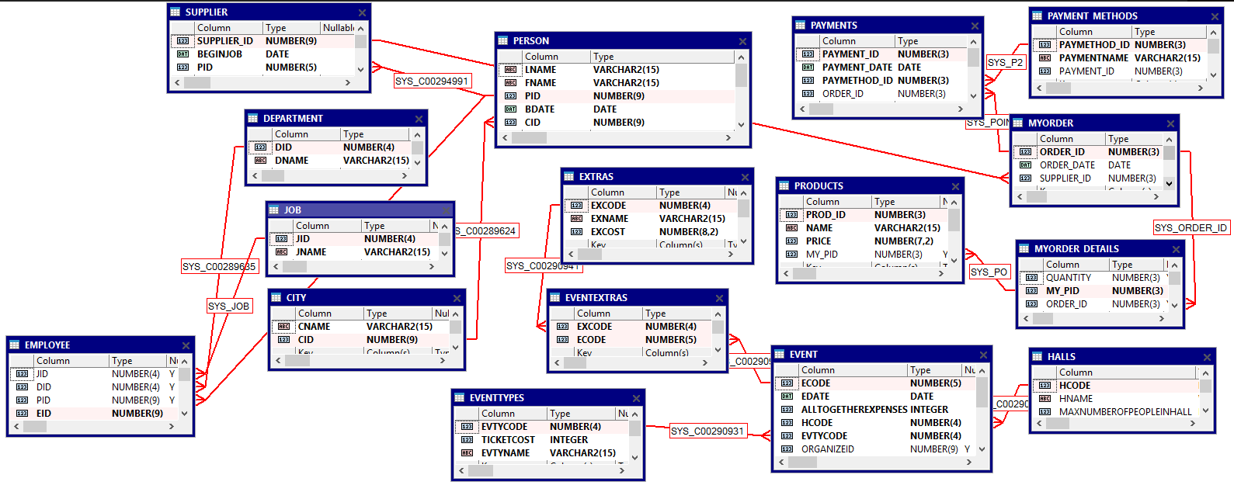

**אינדקסים**

BEFORE INDEX (1

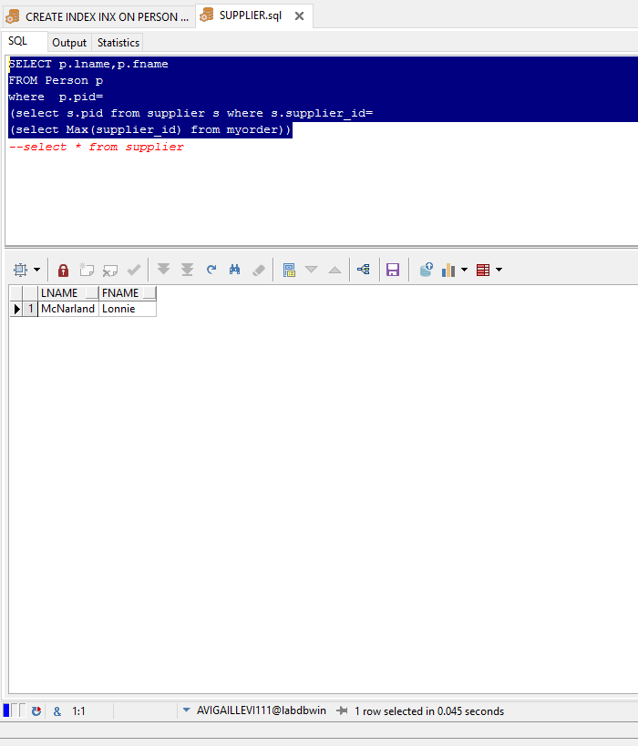

AFTER INDEX :

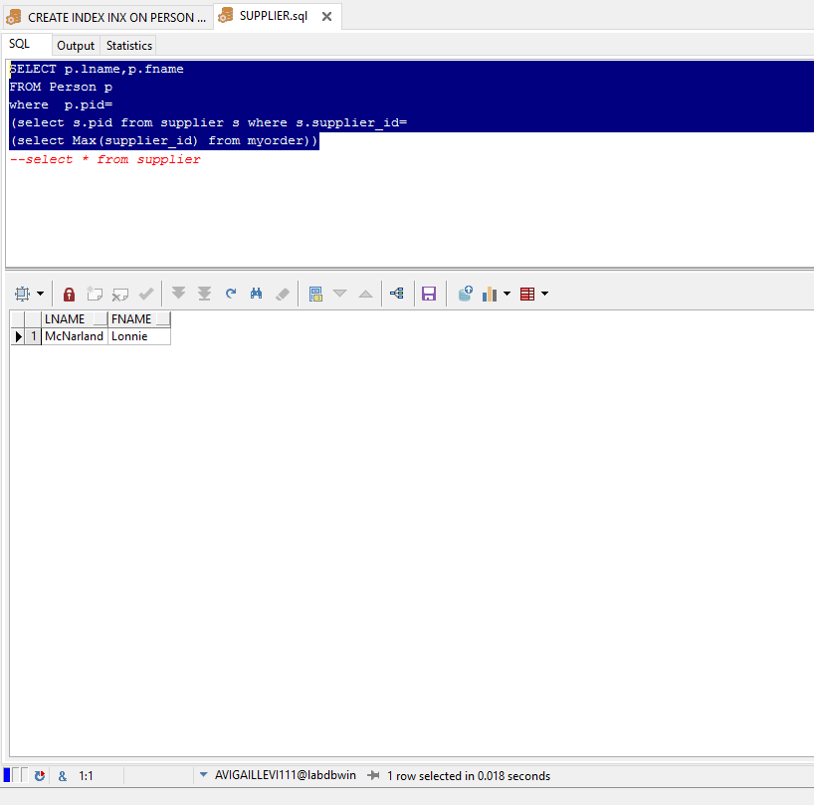

Before index(2 :

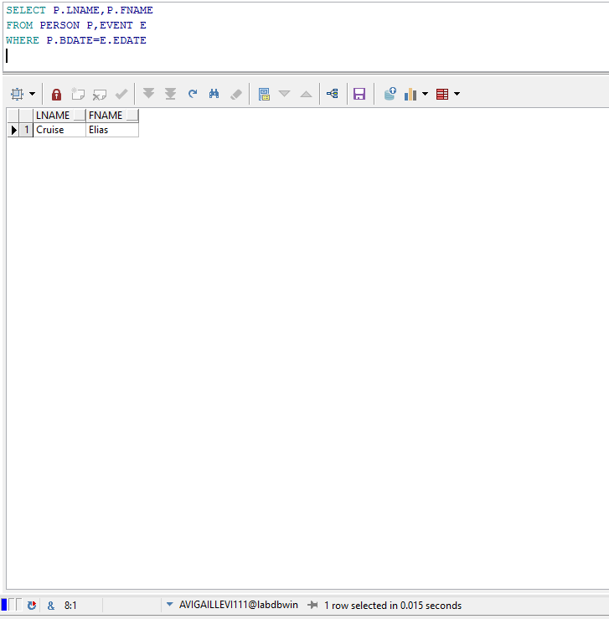

After index :

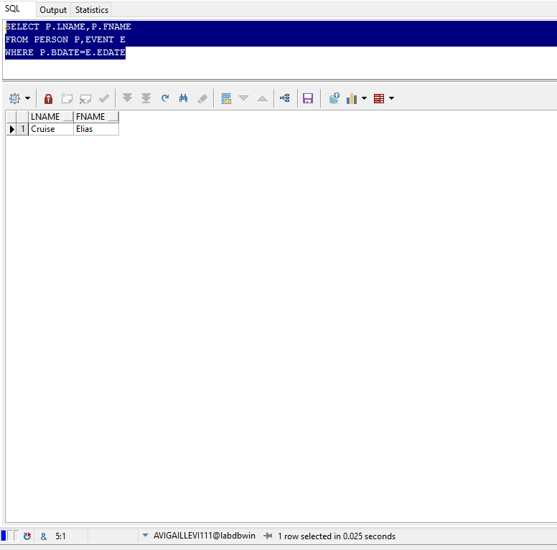

Before index (3

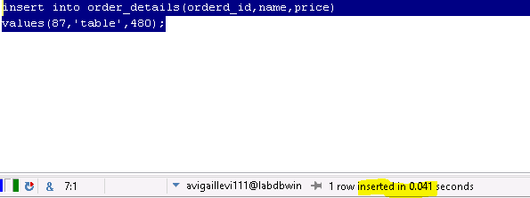

After index :

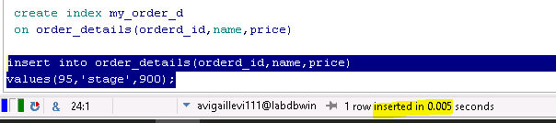

**Before index(4 :**

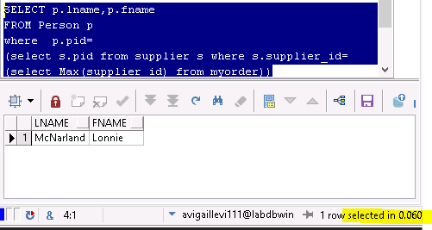

**After index**

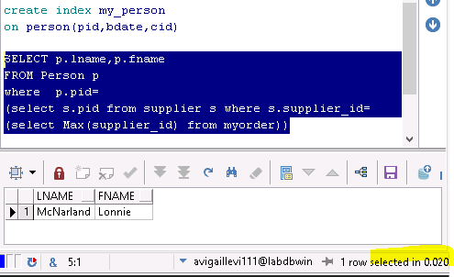

5) לפני INDEX :

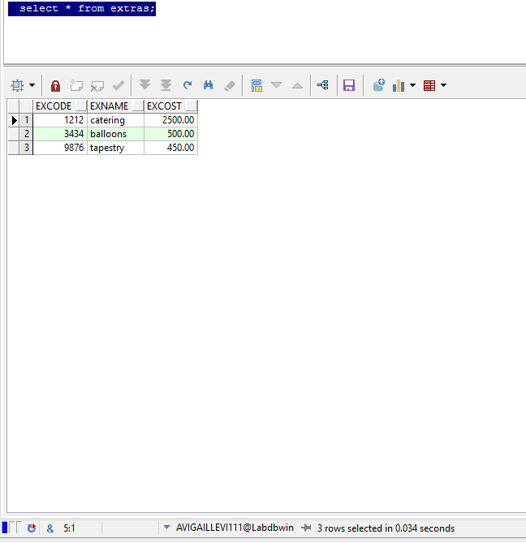

אחרי :

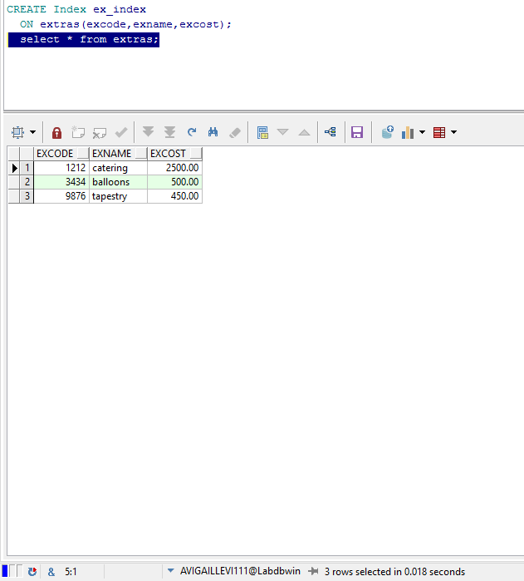

שאילתות של ארגון בסיס

1) מחזיר את הID של הזמנות שספקים ששלמו במזומן:

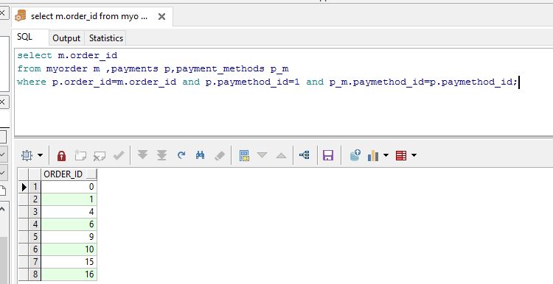

2) שאילתה שמחזירה את שמות המוצרים שנקנו מהספקים שגרים בעיר בה כמות הספקים הכי גדולה:

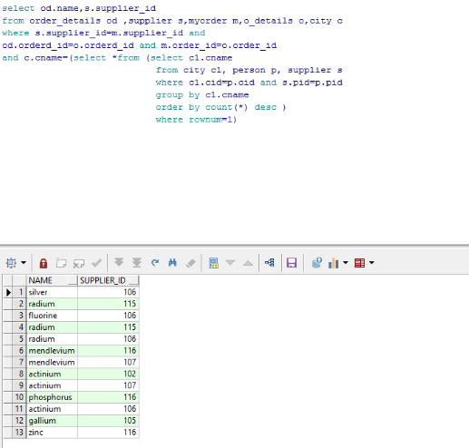

3) שאילתה שמחזירה ספק ששילמו עבורו את הסכום הגבוה ביותר במזומן

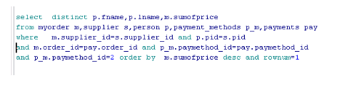



4) שאילתה שמחזירה את כל אלה שאינם בעלי תפקיד‎:

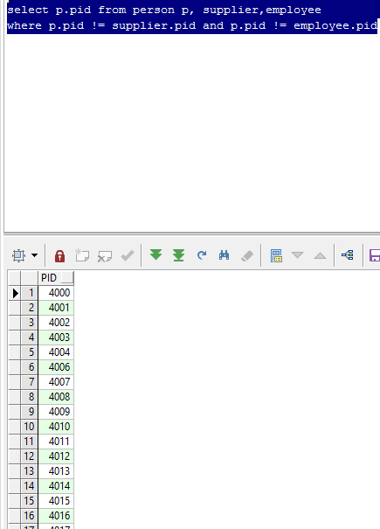

5) שאילתה שמחזירה את רשימת הid של העבודות שאין אנשים שעובדים בהם:‎ 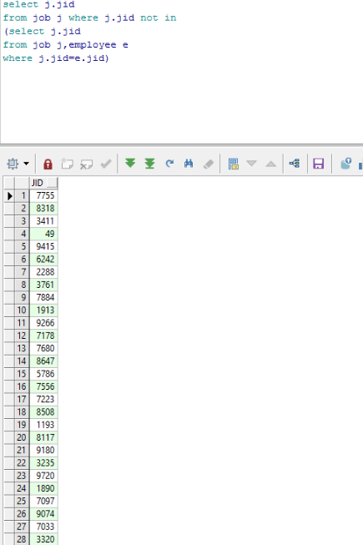

6) שאילתה שעבור כל מספר הזמנה מחשבת את סכום התשלום הכולל:

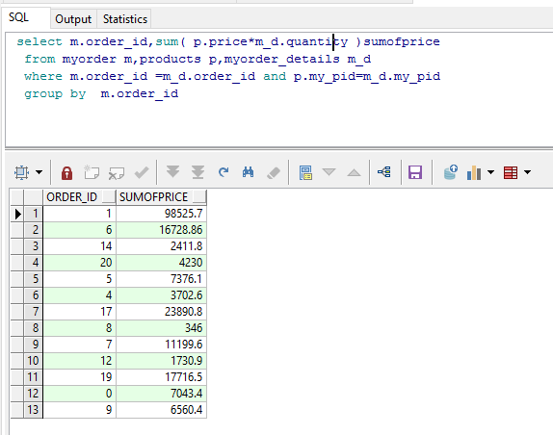

שאילתות משותפות

1)תביאי לי את השם פרטי +משפחה של אלו שהתאריך לידה שלהם בתאריך בו מתקיים אירוע:

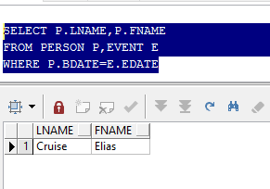

**2 )**השאילתה מחזירה את מספר הספק איפה שת.ז הספק שווה לת.ז של ה(person)

את כל מספרי הזהות של הספקים שקטנים ממספרי הזהות של הרכש

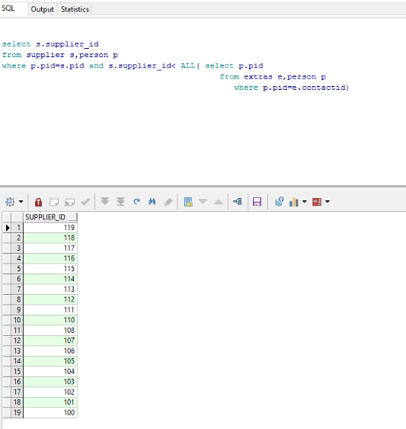

3) השאילתה שולפת את האירוע שבאולם שלו היו הכי הרבה אנשים והוא יתקים אחרון

(בכל תאריך ישנם הרבה אולמות שמתמלאים אז האולם בו היו הכי הרבה אנשים בתאריך האחרון שיתקיים בו אירוע )

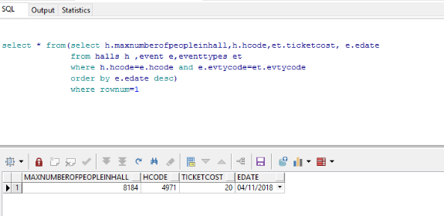

4) שאילתה שמחזיר את הת.ז של העובדים של ה( אירועים)  ושל הספקים של הרכש שגרים באותה העיר

כלומר כל פעם שיש ספק ועובד (אירוע )שגר באותו עיר זה יתן לי שורה חדשה מכיוון שיש רק עובד אירוע אחד שגר בעיר זהה כמו הספקים

אזי בעמודה של הת.ז של העובד אירוע כל העמודה אותו דבר

עשיתי כאן update לעובד אירוע אחד ושיניתי לו את השם של העיר בה הוא גר כדי שתהיה זהה לאחד הערים של העובדים של הרכש

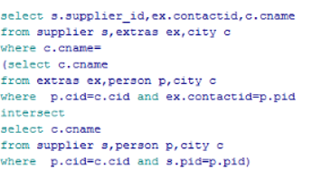

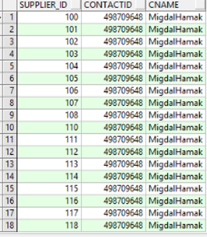

5) כל האולמות שהיה בהם ארוע בחודש נובמבר 2018:

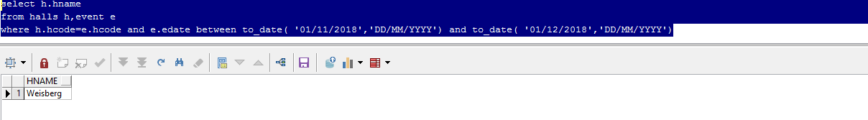

Grant

1)נתינת הרשאות לנעמי לINSERT וכול טבלת PERSON



אחרי שנתתי הרשאה לנעמי והיא עדכנה רואים את avi שהיא הכניסה בטבלת PERSON שלי

s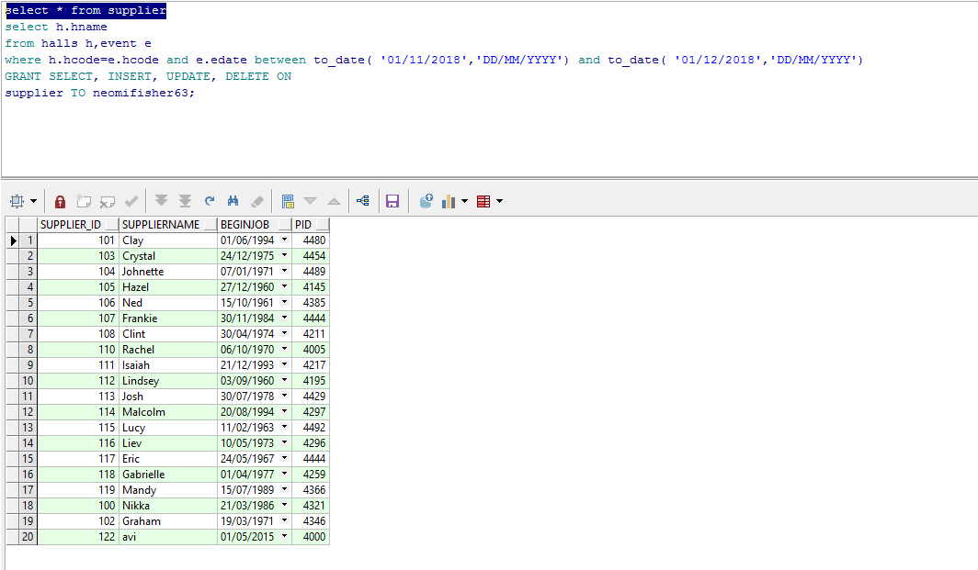

2) הפעם מול אודליה-נתתי הרשאות לSELECT וINSERT

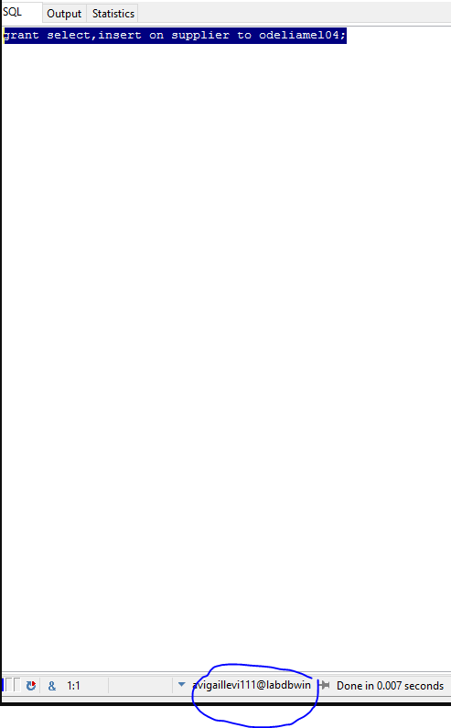

אצל אודליה:

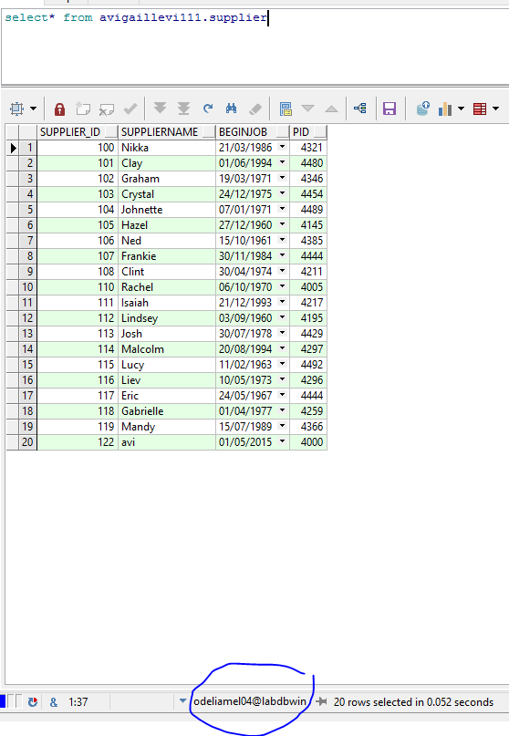

REVOKE

ואז הורדתי את ההרשאות שנתתי לאודליה:

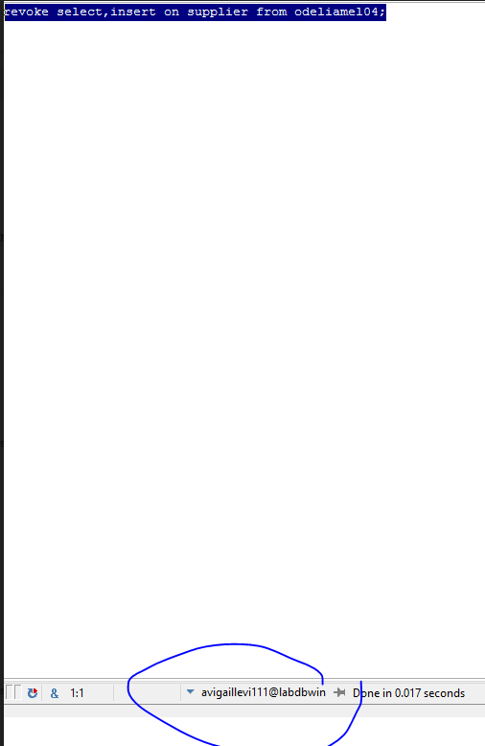

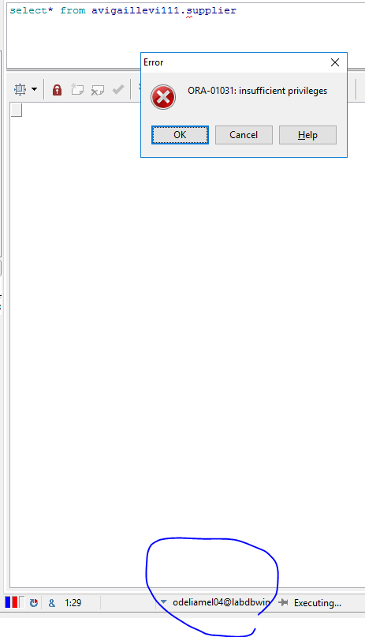

אילוצים :

1)אילוץ של שדה שם אולם:

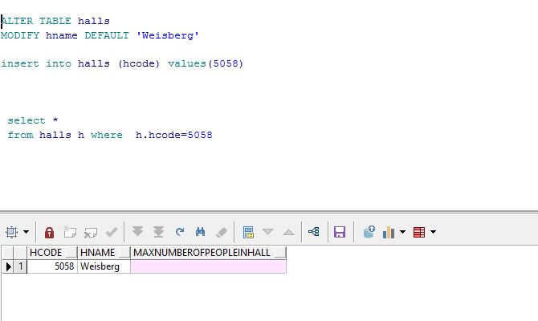

2) אילוץ על מספר מקס באולם, לא ניתן להכניס באולם יותר מ-10000

רואים שניסנו להכניס באולם 'קורוב' 10001 אנשים וקיבלנו שגיאה

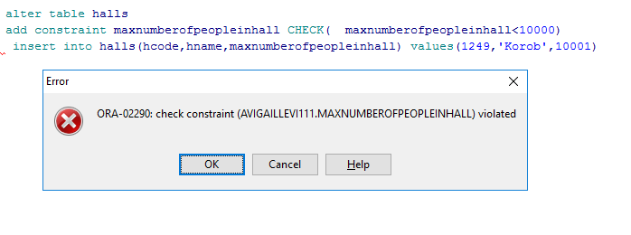

3) אילוץ על המחיר הכולל שיהיה בין 0 ל10000

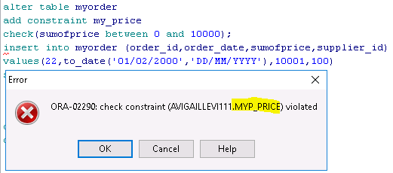

4 ( אילוץ על תאריך לידה של הperson

תאריך הלידה חייב להיות גדול מ 01.01.1959 אחרת הם לא נמצאים ברשימה

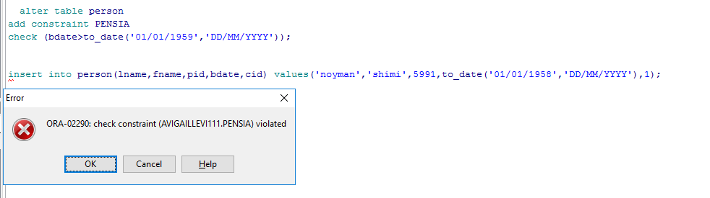

Update

update על אירגון בסיס

(1עדכון שכל מי ששילם באשראי ישלם חצי מחיר במחיר הכולל

לפני עדכון:

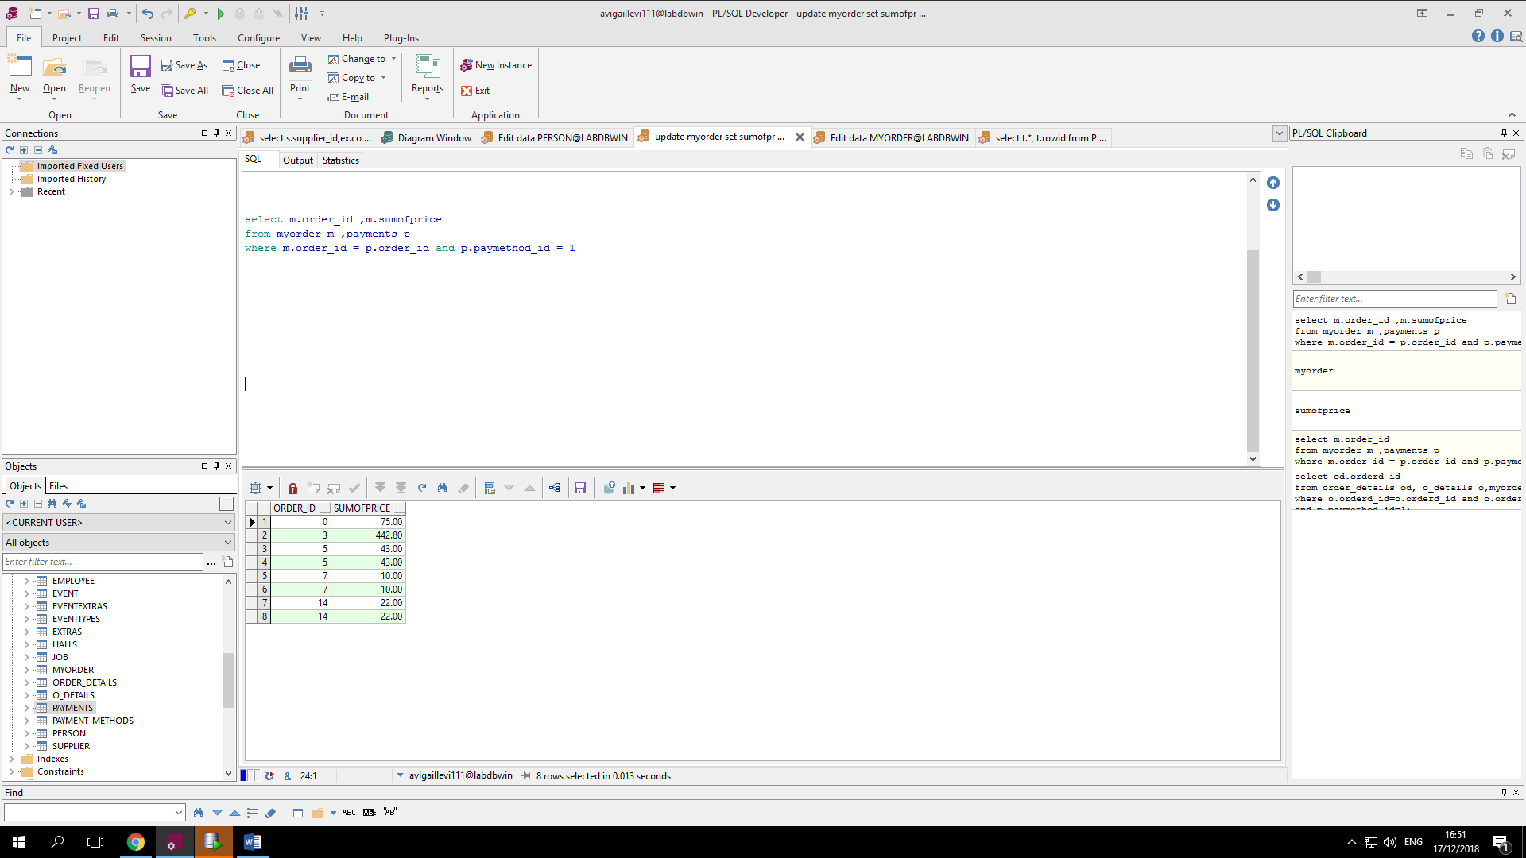

אחרי עדכון:

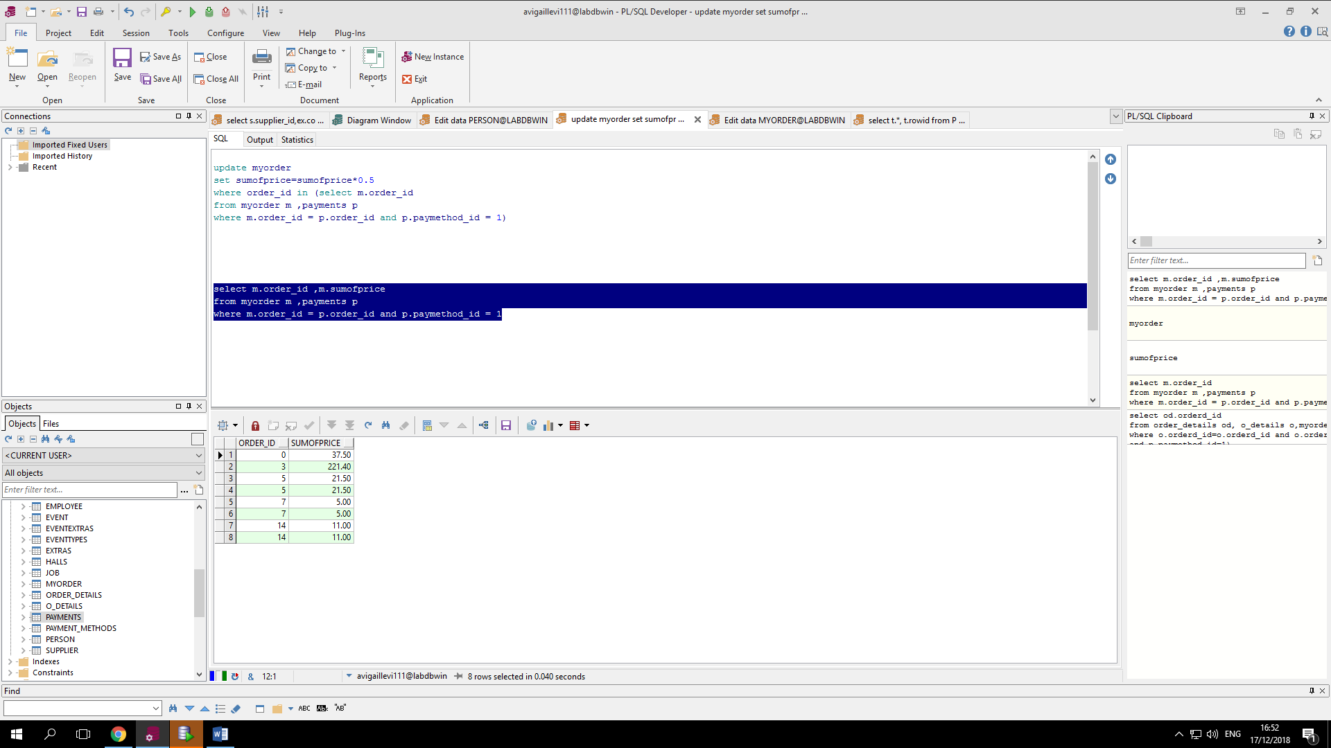

(2מכפיל את המחיר ששווה ל1.73 ב - 20 )לפני עדכון(:

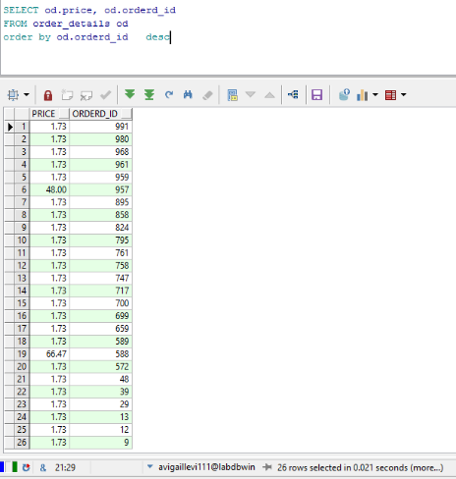

העדכון: לאחר עדכון:

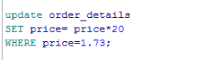

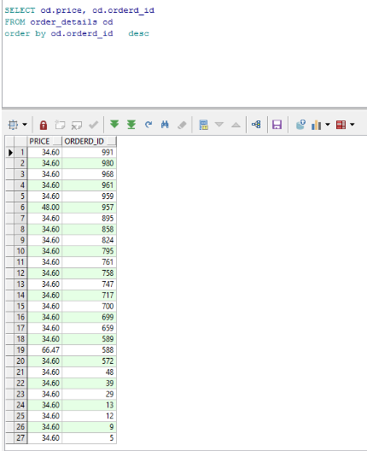

Update על ארגון מורחב

1)עדכון של מחיר כרטיס אולם

**לפני עדכון:**

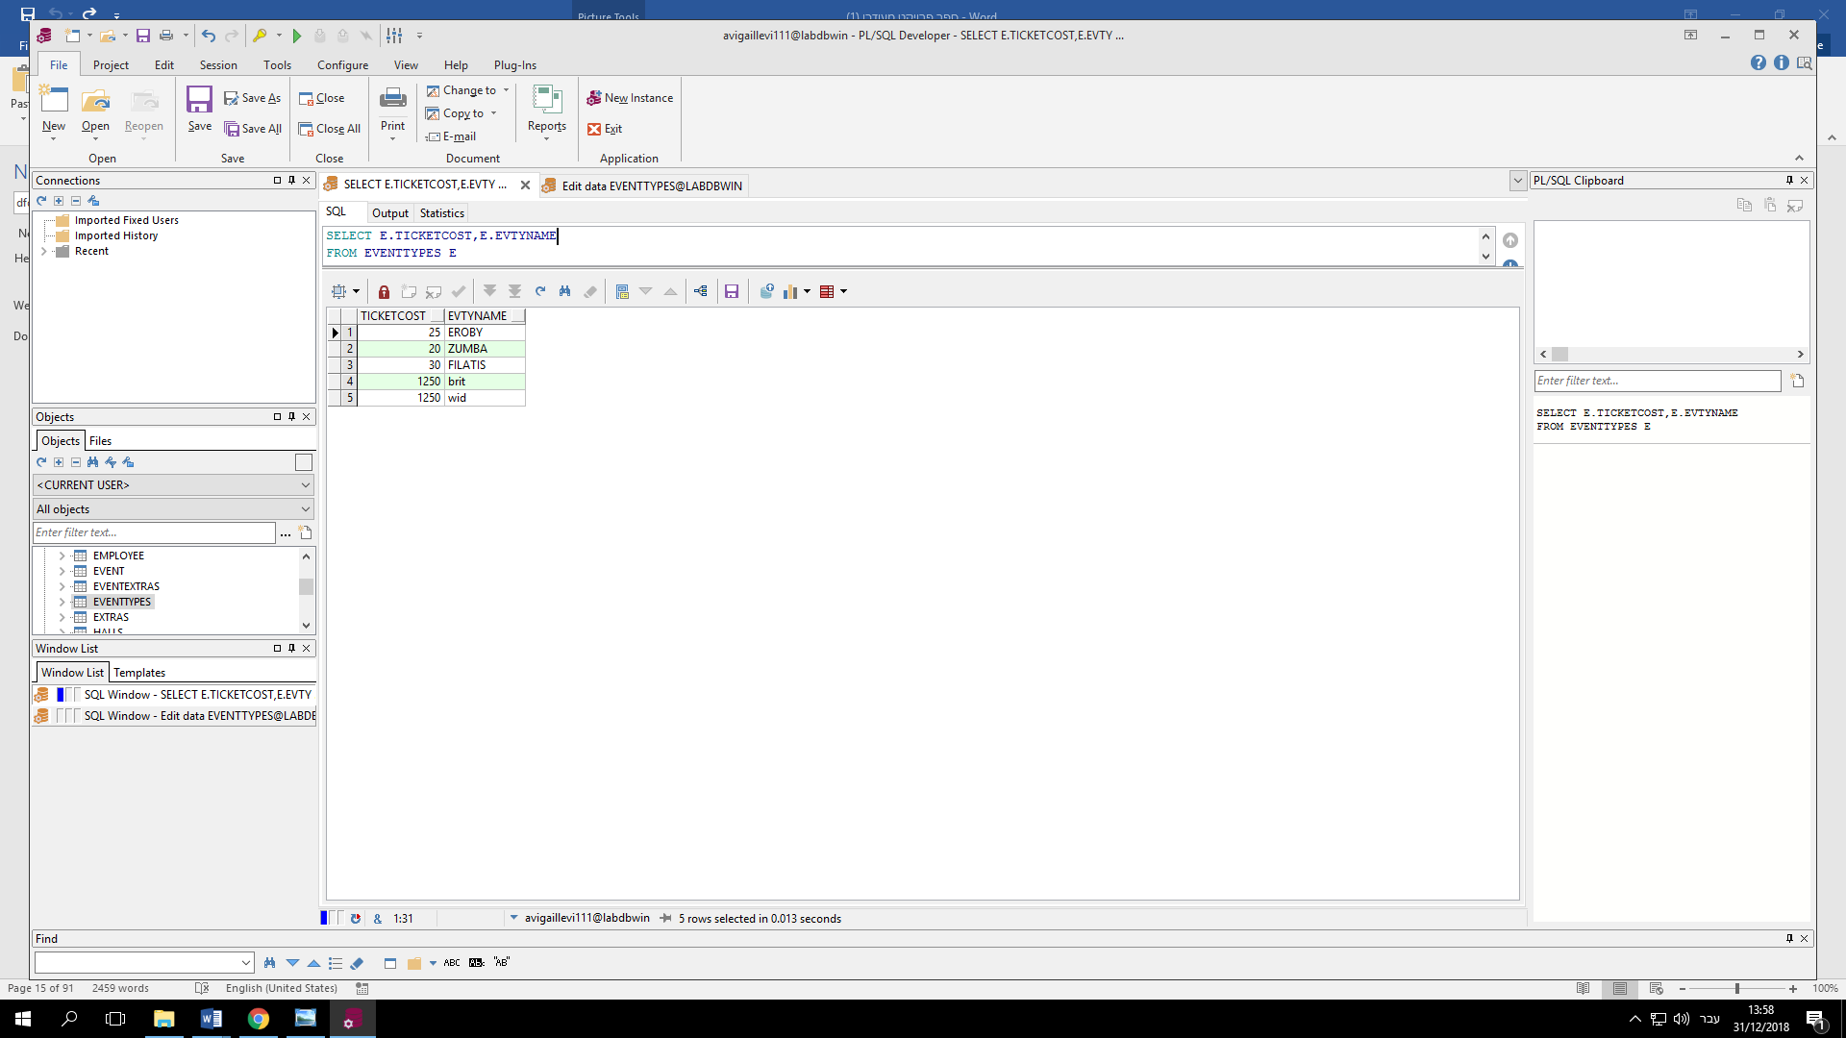

**לאחר עדכון:**

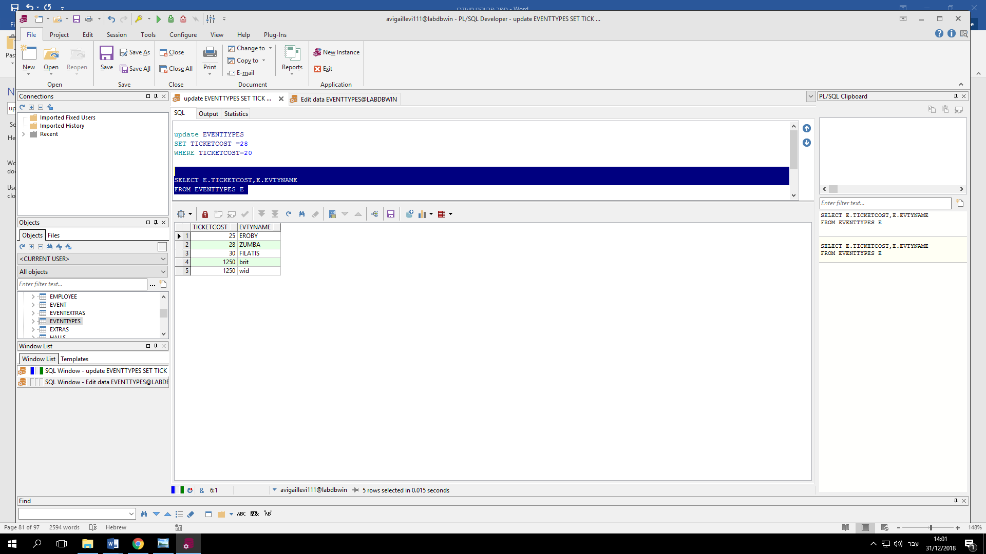

2)עדכון של שם אירוע בתאריך שבו אירוע חל ביום הולדת של person אזי שם האירוע יהיה birthday :

לפני עדכון:

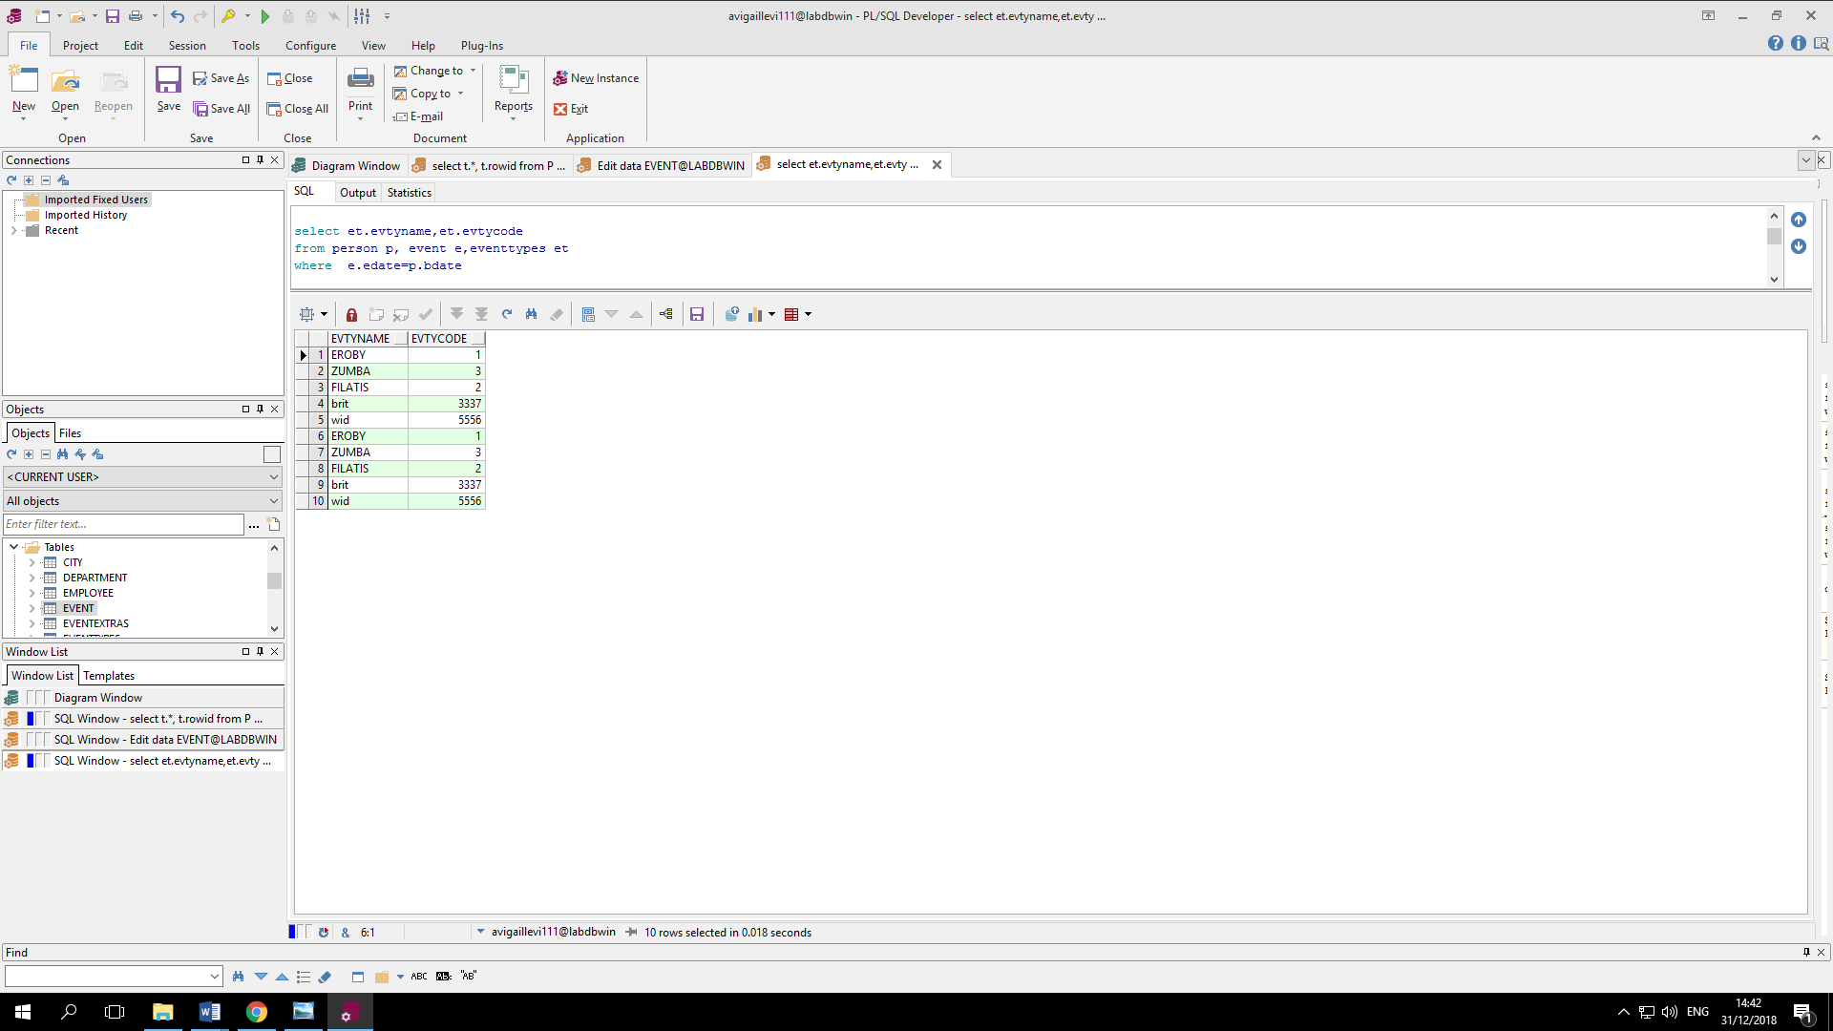

אחרי עדכון:

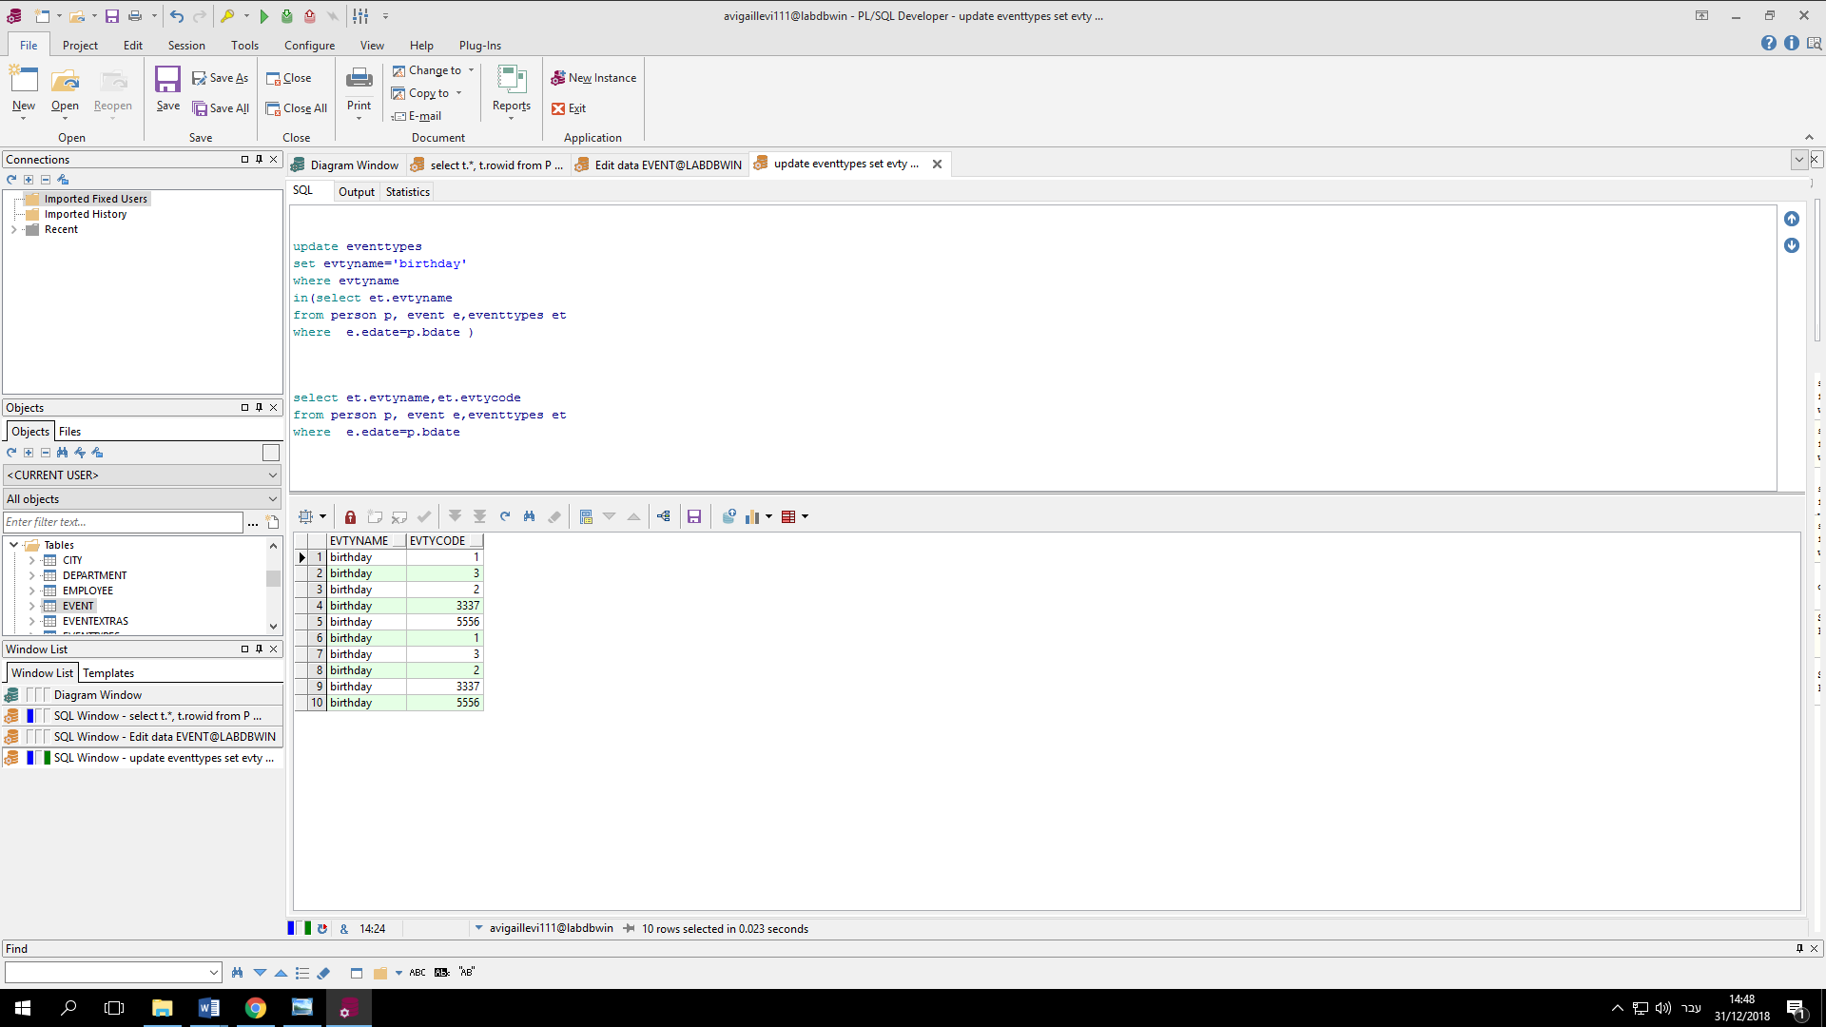

Delete

שאילתות מחיקה בארגון בסיס

מחיקת כל הפנסיונרים שנולדו לפני 1960

לפני מחיקה

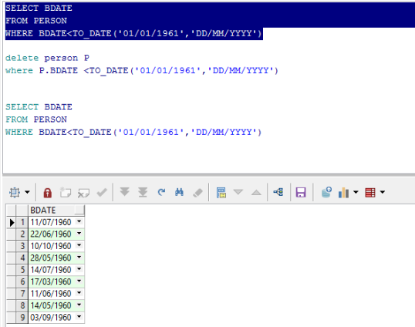

אחרי מחיקה :

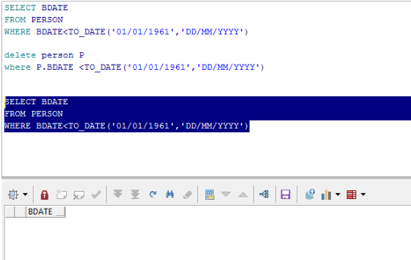

­­

שאילתת מחיקה בארגון המורכב:

**מחיקה של האולם שההכנסה שלו היתה קטנה מ 25000 שח כלומר הסכום בו מחיר הכרטיס כפול מספר האנשים קטן מ25000**

לפני פעולת המחיקה

**כל האולמות**

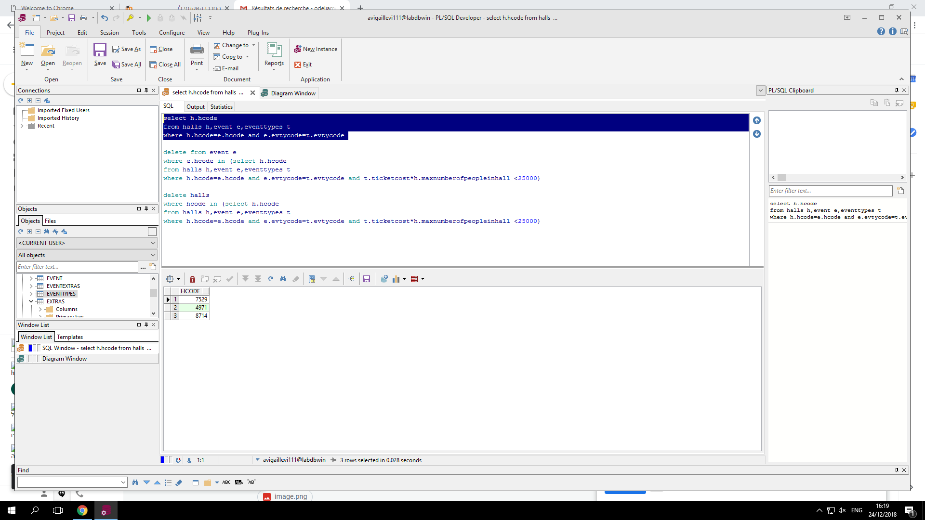

לפני מחיקה:

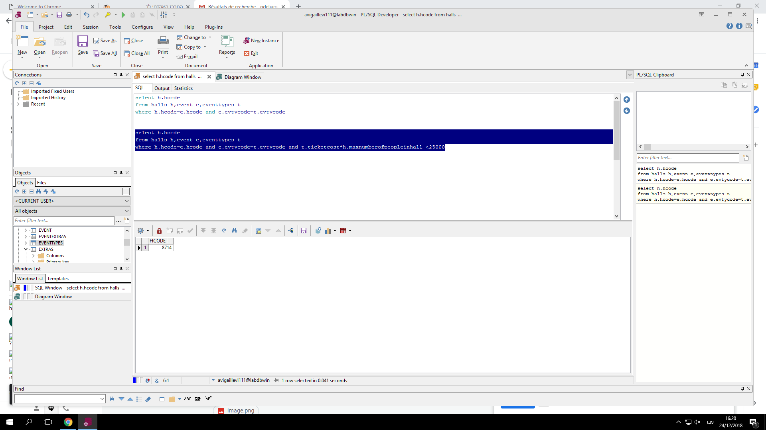

לאחר מחיקה**:**

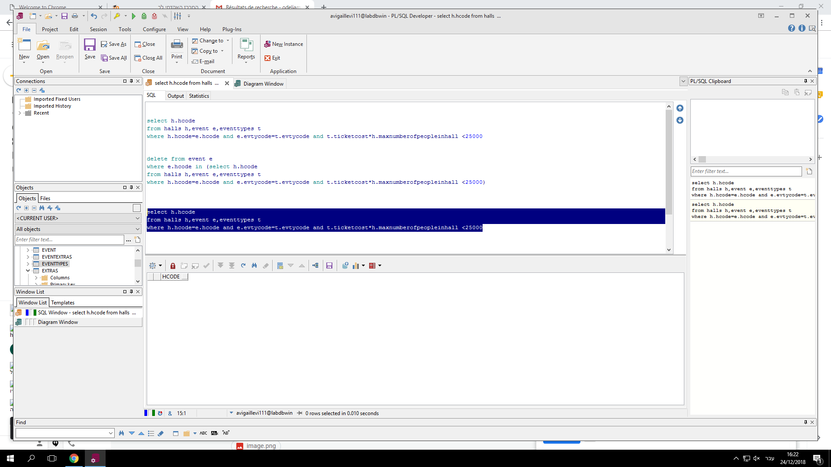

**:commit**

**update לפני**

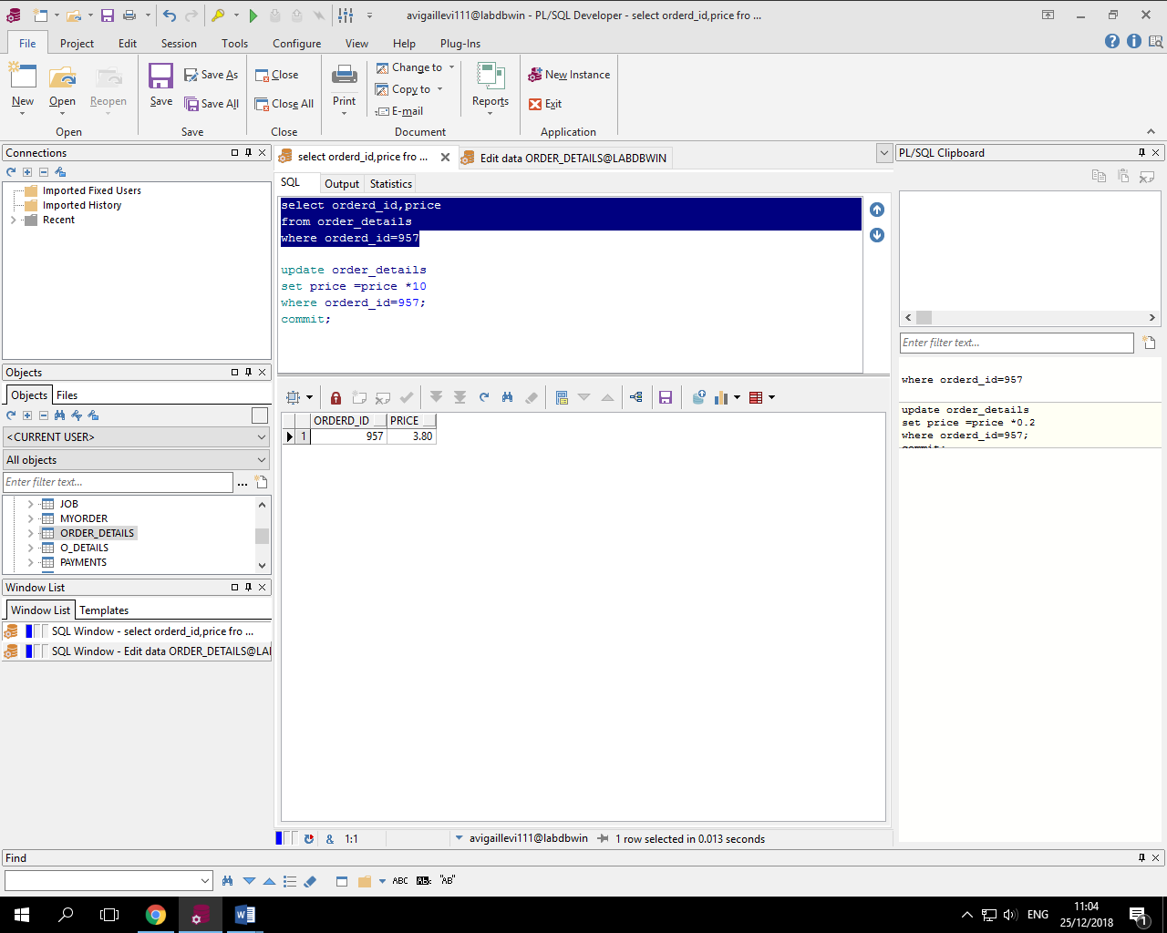

**Update with commit**

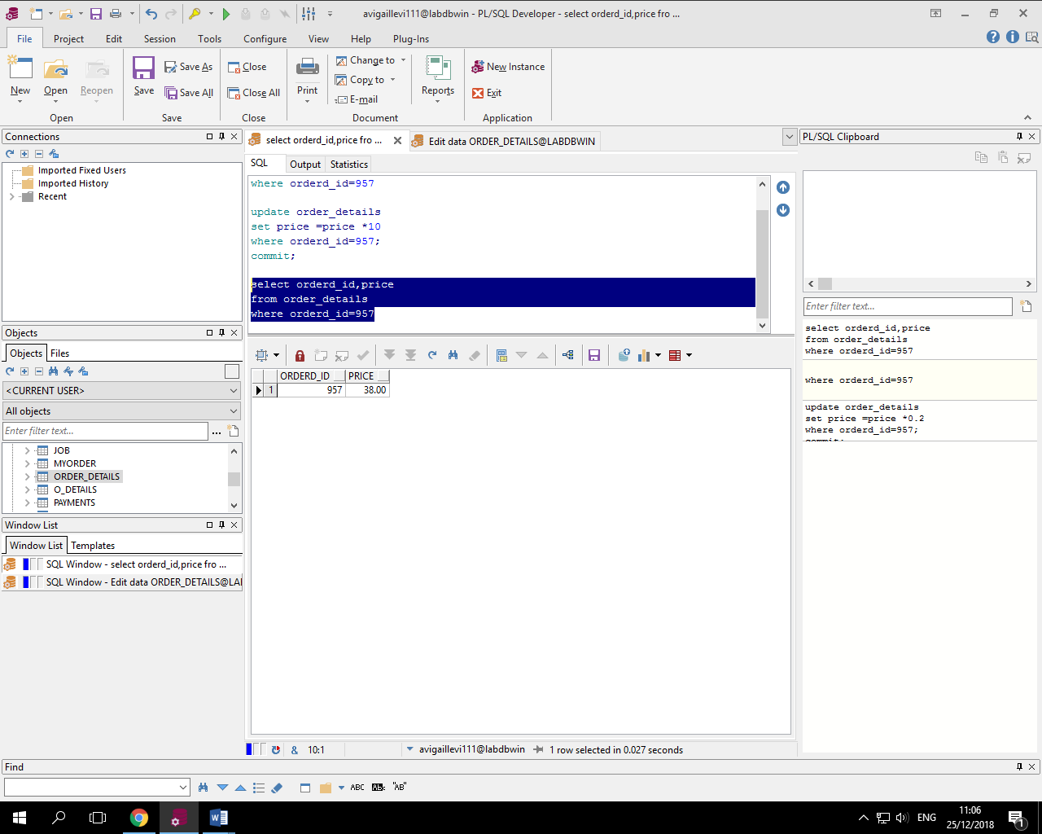

**Rollback ונעשה לו commitכעת נבצע את אותה פעולה רק בלי**

**After update**

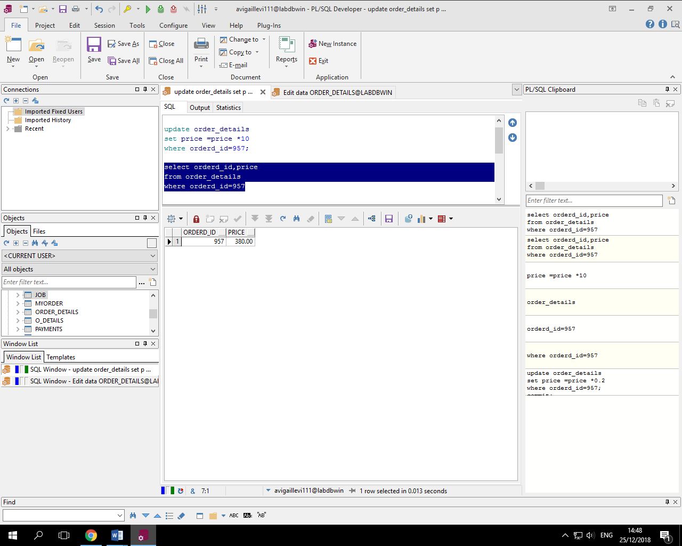

**After rollback**

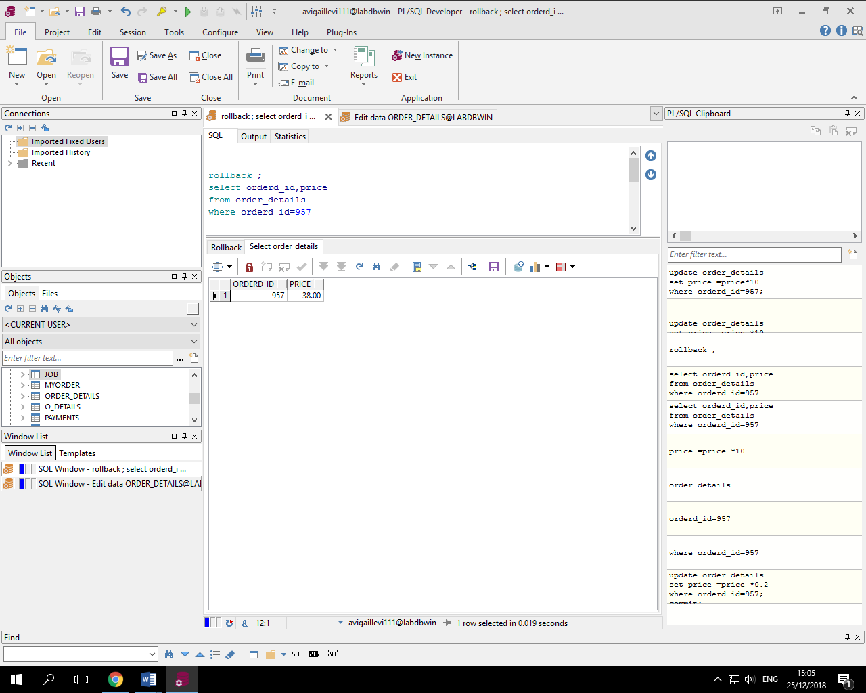

**View**

**: טבלה חדשה שמחזירה את האולמות שיש בהם יותר מ4000 איש**

**הטבלה המקורית: (1**

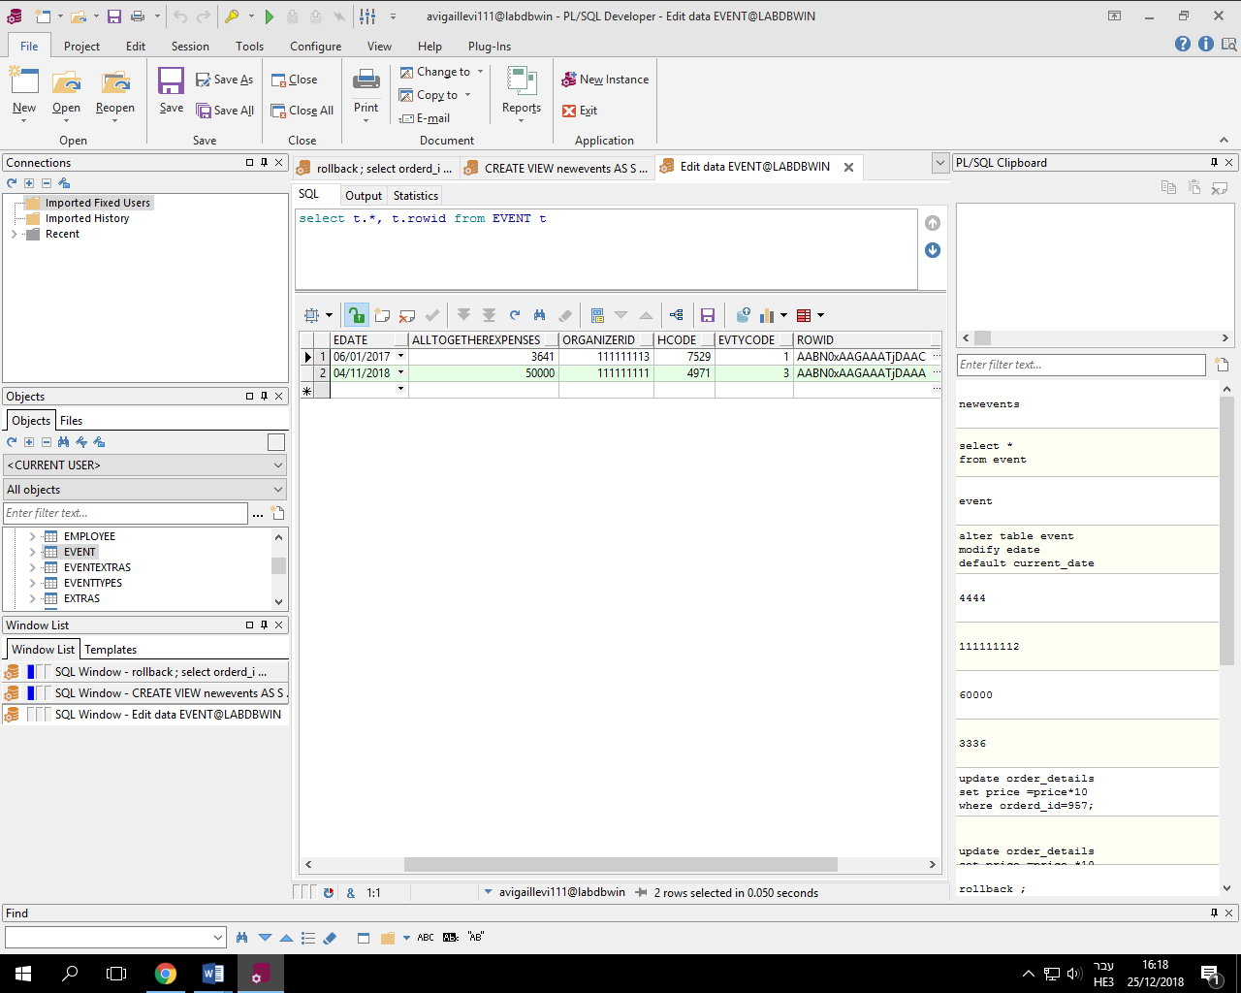

**הטבלה החדשה:**

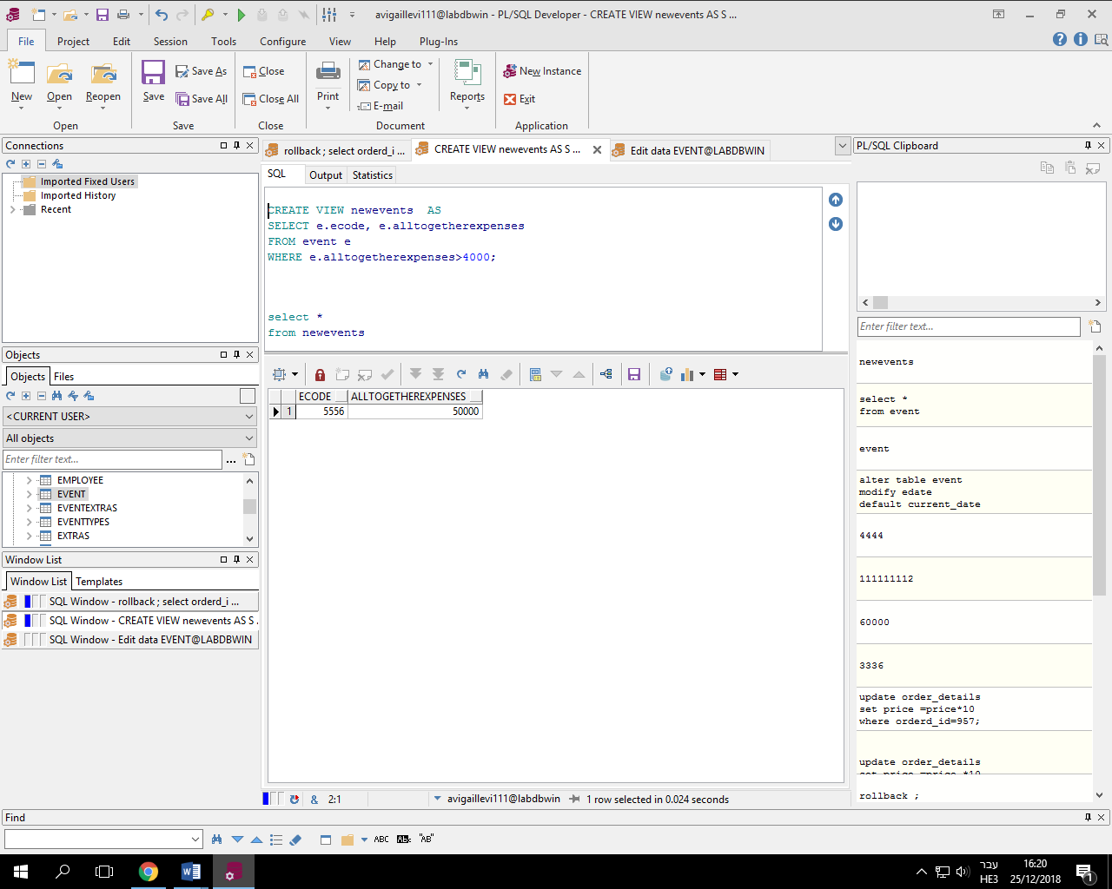

**טבלה חדשה לכל עובד נתון המחלקה שאליה הוא שייך והעבודה שלו**

**טבלה חדשה :(2**

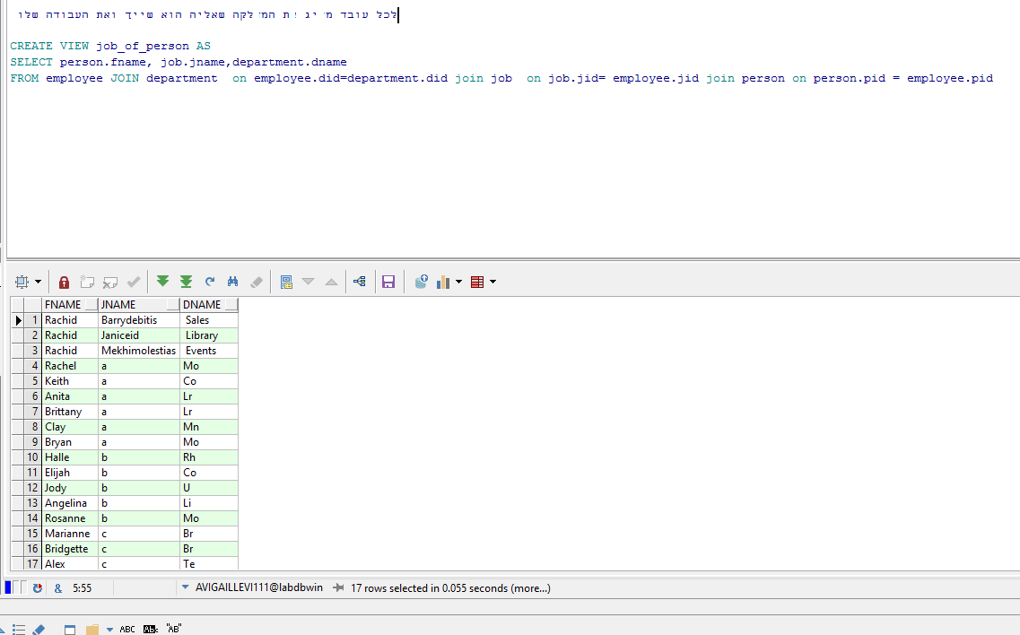

**3) טבלה חדשה שהיא "קבלה" שמקבלים לאחר קניה**

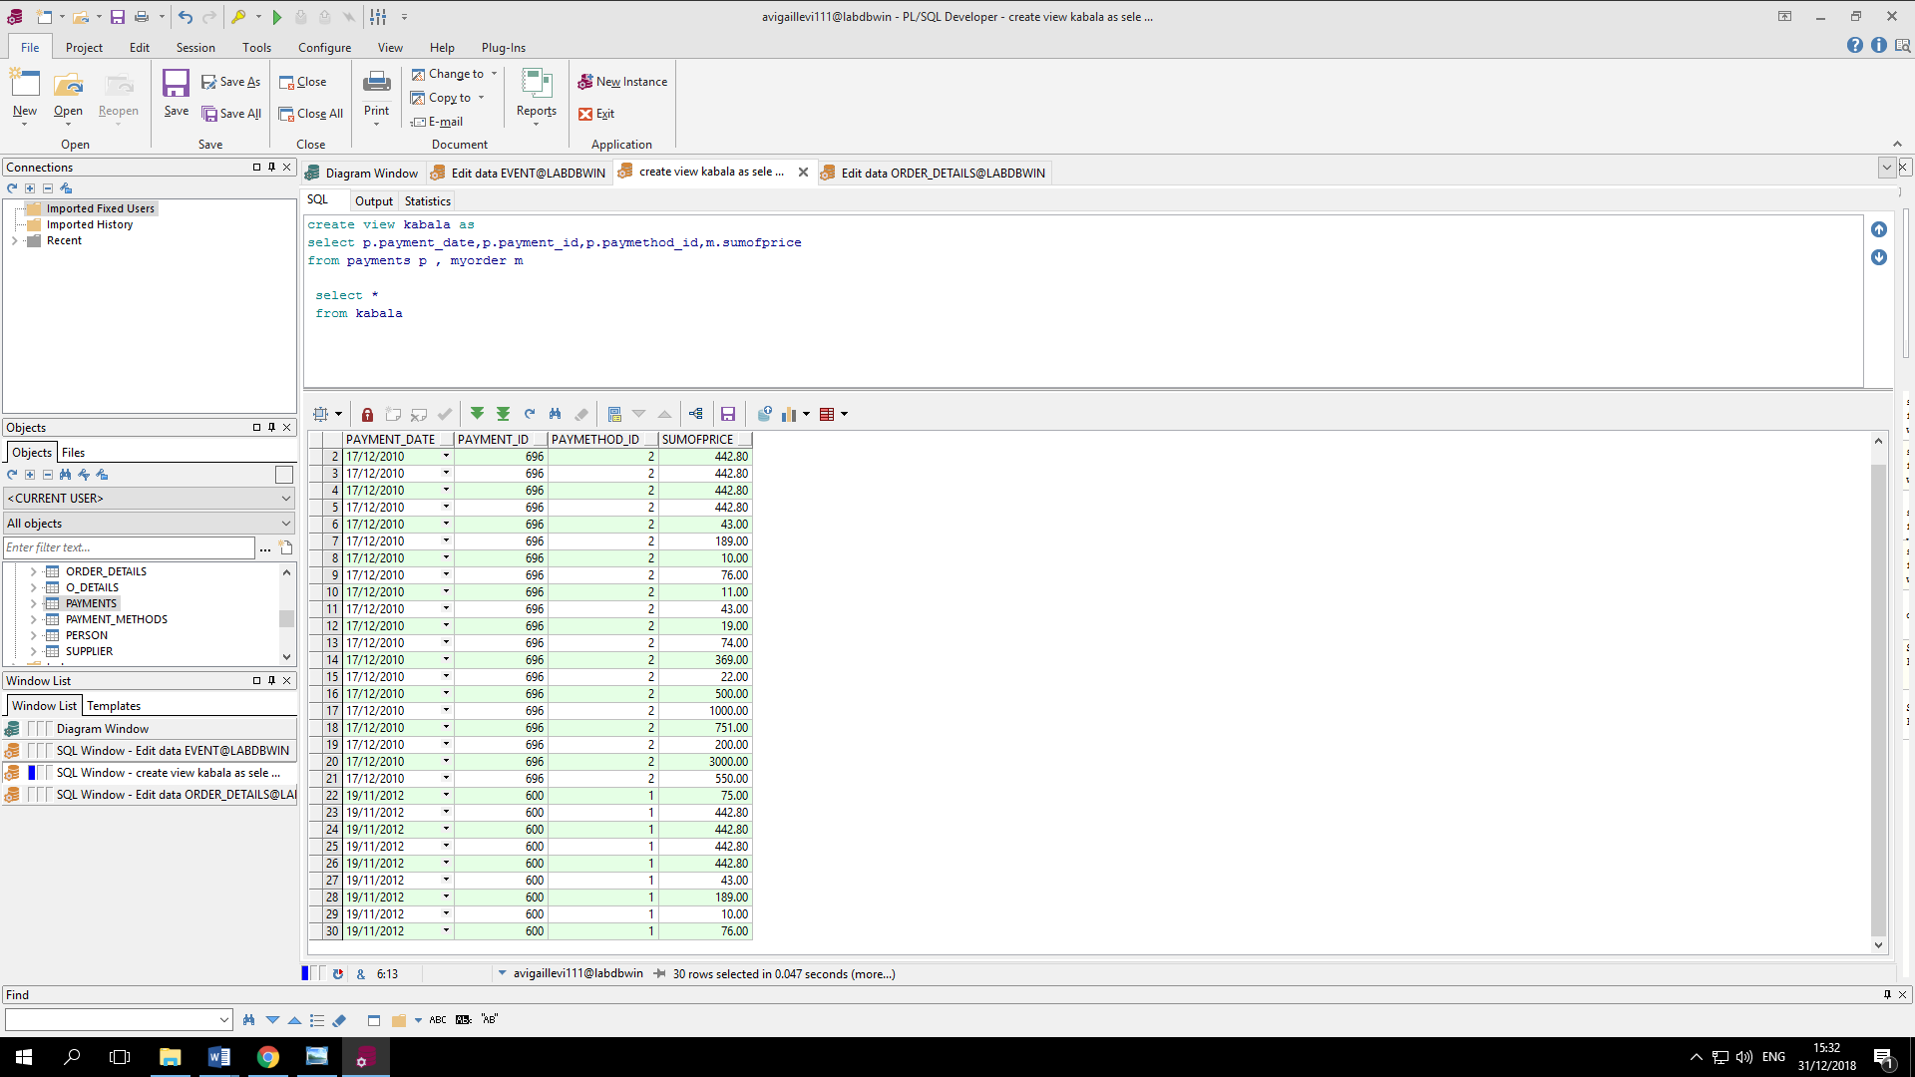

**שאילתה על הטבלה קבלה :**

**תחזיר לי את תאריך הקבלה הראשונה שנעשתה .**

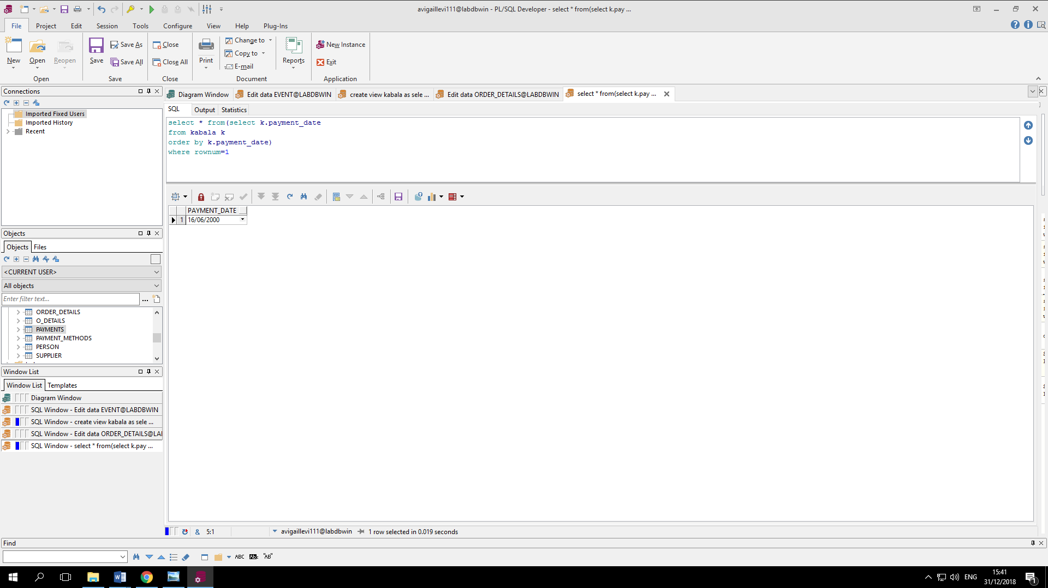

**הוספת מפתח זר\***

**קוד להוספת מפתח זר – ראינו שבפרויקט המשותף חסר עמודה שהינה מפתח זר:**

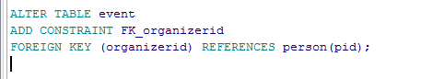

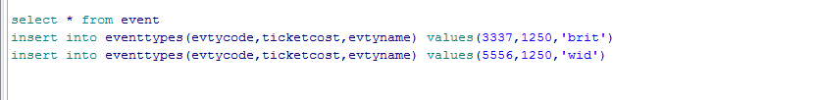

**שלב 4**

**שאילתות עם פרמטרים**

**1)** שאילתה שמחזירה את מספר ההזמנה וסכום התשלום הכולל עבור איש מסוים שביצע הזמנה

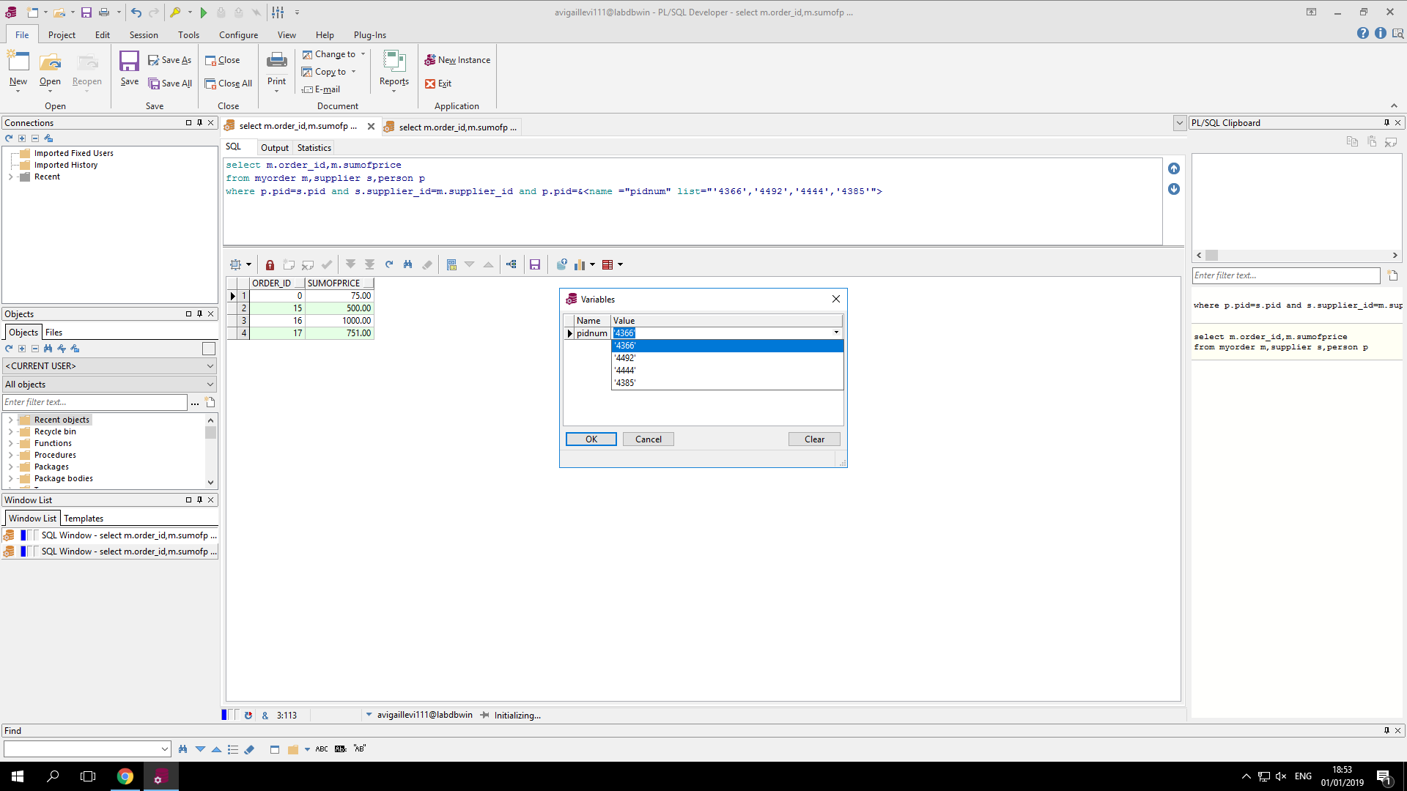

**2)** שאילתה שמחזירה את שמות האנשים שנולדו בטווח תאריכים מסוימים

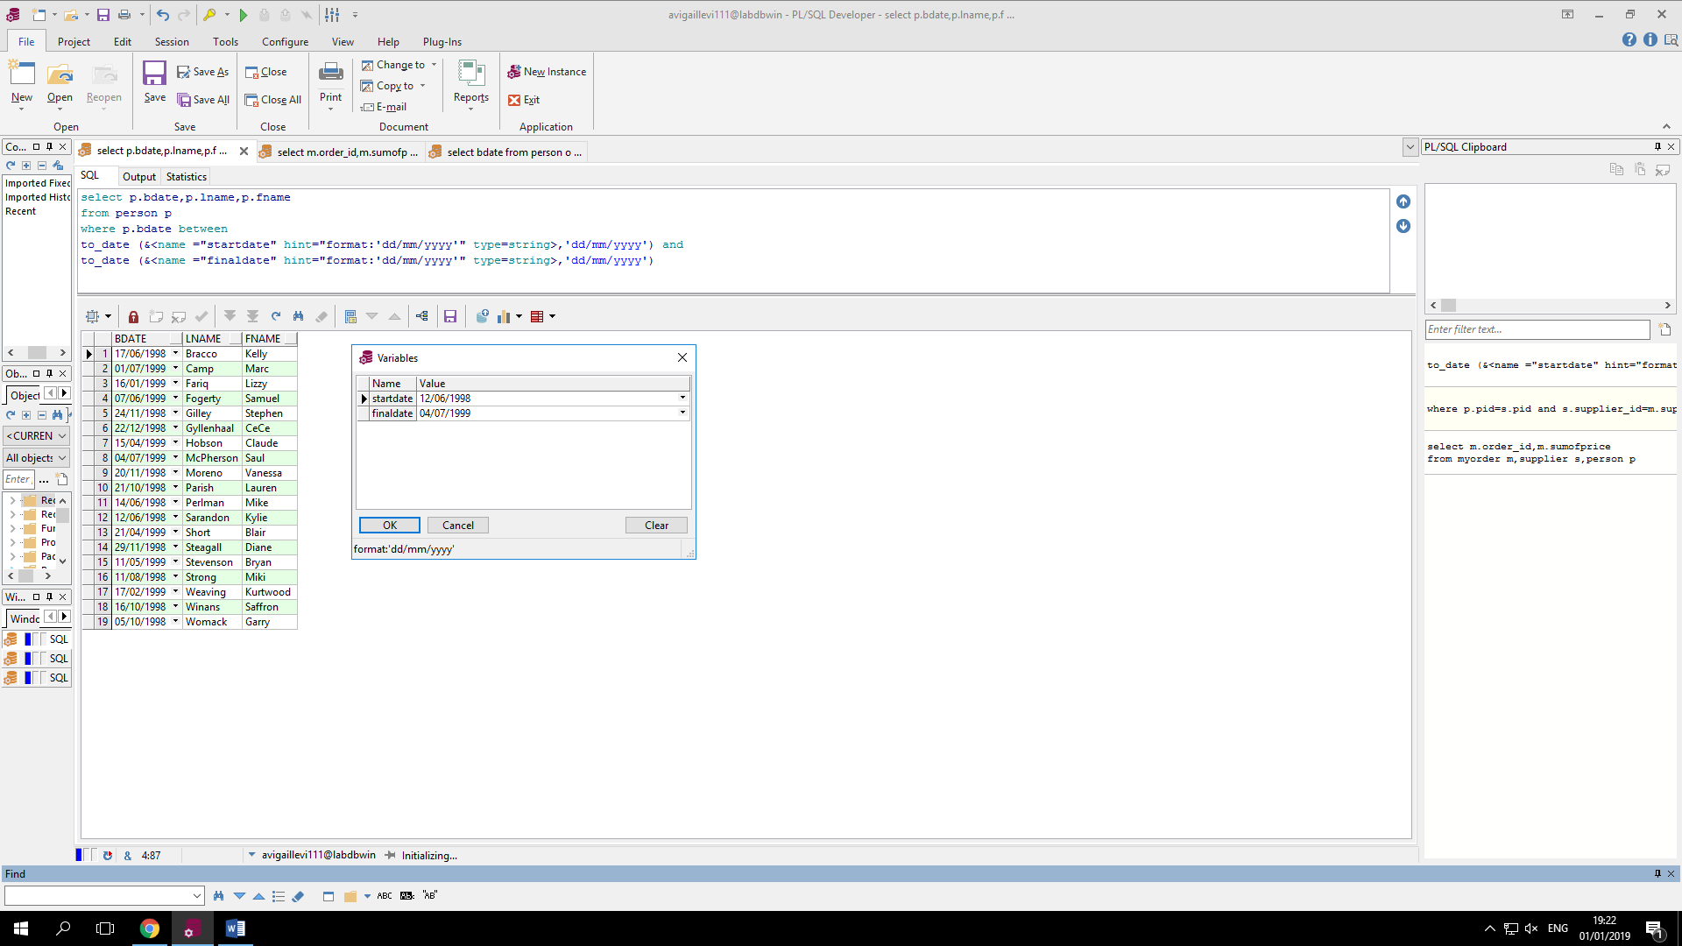

**3)** שאילתה שמחזירה את כל התשלומים שנעשו בשיטה שאותה המשתמש בוחר (אשראי, מזומן, שייק):

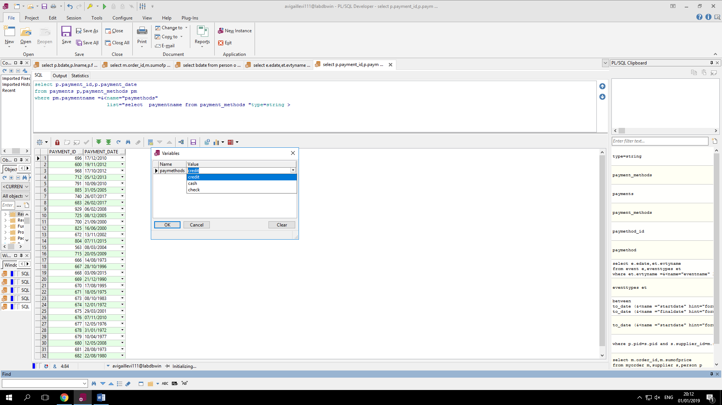

**4 )** שאילתה שמחזירה את שמות כל הספקים שנמצאים במחלקה שהמשתמש בוחר:

כברירת מחדל) Ba (במצב והמשתמש אינו בוחר מחלקה אזי תיבחר המחלקה

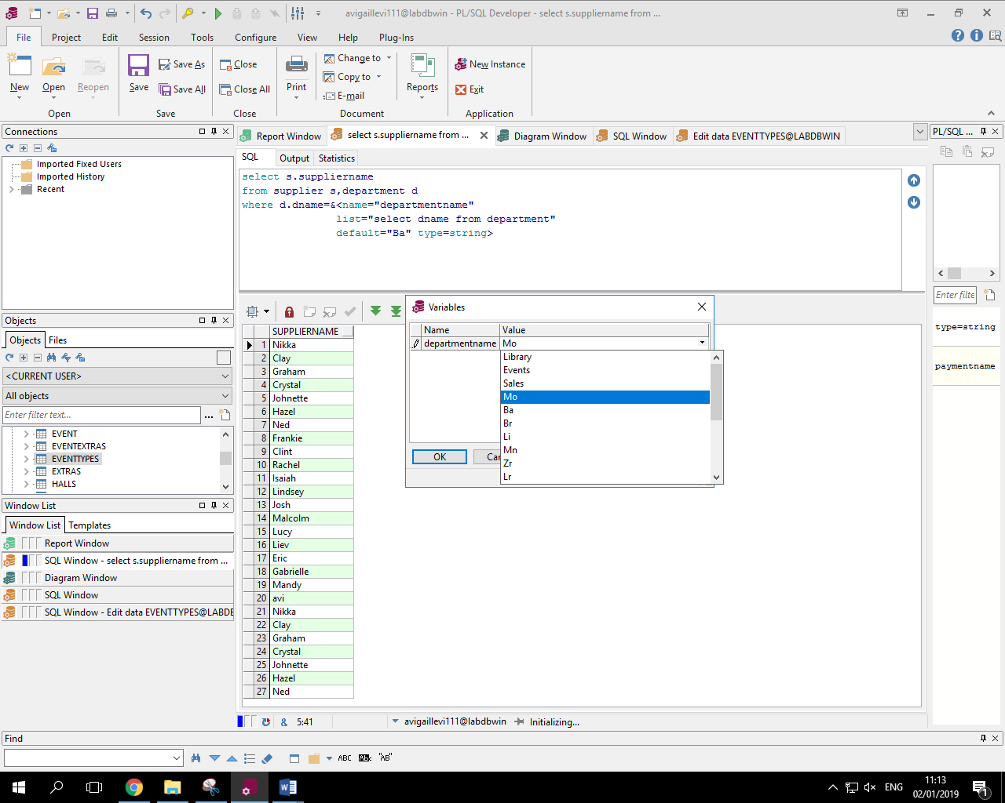

**5)** שאילתה שמחזירה את שמות האנשים שמתחילים באותA שמשתתפים באירוע אותו המשתמש בחר:

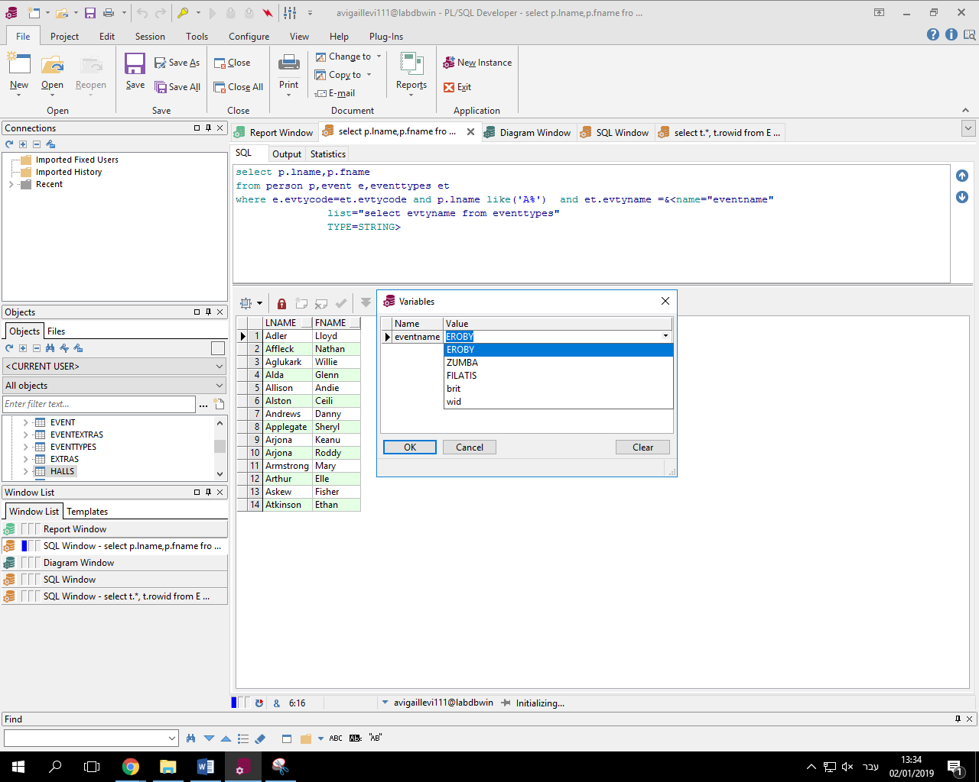

**6)** שאילתה שמחזירה את שמות האנשים שמתחילים באות אותה המשתמש בוחר מתוך הרשימה של האותיות:

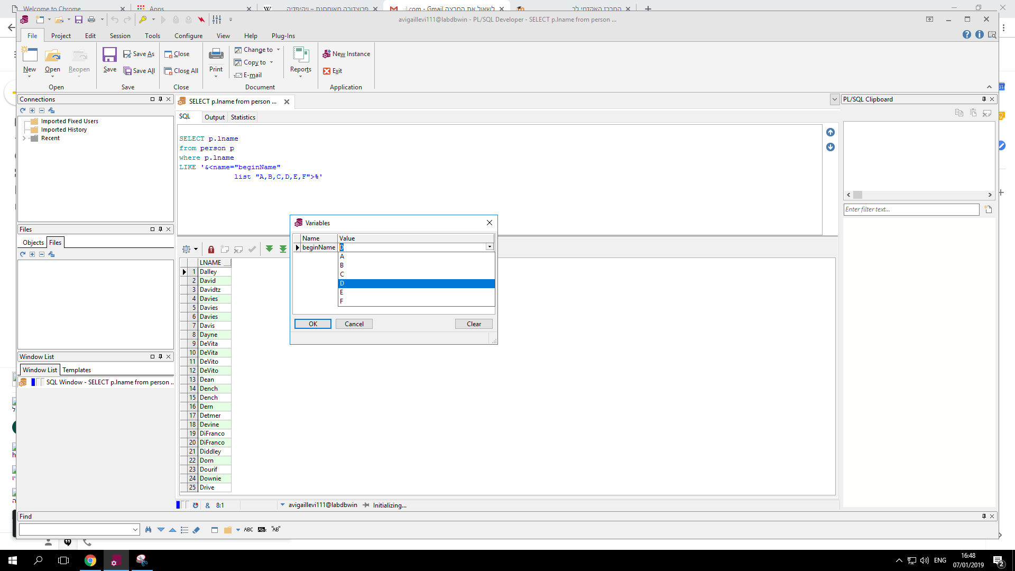

**דו"חות**

1 )הדו"ח מחזיר את רשימת המוצרים שנקנו מהספקים שגרים בעיר בה כמות הספקים הכי גדולה

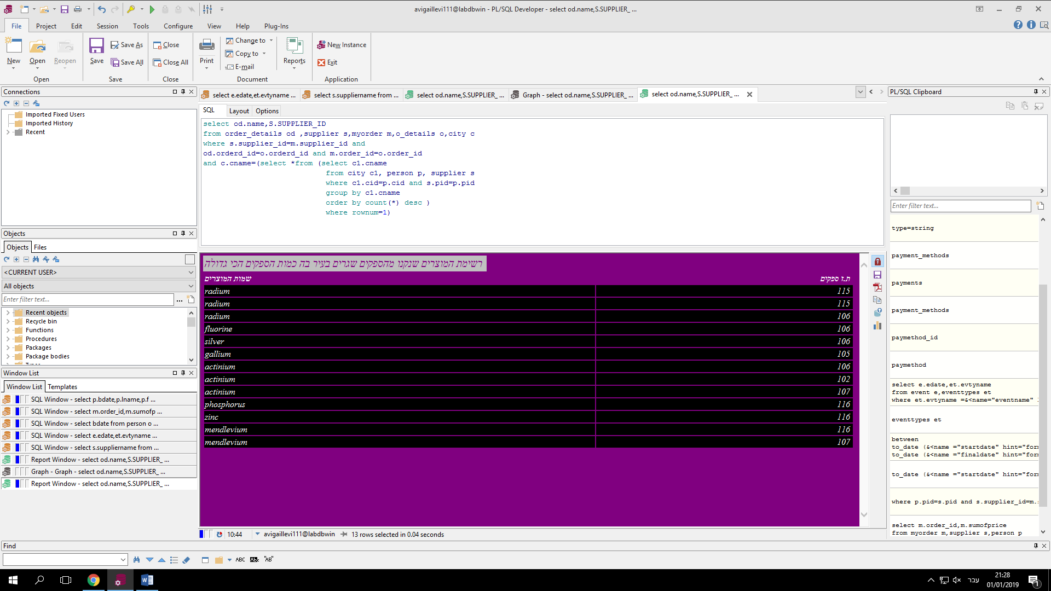

**2)**דו"ח של רשימת האנשים שאינם בעלי תפקיד

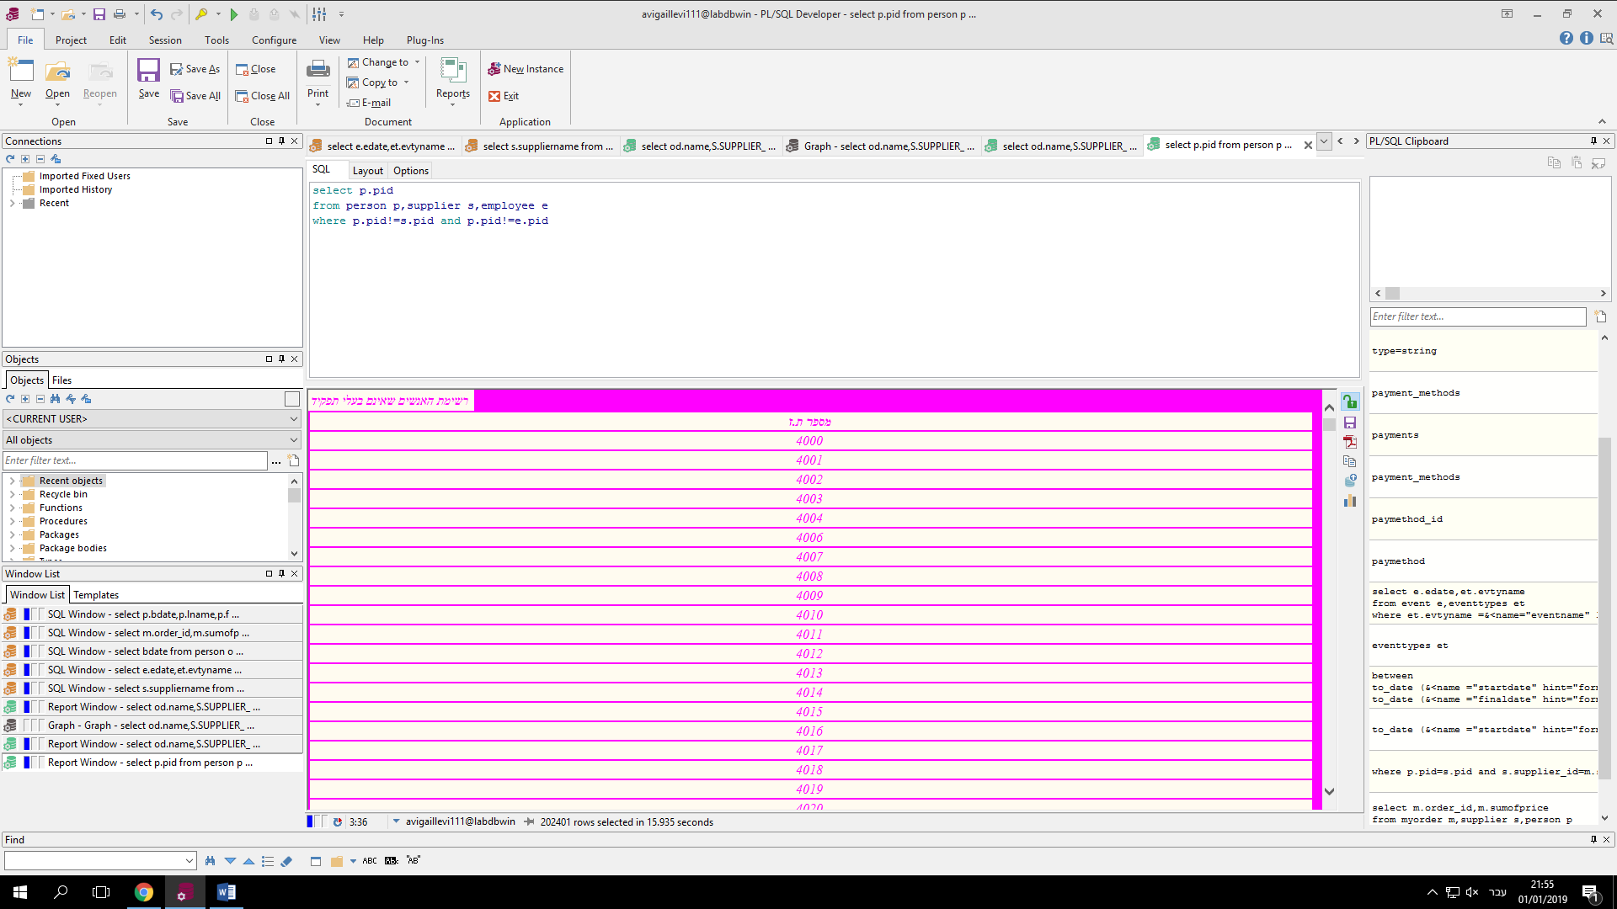

**3)**מחזיר את אמצעי התשלום עם שמות הספקים והסכום הנעים בין התאריכים 01/01/2001-01/12/2005

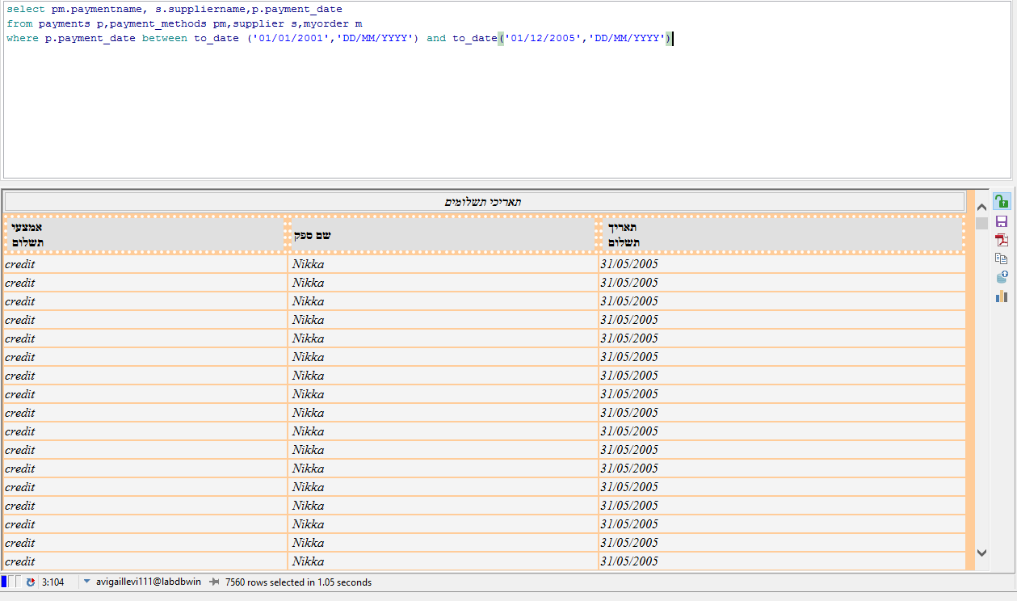

**גרפים:**

**1) מס ה'זהות' של המשרות הלא מאוישות**

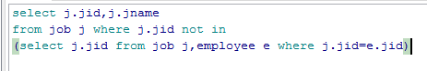

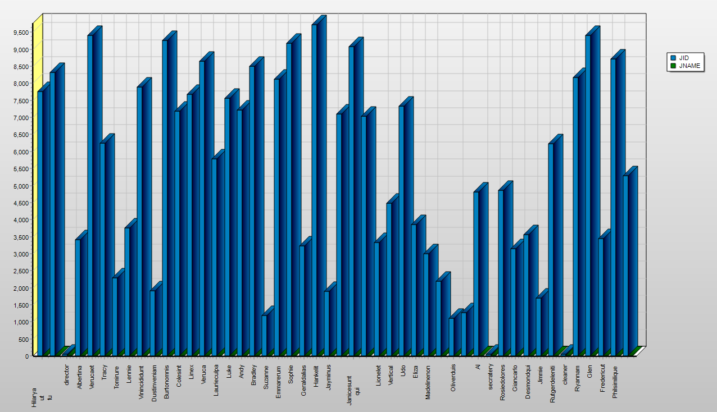

**2)כמות אנשים לכל מחלקה**

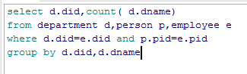

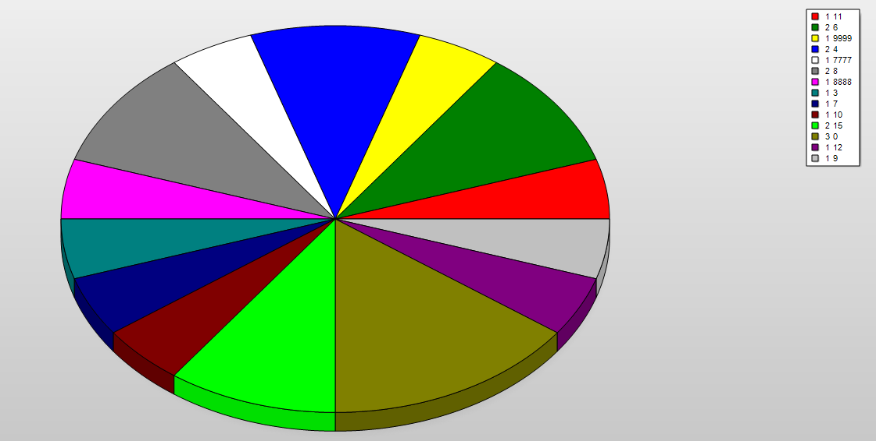

**3)מספר אנשים לכל אולם אשר כמות תפוסה מקס' 10000**



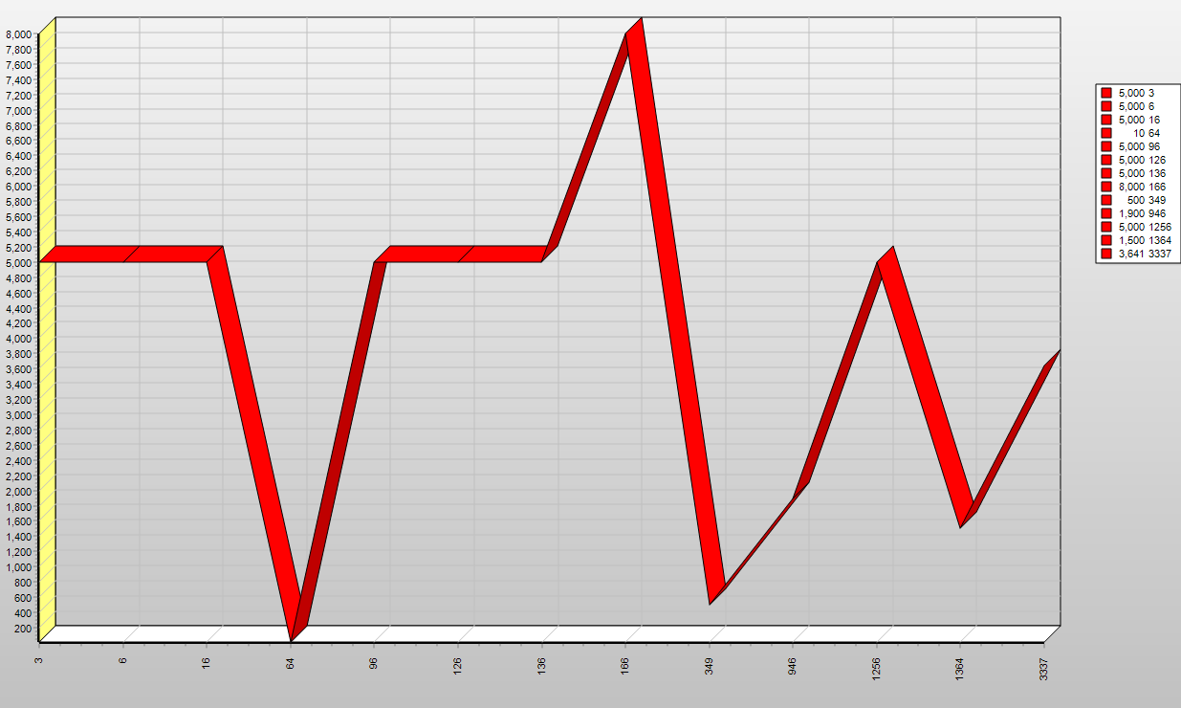

**פרוצדורות:**

1)הפרוצדורה מעדכנת את הסכום של כל מי ששילם במזומן להיות חצי מחיר

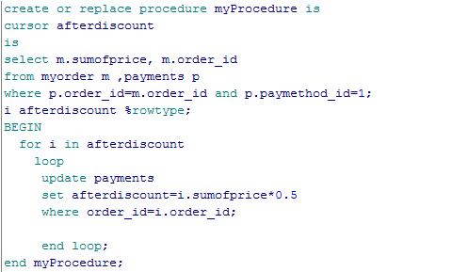

ניתן לראות שמה ששולם במזומן אחרי הנחה היה חצי מחיר וכל שאר התשלומים שלא שולמו במזומן בעמודה של אחרי הנחה הם נישאר אותו הסכ

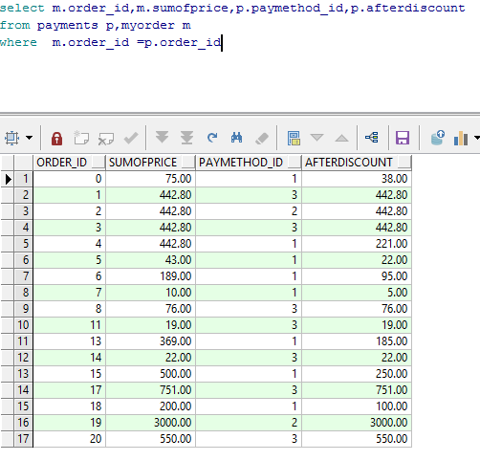

2) פרוצדורה שעוברת על כל השורות בעמודה של הסכום ועושה לי חיבור של כל הסכומים כלומר מחזירה לי תוצאה של הסכום הכולל

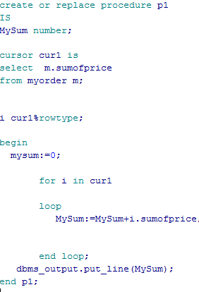

מה שהפרוצדורה מדפיסה

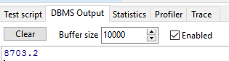

3)מדפיסה את המועמדים הרלוונטים שעומד בקריטריונים הבאים:

א)עובדים במתנס באחת המחלקות

ב) גיל מבוגר מ-40

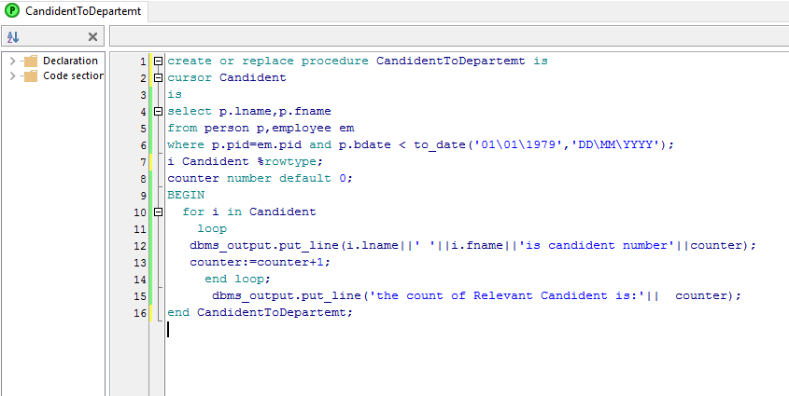

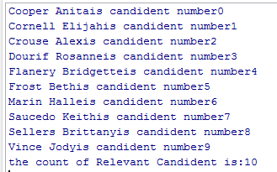

4(למחוק עובד לפי מספר עובד

לפני:

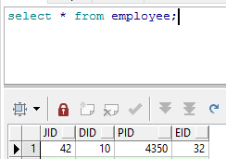

אחרי:

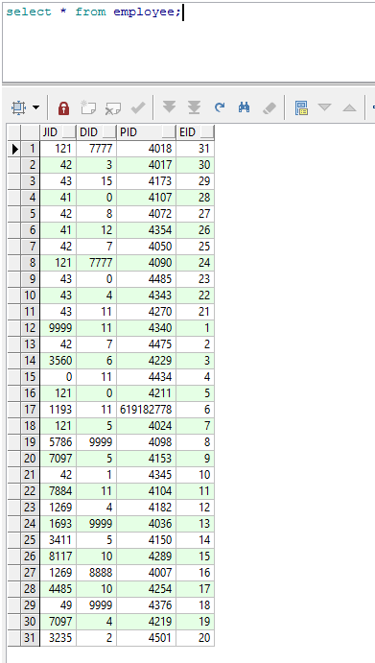

* 1. הפרוצדורה מקבלת מס זהות של עובד ומוחקת אותו מהטבלה:

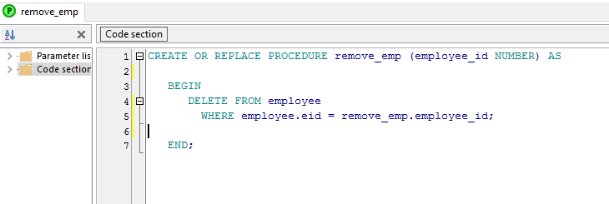

* 1. הפרוצדורה מחזירה את שמות הפרטיים של האנשים ששילמו במזומן:

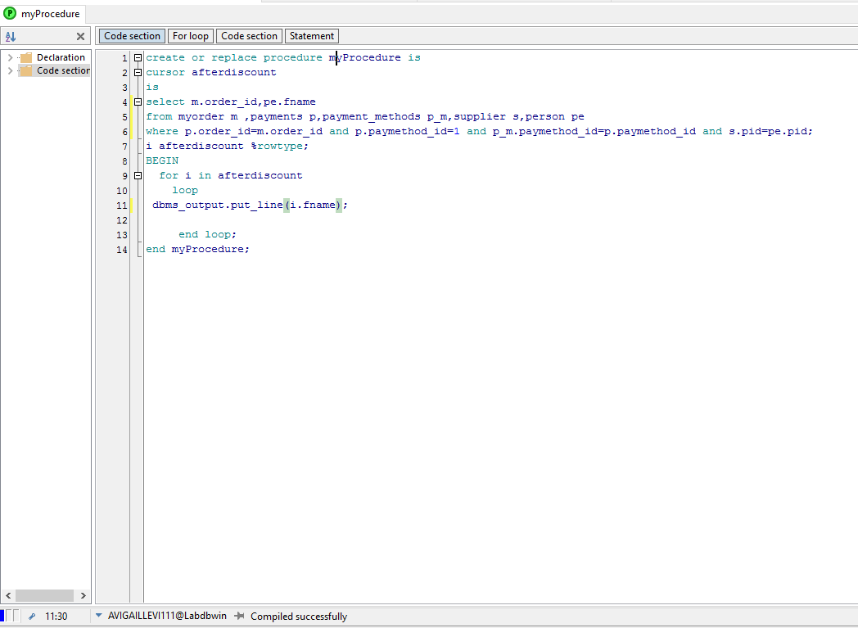

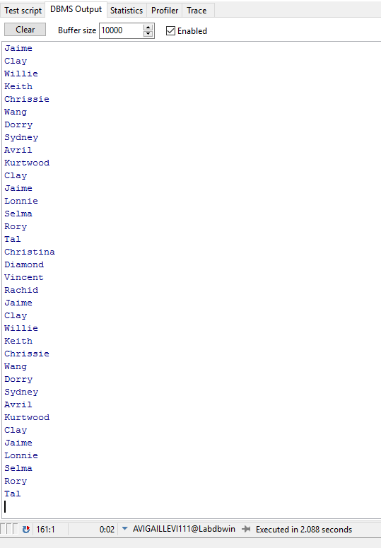

פונקציות:

1) פונקציה שמחזירה את כמות ההזמנות שהיו בטווח המחירם

הכנסתי PRICE1 = 0

PRICE2 = 1000

חזר 34 הזמנות בטווח המחירים הנל:

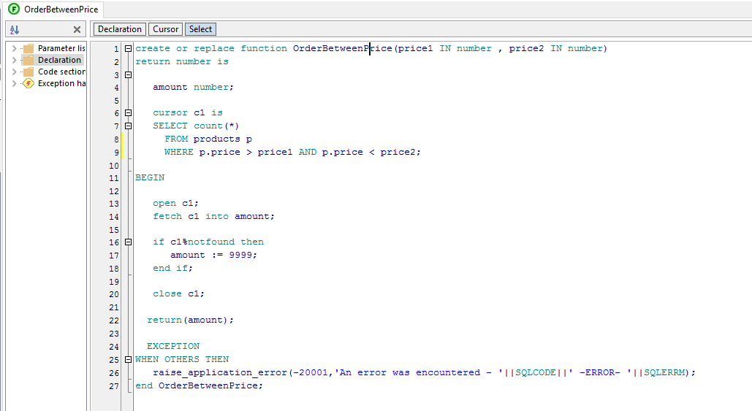

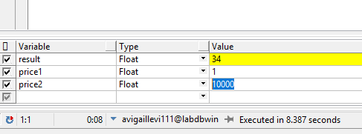

2)הפונקציה מקבלת מספר של אירוע ומחזירה את שם האירוע הנעשה בו

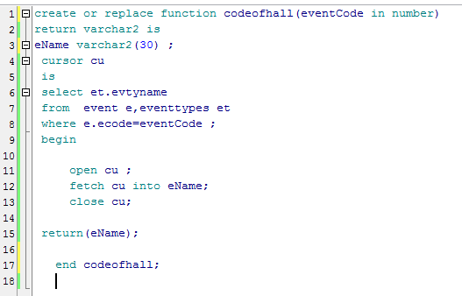

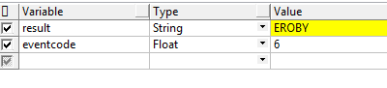

הפונקציה מקבלת מספר הזמנה ומחזירה את הסכום הכולל של ההזמנה (3

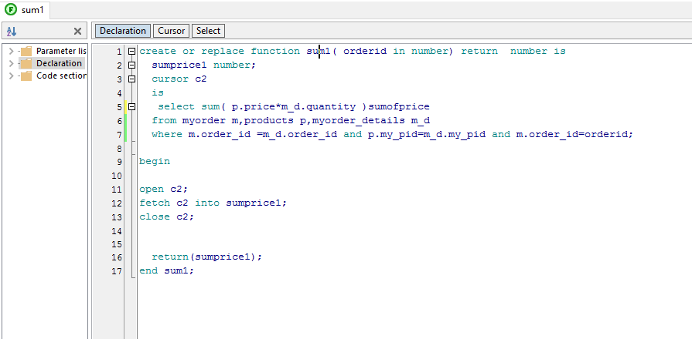

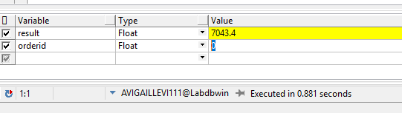

1. מקבלת PID ומחזירה שרשור של שמו ושם משפחתו ושם עירו

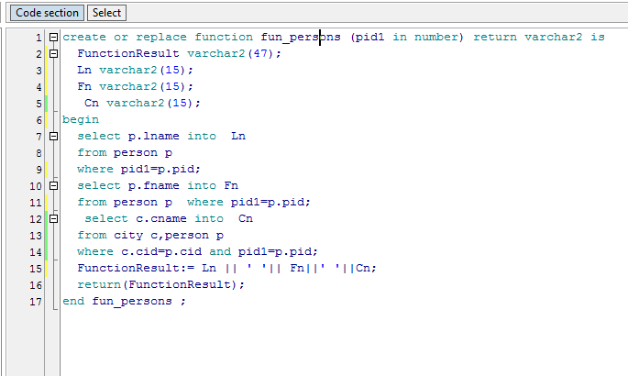

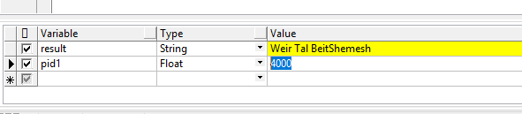

1. פונקציה זהה לקודמתה רק עם שימוש בCURSOR –לבקשת ה מורה בבחינה-יעיל יותר: 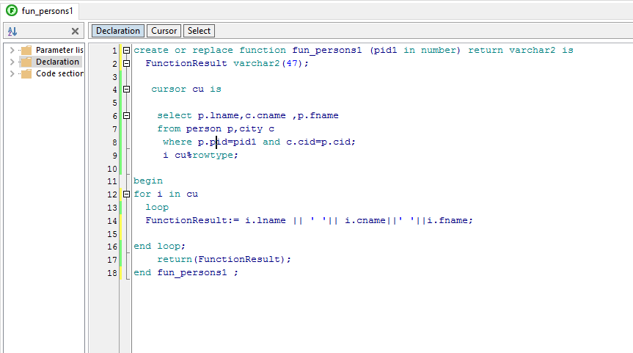

טריגרים:

1)הטריגר סופר את מספר האנשים לאחר הוספת איש במערכת

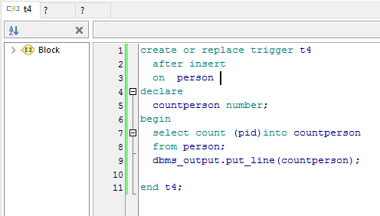

לפני הוספת בן אדם

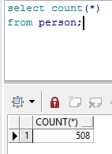

הוספת בן אדם



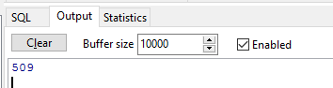

לאחר מחיקת עובד מהמערכת הטריגר מדפיס הודעה שנמחק עובד(2

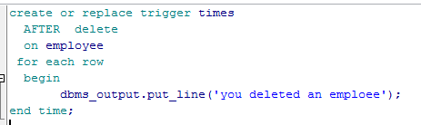

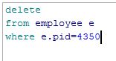

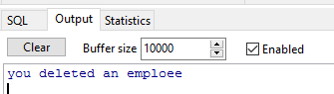

טריגר שבודק לפני הכנסת ספק חדש אם הוא כבר קיים במערכת אם הוא קיים במערכת (3

הוא מדפיס הודעה שהוא כבר קיים

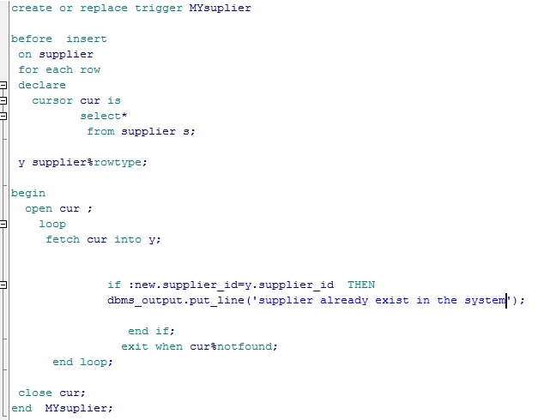

ניסוי הכנסת ספק במערכת(ספק זה כבר קיים)

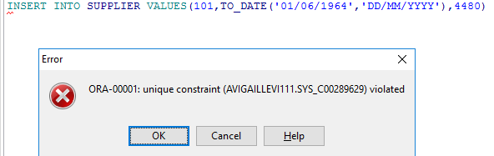

ולכן יודפס:

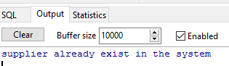

לפני הכנסת שם של עבודה חדשה במערכת הטריגר מחליף את אותיות שם העבודה לאותיות גדולות במקום קטנות(4

